


LEARNER GUIDE
Numeracy Level 2

Unit Standard 7480 Level 2 Credits 3
Unit Standard 9008 Level 2 Credits 3
Unit Standard 9007 Level 2 Credits 5
Unit Standard 7469 Level 2 Credits 2
Unit standard 9009 Level 2 Credits 3

TABLE OF CONTENTS

TABLE OF CONTENTS i
PERSONAL INFORMATION 1
INTRODUCTION 2
Structure 3
Programme Methodology 3
What Learning Material you should have 4
Different types of Activities you can expect 5
Assessments 6
Learner Support 7
Learner Administration 7
Learner Expectations 8
UNIT STANDARD 7480 9
Computational Tools 11
Computational Tools 12
Algorithms 13
Addition and Subtraction 13
Multiplication and Division 13
Parentheses (Brackets) 14
Activity 1 (SO1, AC 1, 2, 7) 14
Integers and real numbers 14
Whole Numbers, Fractions And Rounding 14
Whole numbers 15
Rounding whole numbers 15
Fractions 15
Rounding fractions 16
Groups Of Numbers 17
The effect of error in calculations: 18
Activity 2: (SO1, AC3 – 6) 18
Numbers and Relationships 19
Decimal Number System 20
Hierarchy of Decimal Numbers 20
Fractions 22
Repeating decimals 22
Convert repeating decimals to common fraction form 23
The Effect Of Error In Calculations 24
Significant figures 24
Estimating The Correct Answer 25
Scientific Notation 26
Using scientific notation 27
Activity 3: (SO2, AC, 1-5) 27
UNIT STANDARD 9008 28
Estimate, Measure and Calculate 30
Length 31
Ruler 31
Measuring Tape 31
Mass 31
Spring Balance 32
Measuring fluids 32
Time 32
Clocks And Wristwatches 32
Units Of Time 33
Digital Time 34
Thermometer 34
Symmetry 35
Geometric Formulae 36
Two-dimensions (2D) and areas 36
The area and perimeter of a rectangle 37
The Area and Perimeter of a Square 37
Circle 38
Parallelogram 39
Observations for square, rectangle, parallelogram and rhombus 40
Trapezium 40
Theorem of Pythagoras 41
Combining areas 41
SI Units 42
Using the SI system 43
The imperial (UK) number system 45
Approximations and estimations 46
Temperature scales: 47
Convert from Fahrenheit to Celsius using the formulae 48
Activity 1 (SO1, AC1-7) 49
Rough Sketches 49
Sketching in general 49
Scale Drawings 52
Adding detail to scale drawings 53
Using rectangular grids 53
Legend to sketch 55
Two Dimensional Geometric Figures 56
Transformation 57
Rotate 57
Mirror image (reflection) 58
Translation 59
Other transformations 59
Tessellation 61
Activity 2 (SO2, AC1-5) 63
UNIT STANDARD 9007 66
Representations of Functions 69
The language used in mathematics 70
Equation 70
Activity 1 70
The addition and subtraction of algebraic terms 70
Activity 2 70
Variables 70
Brackets 71
Multiplication, division, adding and subtraction, in the same expression 71
The multiplication of variables 72
Formulae 72
Functions 76
Words 76
Definition 77
Sets 77
Partial function 77
Range 77
Argument 78
Graph 78
Specifying a function 79
Behaviour of Patterns and Functions 80
Activity 3 83
UNIT STANDARD 7469 84
Personal Budgets 86
Budgeting 86
Calculate Your Earnings 86
Activity 1 (SO1, AC1-2) 87
Types of Expenditure 87
Reasons for Budgeting 87
Drawing up a Budget 87
Activity 2 (SO3-4) 88
Why should you save? 88
Example of a personal budget 88
Annual income/expenses 89
Savings 89
Cash balance 89
Variances 89
What Is A Business? 90
Costs 90
Cost Saving Within A Business 90
Income from Sales 90
Cost price 91
Selling price 91
What Is Profit? 91
Simple and Compound Interest 93
Savings And Investments 94
Stokvels 94
Negotiating body 95
Warning 95
Interest 96
Simple interest 96
Compound interest 96
Activity 3(S01-4) Costs, prices, revenue, profit 98
What is Inflation? 98
How is Inflation Measured? 98
What Inflation Does To R50.00 98
How To Combat Inflation 99
The Rule of 72 99
Long-Term Effects of Inflation 99
Activity 5 SO2, (AC1-4) Inflation 100
Depreciation And Appreciation 100
Let's look at two case studies: 101
Activity 6 (SO 1-4) Appreciation and depreciation 101
UNIT STANDARD 9009 102
ORGANISE AND REPRESENT DATA 105
Use Statistics In Work Or Every Day Life 105
Graphical Representation Of Data 106
Bar graphs 106
Line Graphs or Curves 107
Pie Charts 107
Stemplots 108
Displaying Data From a Table 112
Activity 1 (SO1, AC1-7) 117
Frequency distribution and range 117
Activity 2 (SO1, AC4-7) 119
Summarising Data 119
Mean 119
Median 120
Mode 120
Using centres and averages 121
Quartiles 122
Example 1: Q1, 1st quartile 123
Example 2: Median, 2nd quartile 124
Example 3: 3rd quartile 124
Activity 2 (SO1, AC4-7) 124
Modelled Data 125
Activity 2 (SO1, AC4-7) 125
Annexure A 126
FORMATIVE ASSESSMENT WORKBOOK 128
Unit Standard 7480 128
Activity 1 (SO1, AC 1, 2, 7) 128
Activity 2: (SO1, AC3 – 6) 131
Activity 3: (SO2, AC, 1-5) 133
Unit Standard 9008 136
Activity 1 (SO1, AC1-7) 136
Activity 2 (SO2, AC1-5) 138
Unit Standard 9007 140
SO 1-3 All criteria 140
Activity 1 140
Activity 2 140
Activity 3 140
Unit Standard 7469 140
Activity 1 (SO1, AC1-2) 140
Activity 2 (SO3-4) 141
Activity 3(S01-4) Costs, prices, revenue, profit 144
Activity 4 (SO2, AC104) 145
Activity 5 SO2, (AC1-4) Inflation 147
Activity 6 (SO 1-4) Appreciation and depreciation 148
Unit Standard 9009 149
Activity 1 (SO1, AC1-7) 149
Activity 2 (SO1, AC4-7) 154
Activity 3 (SO2, AC1-3), (SO1, AC3-6) 156

PERSONAL INFORMATION

NAME
CONTACT ADDRESS
Code
Telephone (H)
Telephone (W)
Cellular
Learner Number
Identity Number
EMPLOYER
EMPLOYER CONTACT ADDRESS
Code
Supervisor Name
Supervisor Contact Address
Code
Telephone (H)
Telephone (W)
Cellular

INTRODUCTION

Welcome to the learning programme

Follow along in the guide as the training practitioner takes you through the material. Make notes and sketches that will help you to understand and remember what you have learnt. Take notes and share information with your colleagues. Important and relevant information and skills are transferred by sharing!



This learning programme is divided into sections. Each section is preceded by a description of the required outcomes and assessment criteria as contained in the unit standards specified by the South African Qualifications Authority. These descriptions will define what you have to know and be able to do in order to be awarded the credits attached to this learning programme. These credits are regarded as building blocks towards achieving a National Qualification upon successful assessment and can never be taken away from you!

Structure

Programme Methodology
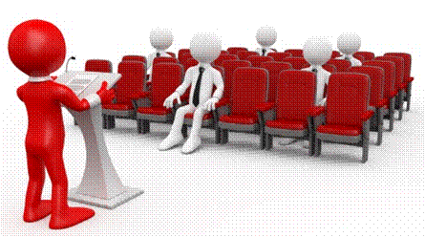

The programme methodology includes facilitator presentations, readings, individual activities, group discussions and skill application exercises.
Know what you want to get out of the programme from the beginning and start applying your new skills immediately. Participate as much as possible so that the learning will be interactive and stimulating.
The following principles were applied in designing the course:
- Because the course is designed to maximise interactive learning, you are encouraged and required to participate fully during the group exercises
- As a learner you will be presented with numerous problems and will be required to fully apply your mind to finding solutions to problems before being presented with the course presenter’s solutions to the problems
- Through participation and interaction, the learners can learn as much from each other as they do from the course presenter
- Although learners attending the course may have varied degrees of experience in the subject matter, the course is designed to ensure that all delegates complete the course with the same level of understanding
- Because reflection forms an important component of adult learning, some learning resources will be followed by a self-assessment which is designed so that the learner will reflect on the material just completed.
This approach to course construction will ensure that learners first apply their minds to finding solutions to problems before the answers are provided, which will then maximise the learning process which is further strengthened by reflecting on the material covered by means of the self-assessments.

Different role players in delivery process
- Learner
- Facilitator
- Assessor
- Moderator

What Learning Material you should have
This learning material has also been designed to provide the learner with a comprehensive reference guide. It is important that you take responsibility for your own learning process; this includes taking care of your learner material. You should at all times have the following material with you:
  Learner Guide | This learner guide is your valuable possession:  This is your textbook and reference material, which provides you with all the information you will require to meet the exit level outcomes. During contact sessions, your facilitator will use this guide and will facilitate the learning process. During contact sessions a variety of activities will assist you to gain knowledge and skills.  Follow along in the guide as the training practitioner takes you through the material. Make notes and sketches that will help you to understand and remember what you have learnt. Take and share information with your colleagues. Important and relevant information and skills are transferred by sharing!  This learning programme is divided into sections. Each section is preceded by a description of the required outcomes and assessment criteria as contained in the unit standards specified by the South African Qualifications Authority. These descriptions will define what you have to know and be able to do in order to be awarded the credits attached to this learning programme. These credits are regarded as building blocks towards achieving a National Qualification upon successful assessment and can never be taken away from you!
  Formative Assessment Workbook | The Formative Assessment Workbook supports the Learner Guide and assists you in applying what you have learnt.  The formative assessment workbook contains classroom activities that you have to complete in the classroom, during contact sessions either in groups or individually.  You are required to complete all activities in the Formative Assessment Workbook. The facilitator will assist, lead and coach you through the process. These activities ensure that you understand the content of the material and that you get an opportunity to test your understanding.

Different types of Activities you can expect
To accommodate your learning preferences, a variety of different types of activities are included in the formative and summative assessments. They will assist you to achieve the outcomes (correct results) and should guide you through the learning process, making learning a positive and pleasant experience.
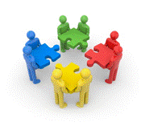
The table below provides you with more information related to the types of activities.
Types of Activities | Description | Purpose
Knowledge Activities   | You are required to complete these activities on your own. | These activities normally test your understanding and ability to apply the information.
Skills Application Activities   | You need to complete these activities in the workplace | These activities require you to apply the knowledge and skills gained in the workplace
  Natural Occurring Evidence | You need to collect information and samples of documents from the workplace. | These activities ensure you get the opportunity to learn from experts in the industry.  Collecting examples demonstrates how to implement knowledge and skills in a practical way

Assessments
The only way to establish whether a learner is competent and has accomplished the specific outcomes is through the assessment process. Assessment involves collecting and interpreting evidence about the learners’ ability to perform a task.
To qualify and receive credits towards your qualification, a registered Assessor will conduct an evaluation and assessment of your portfolio of evidence and competency.
This programme has been aligned to registered unit standards. You will be assessed against the outcomes as stipulated in the unit standard by completing assessments and by compiling a portfolio of evidence that provides proof of your ability to apply the learning to your work situation.


How will Assessments commence?

Formative Assessments
The assessment process is easy to follow. You will be guided by the Facilitator. Your responsibility is to complete all the activities in the Formative Assessment Workbook and submit it to your facilitator.

Summative Assessments
You will be required to complete a series of summative assessments. The Summative Assessment Guide will assist you in identifying the evidence required for final assessment purposes. You will be required to complete these activities on your own time, using real life projects in your workplace or business environment in preparing evidence for your Portfolio of Evidence. Your Facilitator will provide more details in this regard.
To qualify and receive credits towards your qualification, a registered Assessor will conduct an evaluation and assessment of your portfolio of evidence and competency.

Learner Support
The responsibility of learning rests with you, so be proactive and ask questions and seek assistance and help from your facilitator, if required.
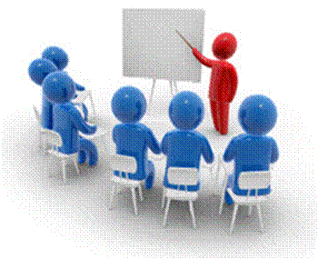

Please remember that this Skills Programme is based on outcomes based education principles which implies the following:
- You are responsible for your own learning – make sure you manage your study, research and workplace time effectively.
- Learning activities are learner driven – make sure you use the Learner Guide and Formative Assessment Workbook in the manner intended, and are familiar with the workplace requirements.
- The Facilitator is there to reasonably assist you during contact, practical and workplace time for this programme – make sure that you have his/her contact details.
- You are responsible for the safekeeping of your completed Formative Assessment Workbook and Workplace Guide
- If you need assistance, please contact your facilitator who will gladly assist you.
- If you have any special needs, please inform the facilitator

Learner Administration
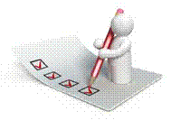

Attendance Register
You are required to sign the Attendance Register every day you attend training sessions facilitated by a facilitator.

Programme Evaluation Form
On completion you will be supplied with a “Learning programme Evaluation Form”. You are required to evaluate your experience in attending the programme.
Please complete the form at the end of the programme, as this will assist us in improving our service and programme material. Your assistance is highly appreciated.

Learner Expectations
Please prepare the following information. You will then be asked to introduce yourself to the instructor as well as your fellow learners
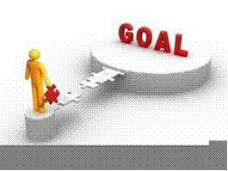

Your name:
The organisation you represent:
Your position in organisation:
What do you hope to achieve by attending this course / what are your course expectations?

UNIT STANDARD 7480

Unit Standard Title
Demonstrate understanding of rational and irrational numbers and number systems

NQF Level
2

Credits
3

Purpose
This unit standard will be useful to people who aim to achieve recognition at some level in Further Education and Training or to meet the Fundamental requirement of a wide range of qualifications registered on the National Qualifications Framework

Learning Assumptions
The credit value is based on the assumption that people starting to learn towards this unit standard are competent in Mathematics and Communications at NQF level 1.

Range
Approximation in relation to the use of computing technologies, the distinction between exact and approximate answers in a variety of problem settings and measurement error in relation to the accuracy of instruments
More detailed range statements are provided for specific outcomes and assessment criteria as needed

Specific Outcomes and Assessment Criteria
Specific Outcome 1: Use and analyse computational tools and strategies, and make estimates and approximations.
Range: This outcome includes the need to
- use technology such as calculators
- demonstrate understanding of mathematical relationships and principles involved in computations
- find rational approximations to irrational numbers
Assessment Criteria
- Computational tools are used efficiently and correctly and solutions obtained are verified in terms of the context or problem
- Algorithms are executed appropriately in calculations
- Solutions involving irrational numbers are reported or recorded to degrees of accuracy appropriate to the problem
- Measurements are reported or recorded in accordance with the degree of accuracy of the instrument used
- Estimates and approximations are used appropriately in terms of the situation and distinctions are made between the appropriate use of estimates versus approximations: Technological and non-technological settings
- The roles and limitations of particular algorithms are identified in terms of efficiency and the complexity of the algebraic formulation
- The viability of selected algorithms is verified and justified in terms of appropriateness to context and efficiency
Specific Outcome 2: Demonstrate understanding of numbers and relationships among numbers and number systems. Notes: Demonstrate understanding of numbers and relationships among numbers and number systems, and represent numbers in different ways
Range: This outcome includes the need to:
- work with rational and irrational numbers
- explore repeating decimals and convert them to common fraction form
- use scientific notation for small and large numbers
Assessment Criteria
- Notation for expressing numbers is consistent with mathematical conventions
- Methods of calculation and approximation are appropriate to the problem types.
- Numbers and quantities are represented using rational and irrational numbers as appropriate to the context
- Scientific notation is used appropriately and consistently with conventions. Situations for the use of scientific notation are provided and described in terms of advantages
- Conversions between numbers expressed in different ways: Between decimal and scientific notation and between repeating decimals and common fractions

Unit Standard Essential Embedded Knowledge
The following essential embedded knowledge will be assessed through assessment of the specific outcomes in terms of the stipulated assessment criteria. Candidates are unlikely to achieve all the specific outcomes, to the standards described in the assessment criteria, without knowledge of the listed embedded knowledge. This means that the possession or lack of the knowledge can be inferred directly from the quality of the candidate’s performance against the standards
- Number systems and rational and irrational numbers
- Estimation and approximation


Critical cross-field outcomes
Upon successful completion of this course, the learner will be able to:
- Collect, analyse, organise and critically evaluate information: Gather, organise, evaluate and interpret numerical information
- Use mathematics: Use mathematics to analyse, describe and represent realistic and abstract situations and to solve problems
- Communicate effectively: Use everyday language and mathematical language to describe relationships, processes and problem solving methods

Computational Tools
God gives us the tools to advance our knowledge.

Outcome
Use and analyse computational tools and strategies, and make estimates and approximations.

Outcome Notes
This outcome includes the need to
- Use technology such as calculators
- Demonstrate understanding of mathematical relationships and principles involved in computations
- Find rational approximations to irrational numbers

Assessment criteria
- Computational tools are used efficiently and correctly and solutions obtained are verified in terms of the context or problem
- Algorithms are executed appropriately in calculations
- Solutions involving irrational numbers are reported or recorded to degrees of accuracy appropriate to the problem
- Measurements are reported or recorded in accordance with the degree of accuracy of the instrument used
- Estimates and approximations are used appropriately in terms of the situation and distinctions are made between the appropriate use of estimates versus approximations: Technological and non-technological settings
- The roles and limitations of particular algorithms are identified in terms of efficiency and the complexity of the algebraic formulation The viability of selected algorithms is verified and justified in terms of appropriateness to context and efficiency

Computational Tools
A sequence of calculations that sets out a series of detailed steps enabling a particular result to be obtained, is called an algorithm. The process of long division, for instance, is an algorithm.
The value of algorithms has been rediscovered with the development of calculating machines. These machines are used in many forms today, varying from pocket calculators to complicated computers.
For the purpose of this course the simple pocket calculator will be discussed as a computational tool.
The liquid crystal display (LCD) of the calculator is made of a liquid crystal, hermetically sealed between two glass plates and caution must be exercised in handling the calculator.
The following general rules must be kept in mind to ensure trouble free operation:
- Do not place the calculator in a location subject to direct sunlight, especially in a car with its windows closed in a hot climate. High temperatures may damage the calculator.
- Avoid locations subject to rapid temperature changes and excessive moisture or dust.
- Do not drop or bump the calculator.
- Always use a soft dry cloth to clean the calculator – not a cloth moistened with any volatile solvent or water.
- If the calculator uses batteries, do not leave the batteries in it for extended periods if the unit is not to be used. Battery acid leakage may damage the calculator.
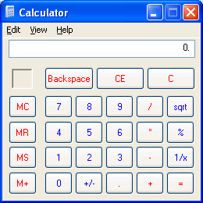
A wide variety of calculations can be done, depending on the type of calculator used. Specialised calculators are used for example scientific, statistic or financial purposes.
It is a good idea to study the manual of your specific calculator well to be able to maximize the use of your computational tool

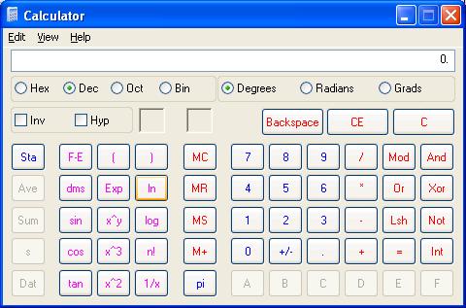

Algorithms

Addition and Subtraction

Example 1
123 + 456 + 789
Key in: 123 + 456 + 789
Answer: 1368

Example 2
100 - 25 - 35
Key in: 100 - 25 - 35
Answer: 40
Pressing the = key gives the answer to the entered formula.

Multiplication and Division

Example 3
50 x (-2) ÷ 4
Key in: 50 x 2 ± ÷ 4 =
Answer: -25

NOTE: To enter a negative number, press the ± (change Sign) key after numeric entry.

Example 4
5 + 2 x 3 - 2 ÷ 0.5
Key in: 5 + 2 x 3 -2 ÷ 1 =
Answer: 7

Parentheses (Brackets)
The parentheses key is used to cluster together a series of operations if it is necessary to do it first. When brackets are used the calculations in brackets take precedence over any other calculation. Calculations within the innermost set of brackets will be performed first.

Example 5
12 + 42 ÷ (8 - 6)
Key in: 12 + 42 ÷ ( 8 - 6 ) =
Answer: 33

Example 6
( 3 + 4 ) x ( 3 - 1 )
Key in: ( 3 + 4 ) x ( 3 - 1 ) =
Answer: 24
Important: An error will occur should the brackets be omitted!

Activity 1 (SO1, AC 1, 2, 7)

Integers and real numbers
Integers are whole numbers (e.g. 1, 45, 77…) and real numbers are numbers with a decimal point (e.g. 24.59, 2.09 and 9.1)
Note that a whole number is real if it is written with a decimal point. Therefore;
64 is an integer, but
64.0 is real

Whole Numbers, Fractions And Rounding
When we say that each number has a value that depends on its place in the range of numbers, we usually shake our heads and say, ‘I know’. In order to understand what this really means, let’s look at a few examples.

Example 7
The number 194 is the same as 1×100 + 9×10 + 4. The ‘4’ is in the unit’s place, the ‘9’ is in the ten’s place and the ‘1’ is in the hundred’s place.
Notice how we say the number when we speak and the repetition of the terms ‘Units, Tens and Hundreds’.

Whole numbers
Whole numbers are numbers without fractions. A dozen eggs consists of 12 eggs and a gross of eggs (not often heard these days) is 12 dozen or 144 eggs. In South Africa numbers greater than 999 are supposed to appear with spaces between each group of 3 digits also called groups of thousands. For example, the following numbers should be written as 874 349 172. However, you will find that computers and calculators are not very friendly to this manner of using numbers. Therefore, this manual uses the US system of commas to separate the groups and the same number appears as 874,349,172.

Rounding whole numbers
Rounding the values of whole numbers is simple. To round the previous number to the nearest tens (10), look at the ten’s position of the number (72) and decide if it is closer to 70 or closer to 80. In this case the number is closer to 70 so 874,349,172 rounded to the nearest 10 is 874,349,170.
To round 874,349,172 to the nearest 100, look at the hundred’s position (and all numbers to its right) and get 170. Now decide if 170 is closer to 100 or closer to 200. It’s closer to 200. Therefore the number 874,349,172 rounded to the nearest 100 is 874,349,200.
The table below shows the number and rounds it as shown.

Number | Round to nearest | Look at | Result
874,349,172 | 10 | 72 | 874,349,170
874,349,172 | 100 | 172 | 874,349,200
874,349,172 | 1,000 | 9,172 | 874,349,000
874,349,172 | 10,000 | 49,172 | 874,350,000
874,349,172 | 100,000 | 349,172 | 874,300,000
874,349,172 | 1,000,000 | 4,349,172 | 874,000,000
874,349,172 | 10,000,000 | 74,349,172 | 870,000,000
874,349,172 | 100,000,000 | 874,349,172 | 900,000,000
874,349,172 | 1,000,000,000 | 874,349,172 | 1,000,000,000
By convention the number ‘5’ in a specific position rounds up to the nearest 10, 100 and so forth. For example, 35 rounds up to 40 as the nearest 10, 150 rounds up to 200 as the nearest 100 and 2,500 rounds up 3,000 as the nearest 1,000. This rounding technique is called conventional rounding or popular rounding.

Fractions
Fractions are very similar to whole numbers but they represent a part of a whole and are less than one. In South Africa, fractional parts of a number are supposed to be represented by a comma. However, this is not what computers and calculators like to use.
Therefore, the US system of representing the fraction part of a number with a period (full stop) is used in this manual.
An example of a fraction would be half an apple that may be represented as 0.5 of an apple (or an apple). It is important to remember that fractions of a whole mean how many pieces there are when the whole is divided into sections. The more pieces you divide something into, the smaller each piece becomes. As you already know, half a pie is larger than a quarter of a pie. Sometimes this concept is difficult to visualize.
The more something is divided, the smaller each piece becomes. At the same time, the more it is divided, the more pieces there are.
Fractions may be combined with whole numbers.

Rounding fractions
The following table lists the various terms used to represent the fraction parts of numbers as well as the terms used to represent the whole parts of numbers. Notice that the fraction parts are very similar to the whole numbers. Instead of starting at the decimal point and moving to the left as whole numbers do, fractions start at the decimal point and move to the right. The names of the fractional parts correspond to the names of the whole numbers but end in ‘th’ instead of ‘s’.

Term | Alternate term | Value
Millionth | 6 decimals | 0.000001
Hundred-thousandth | 5 decimals | 0.00001
Ten-thousandth | 4 decimals | 0.0001
Thousandth | 3 decimals | 0.001
Hundredth | 2 decimals | 0.01
Tenth | 1 decimal | 0.1
Units | Whole number | 1
Tens |  | 10
Hundreds |  | 100
Thousands |  | 1,000
Ten-thousands |  | 10,000
Hundred-thousands |  | 100,000
Millions |  | 1,000,000
Terms, alternate terms and their values

Example 8
When you next buy your favourite cool drink or milk in a bottle, look at all the bottles and notice how the contents vary among them. I have a tin of fruit juice in front of me that says it contains 340ml. I can’t see it but I now know that 340ml is an approximation to the amount of liquid in the tin. I also know that the difference is acceptable to me or I would have stopped buying this brand of cool drink a long time ago.
Below is the range of several values called ‘Minimum’ and ‘Maximum’ that round to 340ml for various rounding values (‘Round to’).

Value | Round to | Minimum | Maximum
340ml | 1ml | 339.5ml | 340.4ml
340ml | 10ml | 335ml | 344ml
340ml | 20ml | 330ml | 349ml
Values that round to 340ml for different precisions
In order to find the range (minimum and maximum values) for any given value and rounding value, following these steps.
- Call the original value you have ‘Value’.
- Divide the rounding value in half and call it ‘Range’.
- Calculate the minimum value as (Value – Range) and call it ‘Minimum’.
- Subtract one (1) from the last digit of ‘Range’. Note that you must ignore the decimal point when doing this. Call this number ‘Adjusted Range’.
- Add the ‘Adjusted Range’ to ‘Value’ (Value + Adjusted Range) and call it ‘Maximum’.
If we use the example of the cool drink and we are told that the rounding value is 1ml, this is the same as saying that the last digit is accurate to within 1ml and has been rounded to 340ml. The following steps show how to calculate the range of numbers when you know the value and its accuracy.
- ‘Value’ = 340ml.
- ‘Range’ = 0.5ml (1ml ÷ 2 = 0.5ml).
- ‘Minimum’ = 339.5ml (340ml – 0.5ml = 339.5ml).
- ‘Adjusted Range’ = 0.4ml (subtract 1 from the last digit of ‘Range’).
- ‘Maximum’ = 340.4ml (340ml + 0.4ml)

Example 9
What numbers round to 1234.56 to the nearest hundredth (0.01)?

- ‘Value’ = 1234.56.
- ‘Range’ = 0.005 (0.01 ÷ 2).
- ‘Minimum’ = 1234.555 (1234.56 – 0.005).
- ‘Adjusted Range’ = 0.004 (reduce last digit by 1).
- ‘Maximum’ = 1234.564 (1234.56 + 0.004).
Determining the range of values that round to a value is a bit more work than rounding a number to a specific accuracy.

Groups Of Numbers
Not all numbers are exact – some are actually infinite. This makes it difficult or impossible to represent them exactly. The main groups of numbers will be discussed below.
All Real numbers, (numbers with real values) can be divided into Rational and Irrational numbers.
Rational numbers have values that can be determined exactly and Irrational numbers have values that cannot be exactly determined. Rational numbers are very often perfect squares.
Real numbers
Rational numbers | Irrational numbers
⅔; √4; √9; √(16/25) | √5; ³√7

Rational numbers are all numbers that can be represented as a ratio () of two numbers. All whole numbers are rational numbers because they may be represented as their value over 1. The number 3 is therefore .
Irrational numbers are those that cannot be represented as a ratio of two whole numbers: this means numbers that cannot be represented as simple fractions. Irrational numbers cannot be represented as terminating or repeating decimals
Two irrational numbers are and π. When dealing with arithmetic involving irrational numbers it is best to keep them as they appear unless an approximate answer is required.

The effect of error in calculations:
From the explanation it can be seen that not all answers are hundred percent correct even if our arithmetic was correct. It depends on more than that. Often we use values that were measured and these can never be perfectly accurate. This is discussed in more detail in the next section.

Activity 2: (SO1, AC3 – 6)
“Now he who supplies seed to the sower and bread for food will also supply and increase your store of seed and will enlarge the harvest of your righteousness.”

2 Corinthians 9:10, NIV

Numbers and Relationships
How great is it to know that when you are with God, no knowledge is unreachable.

Outcome
Demonstrate an understanding of numbers and relationships among numbers and number systems, and represent numbers in different ways

Outcome Notes
This outcome includes the need to
- work with rational and irrational numbers
- explore repeating decimals and convert them to common fraction form
- use scientific notation for small and large numbers

Assessment criteria
- Notation for expressing numbers is consistent with mathematical conventions
- Methods of calculation and approximation are appropriate to the problem types.
- Numbers and quantities are represented using rational and irrational numbers as appropriate to the context
- Scientific notation is used appropriately and consistently with conventions. Situations for the use of scientific notation are provided and described in terms of advantages
- Conversions between numbers expressed in different ways are accurate: Between decimal and scientific notation and between repeating decimals and common fractions

Decimal Number System
There is more than one number system. The decimal number system is the most common where there are 10 elements

Elements:
0, 1, 2, 3, 4, 5, 6, 7, 8, 9

Base number:
10
The decimal system is the one we use to count and perform operations on numbers. Perhaps the decimal system is used because humans have ten fingers and counting objects began with using our ten digits, as they are called. I wonder how we would be counting if we had eight or twelve fingers. I suppose we will never know.
When the decimal system is mentioned, almost everyone says that they know and understand the system. However, when asked to count, they start at 1 and count to 10. This is incorrect! The decimal system consists of ten items but they actually start at 0 and end at 9.
The Arabic nations invented a method to represent two extremely important concepts:
- how to represent zero and
- a system so that each number in a specific position has a well-known and easily definable meaning or weight.
It may sound strange but the invention of zero (or nothing) was the biggest breakthrough in mathematical history. together with the fact that the position of each digit had a specific meaning meant that commerce and trade were simplified. The western world uses slight modifications of the numbering figures invented so long ago by the Arabic nations.

Hierarchy of Decimal Numbers
Number | Name | How many
0 | zero
1 | one | One
2 | two | two ones
3 | three | Three ones
4 | four | Four ones
5 | five | Five ones
6 | six | Six ones
7 | seven | seven ones
8 | eight | Eight ones
9 | nine | Nine ones
10 | ten | one ten
20 | twenty | two tens
30 | thirty | three tens
40 | forty | four tens
50 | fifty | five tens
60 | sixty | six tens
70 | seventy | seven tens
80 | eighty | eight tens
90 | ninety | nine tens

Number | Name | How Many
100 | one hundred | ten tens
1,000 | one thousand | ten hundreds
10,000 | ten thousand | ten thousands
100,000 | one hundred thousand | one hundred thousands
1,000,000 | one million | one thousand thousands

Some people use a comma to mark every 3 digits. It just keeps track of the digits and makes the numbers easier to read.

“And God will generously provide all you need. Then you will always have everything you need and plenty left over to share with others.”

2 Corinthians 9:8

Fractions
Digits to the right of the decimal point represent the fractional part of the decimal number. Each place value has a value that is one tenth the value to the immediate left of it.

Number | Name | Fraction
.1 | tenth | 1/10
.01 | hundredth | 1/100
.001 | thousandth | 1/1000
.0001 | ten thousandth | 1/10000
.00001 | hundred thousandth | 1/100000

Example 10
0.234 = 234/1000 (said - point 2 3 4, or 234 thousandths, or two hundred thirty four thousandths)
4.83 = 4 83/100 (said - 4 point 8 3, or 4 and 83 hundredths)

Repeating decimals
Repeating decimals are decimals with certain digits that repeat.

Example11
1.3333333 never ends and is written as:

However this is a rather complicated method to use. It is much easier to simplify the repeating number to its nearest decimal value. We do however indicate that it is repetitive.
Here are a few examples:

Often when we calculate a number we end up with a lot of decimals, this isn’t practical and we round off to a certain number of decimal numbers.
If a number is between 1 - 4 it is rounded down and if it is between 5-9 it is rounded up.

Convert repeating decimals to common fraction form
Important Note: any span of numbers that is underlined signifies that those numbers are repeated. For example, 0.09 signifies 0.090909.
Only fractions in lowest terms are listed. For instance, to find 2/8, first simplify it to 1/4 then search for it in the table below.

fraction = decimal
1/1 = 1
1/2 = 0.5
1/3 = 0.3 | 2/3 = 0.6
1/4 = 0.25 | 3/4 = 0.75
1/5 = 0.2 | 2/5 = 0.4 | 3/5 = 0.6 | 4/5 = 0.8
1/6 = 0.16 | 5/6 = 0.83
1/7 = 0.142857 | 2/7 = 0.285714 | 3/7 = 0.428571 | 4/7 = 0.571428
 | 5/7 = 0.714285 | 6/7 = 0.857142
1/8 = 0.125 | 3/8 = 0.375 | 5/8 = 0.625 | 7/8 = 0.875
1/9 = 0.1 | 2/9 = 0.2 | 4/9 = 0.4 | 5/9 = 0.5
 | 7/9 = 0.7 | 8/9 = 0.8
1/10 = 0.1 | 3/10 = 0.3 | 7/10 = 0.7 | 9/10 = 0.9
1/11 = 0.09 | 2/11 = 0.18 | 3/11 = 0.27 | 4/11 = 0.36
 | 5/11 = 0.45 | 6/11 = 0.54 | 7/11 = 0.63
 | 8/11 = 0.72 | 9/11 = 0.81 | 10/11 = 0.90
1/12 = 0.083 | 5/12 = 0.416 | 7/12 = 0.583 | 11/12 = 0.916
1/16 = 0.0625 | 3/16 = 0.1875 | 5/16 = 0.3125 | 7/16 = 0.4375
 | 11/16 = 0.6875 | 13/16 = 0.8125 | 15/16 = 0.9375
1/32 = 0.03125 | 3/32 = 0.09375 | 5/32 = 0.15625 | 7/32 = 0.21875
 | 9/32 = 0.28125 | 11/32 = 0.34375 | 13/32 = 0.40625
 | 15/32 = 0.46875 | 17/32 = 0.53125 | 19/32 = 0.59375
 | 21/32 = 0.65625 | 23/32 = 0.71875 | 25/32 = 0.78125
 | 27/32 = 0.84375 | 29/32 = 0.90625 | 31/32 = 0.96875

The Effect Of Error In Calculations
From the explanation it can be seen that not all answers are hundred percent correct even if our arithmetic is correct. It depends on more than that. Often we use values that were measured and these can never be perfectly accurate.

Significant figures

Significant figures
Significant figures help us to work as accurately as possible when working with measured data. A 2 figure measurement, like 91 m is accurate to ±1 m. The percentage error is therefore:
1/91 x 100 = 1, 09% ≈1%
A 4 figure measurement like 91,11m is accurate to 0,01m. The percentage error is therefore:
0, 01/91.11 x 100 = 0, 0109 ≈0, 01
This is 100 times more accurate!
When trying to determine the number of significant figures a number has you should not consider zeros before or after the number. Unless the number has a full stop at the end, this is common in American notation.

Example: 12
10 has 1 significant figure
0,00234 has 3 significant figures
2340. has 4 significant figures
3.45 has 3 significant figures

Rules used to determine the number of significant figures the answer of a calculation should have:
Multiplication and subtraction:
Number with the least significant figures determines the answer:
12,345 x 6, 7 = 83 NOT 82, 7115
Addition and subtraction
Retain the smallest number of decimal places.
10,345 + 9, 9 = 20.2 NOT 20,245 or 20!
Whole numbers, or integers, suffice for discussing numbers of people or cattle, but entities land, wine and grain often need to be measured out in varying quantities that does not correspond to whole numbers. Among the followers of Pythagoras it was discovered that whole numbers and fractions (known as rational numbers because they can be expressed as ratios) do not account for all numbers.
The numbers that can not be expressed as ratios are called irrational. An example is the square root of 2 (the number that multiplied by itself equals 2). Rational and irrational numbers together represent all numbers greater than zero.
It was not until the Renaissance that the progress of mathematics called for a further extension of the numbers below zero. It was gradually realised that these ”negative” numbers were an acceptable mathematical idea, provided that they are handled consistently.
The concept of negative numbers occurs in every day life. A person can not find a negative number of money in his pocket, but his overdraft at the bank can be negative.

Estimating The Correct Answer
In certain circumstances it is sufficient to make use of approximations. That is an estimate of a given quantity to a certain degree of accuracy. If, for example, the distance between two points is measured as 2 385 m, then the measurement is correct to the nearest meter.
If, however, this amount of accuracy is not necessary, the distance could be written as 2 384 m – an approximation accurate to the nearest 10m. Acceptable approximation would be determined by the circumstances – if very small quantities are used, approximation to the nearest meter would not be acceptable.
This subsection takes errors produced by rounding and demonstrates how this can be very useful in our daily lives. When we intentionally introduce errors in arithmetic caused by too much rounding, we obtain a ‘ballpark’ estimate of the correct answer. This estimate may be used when shopping to obtain an idea of the total amount our purchases will be as well as what change we should expect when we pay at the till.
We may estimate the answers to calculations by rounding all the numbers sensibly. Often the rounding may be to one significant figure or two at the most. We are really using our knowledge of rounding to check our arithmetic. For example, 33.78 ÷ 17.24 is approximately 34 ÷ 17, which is 2. This is a sensible rounding and we know that the correct answer should be approximately 2.

Example 13
A box of imported chocolates cost R27.69. Approximately how much will four boxes cost? R27.69 rounded to the nearest ten rand is R30 so four boxes would cost approximately R120. If you are told at the till that you owe R194.62, you know there’s a problem!
You may want your approximation a bit more accurate: Round R27.69 to R28.
Note that 28 = 25 + 3: Use parenthesis and multiple the values inside like this: (25 + 3) × 4 = 100 + 12 = R112. With a little practice you can do this all in your head while still holding a conversation.

Example 14
Hassim used his calculator to work out 8.623 × 4.710 and wrote his answer down as 406.1433.
Estimate the answer as 9 × 5 = 45. It appears he put the decimal point in the wrong place.

Example 15
Thabo is in a hurry to get to work but must carry out the following operations before leaving. The answers are written down rounding to 3 decimal places.
- 3.62 × 8.94 = 32.363
- 47.92 ÷ 2.17 = 1.512
- 184 × 3.616 = 665.344
- (21.4 + 19.7) × 3.61 = 14.837.
Using estimates to check the work we obtain the following:
- Estimate 4 × 9 = 36; the answer could be correct.
- Estimate 50 ÷ 2 = 25; the answer must be incorrect.
- Estimate 200 × 4 = 800; the answer could be correct.
- Estimate (20 + 20) × 4 = 160; the answer must be incorrect.
Rounding used with arithmetic is a shortcut to obtain an approximate answer. In order to ensure that you obtain the correct answer when performing calculations:
- Estimate the answer mentally.
- Calculate the answer (with or without a calculator).
- Check that the calculated answer is sensible by comparing it to your mental estimate.

Example 16
On the next page is a picture of a man standing next to a large building. Estimate the height of the building.
The building appears to be about five times the height of the man standing near the building. Assuming that the man is 1.8m tall, the building is about 9m tall.

Scientific Notation
Scientific notation is very useful as it allows you to express very large or small numbers easily and is also helpful in preventing ambiguity in regard to significant figures. Imagine you have to travel to Dar-Es-Salaam by bicycle and you have a sponsor that is willing to pay you per metre travelled – scientific notation will help you to express this very large amount more easily. Winning 35 million on the Lotto is another example.
Very small amounts: scientists, chemists, etc at times work in minute amounts and scientific notation gives them a short way of expressing these small numbers.
For example: 1000 could be construed as having 1 significant figure or 4, however if it is indicated as 1 x 10³ we know it only has 1 or 1,000 x 10³ and we know it has 4.

Example 23
- 1 km = 1 x 1000 m = 1 x 10³m
- 12345m=1,2345 x 10⁴m
- 0,000012m = 1,2 x 10⁻⁵m
- 0,12m = 1,2 x 10⁻¹m
- 1mm = 1/1000m = 1 x 10⁻³m

Using scientific notation
Calculate (1,234 x 10⁶) + (6, 7 x 10³)
Solution:
(1,234 x 10⁶) + (6, 7 x 10³)
= (1,234 x 10⁶) + (0, 0067 x 10⁶)
= (1,234 + 0, 0067) x 10⁶
= 1, 2407 x 106
≈ 1,241 x 10⁶

Activity 3: (SO2, AC, 1-5)

“But blessed are those who trust in the Lord and have made the Lord their hope and confidence. They are like trees planted along a riverbank, with roots that reach deep into the water. Such trees are not bothered by the heat or worried by long months of drought. Their leaves stay green, and they never stop producing fruit.”

Jeremiah 17:7-8

UNIT STANDARD 9008

Unit Standard Title
Measure, estimate and calculate physical quantities and explore, describe and represent geometrical relationships in 2-dimensions in different life or workplace contexts

NQF Level
2

Credits
3

Purpose
This unit standard is designed to provide credits towards the mathematical literacy requirements of the NQF at level 2. The essential purposes of the mathematical literacy requirements are that, as the learner progresses with confidence through the levels, the learner will grow in:
- An insightful use of mathematics in the management of the needs of everyday living to become a self-managing person.
- An understanding of mathematical applications that provides insight into the learner’s present and future occupational experiences and so develop into a contributing worker.
- The ability to voice a critical sensitivity to the role of mathematics in a democratic society and so become a participating citizen

Learning Assumptions
The credit value is based on the assumption that people starting to learn towards this unit standard are competent in Mathematics and Communications at NQF level 1.

Range
The scope of this unit standard includes symmetry, transformations; making conjectures; measurement in practical situations and calculations involving plane figures. Situations should preferably be related to the teenager, peer groups and the school or work community. More detailed range statements are provided for specific outcomes and assessment criteria as needed.

Specific Outcomes and Assessment Criteria
Specific outcome 1: Estimate, measure and calculate physical quantities to solve problems in practical situations
Range:
- Basic instruments to include those readily available such as rulers, measuring tapes, measuring cylinders or jugs, thermometers, spring or kitchen balances, watches and clocks
- Quantities to estimate or measure to include length, mass, time and temperature
- The quantities should range from the low or small to the high or large
- Mass, volume and temperature values are used in practical situations relevant to learners or the workplace
- Calculate lengths using Pythagoras` theorem
- Calculate perimeters and areas of rectangles, parallelograms, circles, trapesia, from measurements in practical situations
- Use rough sketches to interpret represent and describe situations
- Use and interpret scale drawings of plans (e.g., teenager rooms, factory floors; in painting walls, designing gardens)
- SI units to be used but conversions from imperial to SI included
Assessment criteria
- Scales on the measuring instruments are read correctly
- Quantities are estimated to a tolerance acceptable in the context of the estimation
- The appropriate instrument is chosen to measure a particular quantity
- Calculations are carried out correctly
- Appropriate units are used in measurement and calculation
- Rough sketches are interpreted or used correctly to represent and describe situations
- Scales are used correctly in interpreting and describing situations through scale diagrams
Specific outcome 2: Explore transformations of two-dimensional geometric figures
Range:
- Use parallelism, symmetry, translation, reflection and rotation in describing artefacts
- Make conjectures about mathematical relationships found in artefacts
- Use transformations and symmetry in describing objects
- Use transformations and symmetry in designing patterns in 2 dimensions (e.g., tessellations, dress material, logos) of interest to teenagers
Assessment criteria
- Properties of symmetrical shapes are recognised and described
- The concept of lines of symmetry in 2-dimensional figures is explored using paper folding and reflections in the lines of symmetry
- The concept of transformation in terms of reflections, translations and rotations is identified and explained using concrete materials
- The descriptions are based on correct application of transformations and other geometrical properties
- Designs, based on transformations and other geometrical properties are innovative, and correct geometrically

Essential embedded knowledge
The following essential embedded knowledge will be assessed through assessment of the specific outcomes in terms of the stipulated assessment criteria. Candidates are unlikely to achieve all the specific outcomes, to the standards described in the assessment criteria, without knowledge of the listed embedded knowledge. This means that the possession or lack of the knowledge can be inferred directly from the quality of the candidate’s performance against the standards.
- Properties of geometric shapes
- Length, area, mass, temperature, time
- Scale drawing

Critical cross field outcomes
- Identify and solve problems using critical and creative thinking: Solve a variety of problems relevant to the learner involving physical quantities and time using geometrical techniques.
- Collect, analyse, organise and critically evaluate information: Gather, organise, and interpret information about objects and processes.
- Communicate effectively: Use everyday language and mathematical language and drawing or geometrical diagrams to describe geometric and other physical properties, and processes relevant to the learner and the workplace
- Use mathematics: Use mathematics to describe and represent realistic situations and to solve practical problems

Estimate, Measure and Calculate
With God your calculations will always add up.

Outcome
Estimate, measure and calculate physical quantities to solve problems in practical situations

Outcome Range
- Basic instruments to include those readily available such as rulers, measuring tapes, measuring cylinders or jugs, thermometers, spring or kitchen balances, watches and clocks
- Quantities to estimate or measure to include length, mass, time and temperature
- The quantities should range from the low or small to the high or large
- Mass, volume and temperature values are used in practical situations relevant to learners or the workplace
- Calculate lengths using Pythagoras` theorem
- Calculate perimeters and areas of rectangles, parallelograms, circles, trapesia, from measurements in practical situations
- Use rough sketches to interpret represent and describe situations
- Use and interpret scale drawings of plans (e.g., teenager rooms, factory floors; in painting walls, designing gardens ).
- SI units to be used but conversions from imperial to SI included

Assessment criteria
- Scales on the measuring instruments are read correctly
- Quantities are estimated to a tolerance acceptable in the context of the estimation
- The appropriate instrument is chosen to measure a particular quantity.
- Calculations are carried out correctly
- Appropriate units are used in measurement and calculation
- Rough sketches are interpreted or used correctly to represent and describe situations
- Scales are used correctly in interpreting and describing situations through scale diagrams

Length
We measure lengths in millimetres (mm), centimetres (cm), meters (m) and kilometres (km), These are the units of length in the SI (System International) Metric System.
The relations are: 1m = 100 cm = 1000mm and 1km = 1000m

Ruler
0
10
20
30
40
mm
A ruler is a straight rigid strip of plastic, wood, metal, marked at regular intervals and used to draw straight lines or measure distances.
Each smallest increment (an increase in a number) represents 1 millimetre. Each 10th increment is marked with the relevant value. To measure the length of any straight line, place the ruler along that line so that one end of the line is at the zero mark. The other end will be at the number indicating its length.

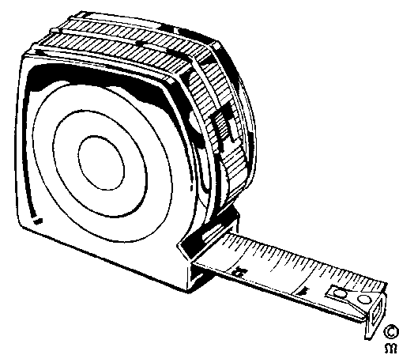
Measuring Tape
A measuring tape will have similar markings and applications as a ruler. The main difference is that a measuring tape is designed for use over longer lengths. As a result increments of 100 mm and 1000 mm are also distinguished.
The length of a measuring tape usually starts at 1metre (1000 millimetre) and some can be as long as 100 metres. The measuring tape used by dress makers is usually 1metre or 1.5 metres long and the very long measuring tapes are used by people in the construction business.

Mass
What is the difference between weight and mass?
We say that the weight (“heaviness”) of an object depends on its mass. The bigger the mass, the bigger the pull of the earth is on it.
To measure mass we choose a unit of mass and express the mass of an object in this unit. In the metric system we use the gram (g) and the kilogram (kg) as units of mass. 1kg = 1000g, 1g = 1000 mg
Remember to use the same units when comparing the masses of different objects.

“But remember the Lord your God, for it is he who gives you the ability to produce wealth, and so confirms his covenant, which he swore to your ancestors, as it is today.”

Deuteronomy 8:18

Spring Balance
A balance is an instrument for comparing the weights of two bodies to determine the difference in mass.
30
25
20
15
10
5
kg
A spring balance is a balance that measures weight by the tension of a spring, in other words you hang the object you want to weigh from the spring balance. Fishermen use this to weigh the fish they have caught in competitions. Butchers also use spring balances to weigh carcasses.
Hang a spring balance like this from any support strong enough for the object to be weighed. Attach the bottom hook to the object. The indicator shows the mass of the object.

Measuring fluids
200
100
ml
In this case each small increment represents 10 millilitres. Every 100 ml has its value indicated.
To acquire a certain amount of a liquid or powdery solid it is poured into the measuring cylinder. The marking next to the flat level of the substance would indicate the volume contained.
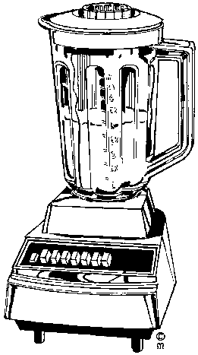
Measuring cylinders are used every day by people baking cakes, cooking, as well as by hairdressers laboratory technicians, pharmacists, students studying chemical science, chemical scientists and at times even barmen.
Measuring cylinders are used to measure the amount of water or liquid and/or powdery solid in order to:
Mix hair colouring
- Mix batter for cake, where you would add milk or water to flour, salt, sugar and other powdery solids
- Mix the amounts of alcoholic beverages to make a cocktail or other drink
- Mix chemical substances which can be in liquid or powder form.
In the metric system, the units used to measure capacity are the litre and millilitre. When a solid is dropped into water, the object takes the place of some of the water. We see that the level of the water rises. One millilitre (1 ml) of water is the volume of water that is displaced by 1 cm³. Or we can say that 1 ml of water fills 1 cm³.
Fluids such as water, milk and cold drinks are measured in millilitres or litres.
One litre = 1 000 ml.
For big volumes of fluid we can use the kilolitre (kl) as unit. 1 kl = 1 000 l.
Example: 5 ml of fluid fills 5 cm³
¼ l = 250 ml
1 kl of fluid fills 1 000 000 cm³ or 1 m³

Time

Clocks And Wristwatches
A clock is an instrument that measures and indicates the time. A watch is a small timepiece usually worn on a strap on one’s wrist. So we use watches and clocks to tell the time.
Clocks like these indicate the minutes between hours with the long arm and the hours with the short one. The numbers are indicated in Roman Numerals.
Every hour marking indicates the hour to be read with the short arm. It also indicates 5 minute increments to be read with the long arm.
The minute indication starts with 5 minutes past the hour at 1, and ends with 55 minutes past (5 minutes before) at 11.
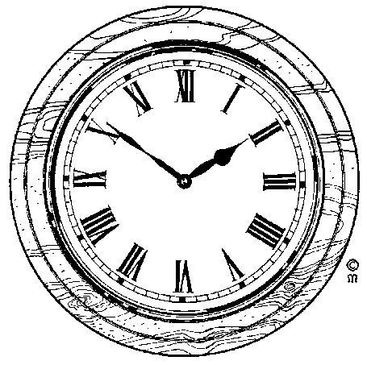
Before wristwatches were common, most people, churches and government buildings used clocks to tell the time. These days clocks are not commonly found, except in church towers and government buildings. Most of us use watches to tell the time.
Luckily, watches are no longer commonly numbered in Roman numerals, but rather the numbers as we use them from day to day. This watch only indicates hours (12), half hours (6) and quarter hours (3) and (9). It is left up to the wearer of the watch to work out when it is 5 past 10 or 20 to 7.
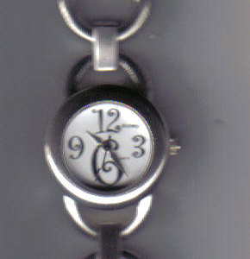

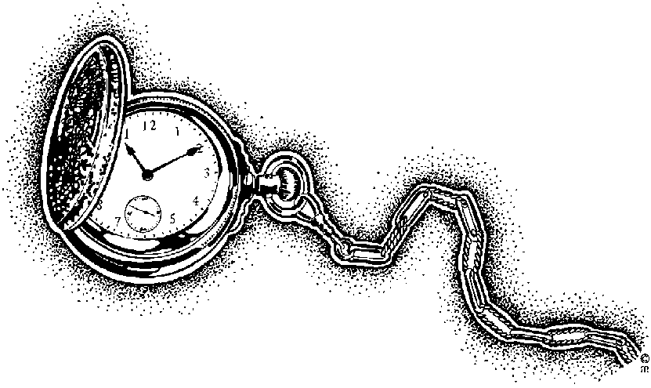

Units Of Time
The basic unit of time is the second (s). We can also measure time in minutes (min), hours (h), days, weeks and so on. There are 7 days in a week, 24 hours in a day, 60 minutes in an hour and 60 seconds in a minute.
The face of a watch with hands is divided into 12 divisions. The hours between 12 o’clock midday and 12 o’clock midnight used to be written as 1 p.m, 2 p.m etc up to 12 p.m (midnight). The hours after midnight used to be written as 1 a.m., 2 a.m. etc up to 12 a.m (midday).

Digital Time
Today we use the international system of time. In this system the hours after midnight are counted 01:00, 02:00 and so on. Midday is 12:00 and midnight is 24:00. The digits before the “:” show the hours and the digits after the “:” show the minutes. Digital watches sow time in this way.
16:30:00

Digital watches do the same thing as ordinary wristwatches, the only difference is that they show the time differently. The time on your cell phone or PC screen is shown digitally:
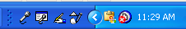
The digits display the current time. AM is for morning and PM is for afternoon. The 16 indicates the current hour, which is four o’ clock. The 30 indicates the minutes and the 00 the seconds. The time on this digital watch is 30 minutes past four o’ clock.
The time as shown on a PC screen.

Thermometer
40
37
36
38
35
39
34
33
41
42
ºC
A thermometer is an instrument for measuring or sensing temperature, typically consisting of a graduated glass tube containing mercury or alcohol which expands when heated.
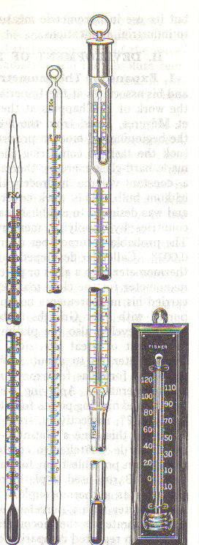
Thermometers are used by doctors, nurses and medical staff to determine the temperature of a patient. A patient with a higher than normal temperature, 36ºC, would indicate illness, as 36 degrees Celsius is the normal body temperature for human beings.
Thermometers are also used by the weather bureau to determine the daily temperatures. You can also buy a thermometer to determine the temperature in your house on a day to day basis and swimming pool owners use them to find out what the water temperature is.
The example on the previous page looks like a typical thermometer used to measure body temperature. It contains mercury or a coloured liquid where the level indicates the ambient temperature.
Some thermometers used by medical staff and found in households are shown on the right. You may have seen one or more of them during visits to the doctor or hospital.
Thermometers that make use of digital display have temperature influenced components that generate code. This code is processed and the relevant temperature is displayed as follows: 36ºC
In some countries, such as the USA, temperature is measured in Fahrenheit, but in South Africa temperature is measured in Celsius.
In Celsius, 0ºC is the point at which water freezes and 100ºC is the point at which water boils. Of course, the freezing and boiling point of water as indicated above is at sea level, the exact temperature changes a little bit as you move farther inland and higher than sea level.

Symmetry
A symmetrical object is one that remains identical if rotated or reflected (‘flipped’) around a line through its centre. There may be many angles of rotation for an object.
Using symmetry reduces the amount of work you must do when calculating areas and volumes. Use symmetry to your advantage. If you draw an object that has symmetry, draw the portion you need then place copies in the correct places by rotating or reflecting them about their axis of symmetry.
When we talk about seeing things in three dimensions, it means the following:
The first two dimensions are height (or length) and width on a flat surface. If you look at a rectangle, you have height (length) and width. A piece of paper has a length and a width that you can measure.
The third dimension is shown by introducing depth. A box has length, width and depth. This drawing shows you a box shape in three dimensions: length, width and depth.
Width
Depth
Height
Length
width

Geometric Formulae
The purpose of this section is to introduce you to two-dimensional objects in terms of their various shapes in order to determine their areas and symmetries.
Areas are always in demand for many different uses. This section shows you how to calculate some of these so that you can estimate the surface areas when you need them.

Two-dimensions (2D) and areas
Below is a summary various 2D shapes. The name, a small drawing and a short description of each shape is shown in order to provide you with an overview of what follows.

Name | Drawing | Description
Circle |  | The edge of the circle is at a constant distance from the middle. This distance is called the radius.
Triangle |  | A triangle has three straight sides.
Square |  | A square has four equal sides and four right angles.
Rectangle |  | A rectangle has the opposite sides of equal length and four right angles.
Trapezium |  | A trapezium has one parallel pair of opposite sides.
Parallelogram |  | A parallelogram has both opposite sides equal and parallel.
Various 2D shapes
Note that small lines drawn through the edges of an item indicate that those edges (lines) have the same length. The parallelogram is an example that shows two pairs of equal lines. A small square in a corner indicates a right angle of 90 degrees (90°). The square is an example that has four right angles. The greater than signs (>) indicate lines that are parallel to one another. The parallelogram has two parallel sides.

There are many geometric formulas, relating height, width, length, or radius to perimeter, area, surface area volume. Some of the formulas are rather complicated, and you have hardly seen them, let alone used them. But there are some basic formulas you have to remember.

The area and perimeter of a rectangle
A plane figure with four straight sides and four right angles and with unequal adjacent sides.

l
a
w

Area(a) = l × w (unit: m ²)

The Perimeter of a Rectangle
If you look at the picture of a rectangle, and remember that “perimeter” means “length around the outside”, you’ll see the rectangle’s perimeter is the sum of the top and bottom lengths (l) and the left and right widths (w):

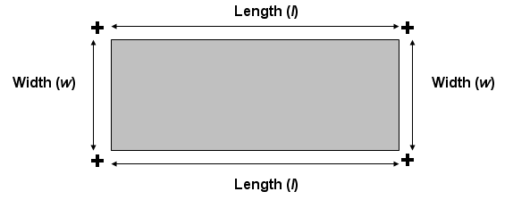

P_{rect} =2l +2w

The Area and Perimeter of a Square
A square is a four-sided figure in which all four sides are the same length, they are parallel to one another and the angle between each adjacent side is at right angles to its neighbour. It’s a lot easier to see a square than to describe one.

A square showing all sides are equal, parallel and at right angles to one another
The sides all have the same length, A, and each side is parallel to the opposite side and at 90 degrees to its neighbours. The square in each corner indicates that these are right angles.
Area(a) = l × w (unit: m ²)
If the side of a square is 12 centimetres, what is its area? The area is 12 × 12 = 144 so its area is 144 square centimetres (cm²).
Squares are therefore simpler, because their lengths and widths are identical. The area and perimeter of a square versus length (s) are given by:
P_{sqr} = 4s

Circle
A round plane figure whose boundary is made up of points at an equal distance from the centre. The area of a circle is a bit more complicated to calculate but not difficult. Below is a circle with a radius, r.
The radius is the measurement from the centre of the circle to its boundary. Note that the radius is always the same in the same circle no matter the angle it is drawn at. The diameter is the cross section of the circle and is always twice the length of the radius.
An irrational number, π (Greek letter ‘pi’), is used in circular calculations. An irrational number is one that has an infinite number of digits after the decimal point. In addition, the decimal portion of an irrational number does not have a pattern of digits that repeat and never ends in zero. Furthermore, irrational numbers cannot be represented by a fraction.
r
a
Area (a) = π × r ² (unit: m ²)
The area of the circle is π × r², where π = 3.14159265, or simply 3.14, approximately.
So the area of a circle is 3.14 × r².

For an example, if the radius of a circle is 8 metres, the area would be 3.14 × 8² = 3.14 × 64 = 200.96 square metres (m²), approximately.

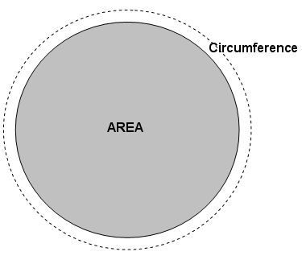
Many people use as an approximation for π.
= 3.1429 rounded to 4 decimal places (ten-thousandth)
You should know the formula for the circumference C and the area A of a circle, or given the radius r:
A_{cir} = (pi)r²

Circumference: C_{cir} = 2(pi)r
(“pi” is the number approximated by 3.14159)
The circumference of the circle is 2 × π × r, where π = 3.14 and 2 × π = 6.28, approximately. So the circumference of a circle is 6.28 × r.
For an example, if the radius of a circle is 8 metres, the circumference would be 6.28 × 8 = 6.26 × 8 = 50.08 metres (m), approximately.
Remember that the radius is the distance from the centre to the outside of the circle. In other words, the radius is halfway across. If you deal with the diameter of a circle, the length of a line going all the way across, then you have to divide in half to apply the above formulas.

Parallelogram
A parallelogram is rectangle with a tilt. All sides are parallel but the angles between the sides differ.
In order to help you visualize a parallelogram, I drew in vertical lines to form a right-angled triangle from the intersection of the sides A and B to the opposite side. Notice what this figure is showing us. If I cut the left triangle off the parallelogram and stick it on the right side, I have a rectangle! Therefore, the parallelogram is nothing but a rectangle with a tilt. The tilt is called a ‘shear’ in many industries. (And it has nothing to do with sheep!) You won’t find parallelograms with the dashed lines so don’t expect to see them. However, you should be able to look at a parallelogram, or something close to one, by putting in the dashed lines mentally.
In order to calculate the area of a parallelogram I use exactly the same formula to calculate the area of a rectangle: Area = A × B.

Observations for square, rectangle, parallelogram and rhombus
The rectangle, square and parallelogram have the same characteristics: each has two pairs of parallel sides. Therefore, each one is simply a variation on the parallelogram and all their areas are calculated as base × height. The square is a rectangle with its base and height equal. The rectangle is a parallelogram with straight sides and the rhombus is a parallelogram with an equal base and height.
The most general of these four figures is the parallelogram: it has two parallel sides. And nothing is said about the lengths of these sides or the angle between the two sets of parallel sides. A rectangle is a parallelogram with right angles (90 degrees). A square and a rhombus have equal sides.

Trapezium
Trapezium is a quadrilateral: a closed shape with four linear sides that has one pair of parallel lines for sides. Some [define it as a quadrilateral having exactly one pair of parallel sides, so that parallelograms can be excluded, but most mathematicians use the inclusive definition.

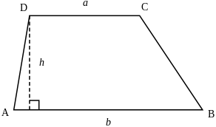

The area of a trapezoid can be computed as the length of the mid-segment, multiplied by the distance along a perpendicular line between the parallel sides. Thus, if a and b are the two parallel sides and h is the distance (height) between the parallels, the area formula is as follows:
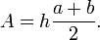

The quantity 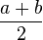is the average of the horizontal lengths of the trapezoid, so the area can be understood to be the product of the height and average length of the shape.

Theorem of Pythagoras
The Greek mathematician, Pythagoras, made a very important discovery about the sides of a right-angled triangle. A right-angled triangle is one in which two of the three legs are at right angles to one another, that is, they are 90° to one another.
All triangles have three sides. In this triangle the three sides are named ‘A’, ‘B’ and ‘C’. The little square at the bottom left and inside the triangle indicates the angle between side B and side C is 90° making this a right-angled triangle.
Pythagoras discovered that the relationships between the sides of a right-angled triangle are related in a specific way: A² = B² + C². That is, the length of side B squared (multiplied by itself) plus the length of side C squared equals the square of the length of A. Side A is also called the hypotenuse.

Hypotenuse example
Calculate the hypotenuse of the right-angled triangle:
The hypotenuse is equal to the square root of the sum of the square of the other two sides: A² = B² + C². Therefore: A² = 5² + 12².= 25 + 144 = 169. Since 13 × 13 = 169, the hypotenuse is 13 metres.

Combining areas
We now know enough about rectangles and triangles to work out some simple problems. The figure below shows a rough drawing of the side of a large building. Calculate the surface area of this building so you know how much paint to order so that it may be painted.

The house basically consists of a rectangle and a triangle. The area of the rectangle is 16 × 8 = 128 square metres (m²). The area of the triangle is (16 × 4) = 32 square metres (m²). Adding these figures we obtain 160 square metres (m²). If we knew that we use about 5 litres of paint for each 20 m² we could calculate that we need about 8 tins each of 5 litres of paint. This would be 40 litres altogether. Check if I’m correct!
Noticing symmetry often allows quicker and simpler calculations to be made. So if you have to measure something that looks symmetrical, take advantage of it. You will not only save yourself some time but may make fewer mistakes because you have less to do.

SI Units
The SI or Systéme International consists of 7 base units, which were taken into use in order to have a worldwide acknowledged unit system. This has significantly simplified the sharing of information between countries with different traditional units.

Quantity | Unit | Abbreviation
Mass | Kilogram | kg
Length | Meter | m
Time | Second | s
Temperature | Kelvin | K
Current | Ampére | A
Light | Candela | cd
Chemical standard unit | Mole | mol

It is VERY important to always indicate a unit. The unit is what gives meaning to a number. Just think 3000 tells you nothing about what this number is for or what it does, but R3000 is very useful! Also remember to indicate the unit EXACTLY as it is shown above. Km is wrong and so is S, if the unit is not given exactly right your answer will be wrong!
The symbols in the last column are not abbreviations (hence, no periods are used), and they are exactly the same in all languages. Prefixes may be added to these symbols in order to conveniently refer to very large or very small quantities. The prefixes are listed below:

Prefix | Symbol | Factor | Power of 10
Exa | E | 1,000,000,000,000,000,000 | 18
Peta | P | 1,000,000,000,000,000 | 15
Tera | T | 1,000,000,000,000 | 12
Giga | G | 1,000,000,000 | 9
Mega | M | 1,000,000 | 6
Kilo | k | 1,000 | 3
Hecto | h | 100 | 2
Deka | da | 10 | 1
Deci | d | 0.1 | -1
Centi | c | 0.01 | -2
Milli | m | 0.001 | -3
Micro | µ | 0.000001 | -6
Nano | n | 0.000000001 | -9
Pico | p | 0.000000000001 | -12
Femto | f | 0.000000000000001 | -15
Atto | a | 0.000000000000000001 | -18

These prefixes are used for every unit (supplementary or derived) with the exception of the kilogram. Examples are millimetre (mm), kilometre/hour (km/h), megawatt (MW), and picofarad (pF). Because double prefixes are not used, and because the base unit kilogram already contains a prefix, prefixes are not used with kilogram, although they are used with gram.
The prefixes hecto, deka, deci and centi are used only rarely, and then usually with metre to express areas and volumes. Because of established usage, the centimetre is retained for body measurements and clothing.
Converting between units is straightforward as these examples show. Remember that you are only moving a decimal point and changing a name. You don’t have any real arithmetic to do.
1kg (kilogram) = 1,000g (grams) = 100dag (dekagrams) = 10hg (hectograms).
1kl (kilolitre) = 1,000l (litres) = 100dal (decilitres) = 10hl (hectolitres).
Although the values of the factors differ by multiples of 10, some symbols and names are rarely used. Of the six symbols and names in this example, I have only seen kg (kilogram), g (gram) and l (litre). So let’s look at some common uses.
If I travel 1,000km I say: ‘I travelled 1,000kms.’ I don’t say: ‘I travelled 1Mm (megametre)’. It is not incorrect to use megametre for 1,000km but nobody I know uses that phrase. However, you may see a few other uses that at first glance appear strange. The contents of bottles may contain 750ml or 75dl but not usually 0.75l and medication may contain 600mg of a substance but not usually 0.6g. These values refer to the same measurements (750ml = 75dl = 0.75l and 600mg = 0.6g).

Using the SI system
The SI system uses the metric (decimal) system and uses a number of standard prefixes for units of length and mass that were covered in the previous section. Using the SI system means that we should know the most important ones. The three most important ones are:
The SI unit of time is the second. Time measured in intervals less that one second follow the factors defined by the SI system. However, time is not completely decimal and intervals greater than a second are measured differently. Below are the relationship between the different time units based on the second.

Unit | Consists of
1 minute | 60 seconds
1 hour | 60 minutes
1 day | 24 hours
1 week | 7 days
1 year | 12 months
1 decade | 10 years
1 century | 100 years
1 millennium | 1000 years

Note that one year consists of 12 months but the month has not been defined. As an approximation, a month consists of 30 days and 22 workdays. For calculations of intervals less than one week the second is accurate and may be used. However, the second is rarely used for intervals greater than one day.
The relationship of a week, day, hour and minute calculated in terms of seconds.

Unit | Calculation to seconds
1 minute | 60 seconds
1 hour | 60 minutes  3600 seconds (60 × 60)
1 day | 24 hours  1,440 minutes (24 × 60)  86,400 seconds (24 × 60 × 60)
1 week | 7 days  168 hours (7 × 24)  10,080 minutes (7 × 24 × 60)  604,800 seconds (7 × 24 × 60× 60)

The imperial (UK) number system
The imperial system, now called the UK system, was used, until very recently, for all weights and measures throughout the UK. There are many aspects of everyday life where the system is still in common usage. Road signs are an obvious example where miles instead of kilometres are used.
The UK system measurement of length:

Length
12 inches | = | 1 foot
3 feet | = | 1 yard
22 yards | = | 1 chain
10 chains | = | 1 furlong
8 furlongs | = | 1 mile
5280 feet | = | 1 mile
1760 yards | = | 1 mile
UK system for length
The UK system for area.
Area
144 sq. inches | = | 1 square foot
9 sq. feet | = | 1 square yard
4840 sq. yards | = | 1 acre
640 acres | = | 1 square mile
The UK system for volume
Volume
1728 cu. inches | = | 1 cubic foot
27 cu. feet | = | 1 cubic yard
The UK system for capacity.
Capacity
20 fluid ounces | = | 1 pint
4 gills | = | 1 pint
2 pints | = | 1 quart
4 quarts | = | 1 gallon (8 pints)
The UK system for mass (avoirdupois)
Mass (Avoirdupois)
437.5 grains | = | 1 ounce
16 ounces | = | 1 pound (7000 grains)
14 pounds | = | 1 stone
8 stones | = | 1 hundredweight [cwt]
20 cwt | = | 1 ton (2240 pounds)

Approximations and estimations
Before looking at approximations, there are a number of definitions between the UK system of measurement and the SI system of measurement that must be mentioned. The definitions in the table below marked with an asterisk (*) are exact and have been agreed upon by the international agencies that regulate and define the methods of measurements. Only the commonly used units are given in this manual.

Factors for converting customary UK units to SI units
1 yard | 0.9144 metre*
1 foot | 0.3048 metre*
1 inch | 0.0254 metre*
1 statute mile | 1,609.344 metres*
1 nautical mile (international) | 1,852 metres
1 pound (avdp.) | 0.45359237 kilogram*
1 oz (avdp.) | 0.02834952 kilogram
1 pound force | 4.44822 newtons
1 slug | 14.5939 kilograms
1 foot pound | 1.35582 joules
Temperature (Fahrenheit) | 32 + (9/5) Celcius*
Common conversion factors from UK and US units to SI units
To convert between the two systems, do the following:
To convert from Imperial to S1, multiply the imperial unit by the factor in the S1 column, e.g. if you want to know what 25 yards are in metres, multiply 25 by 0.9144 = 22.86 metres.
To convert from S1 to Imperial, divide the S1 unit by the factor shown in the S1 column, e.g. if you have a distance of 25 metres and you want to know what that distance is in yards, divide 25 by 0.9144 = 27.34 yards.
if someone weighs 300 pounds, multiply 300 by 0.45359237 = 136.07 kg. If someone weighs 75kg, divide 120 by 0.45359237 = 165.35 pounds.

Temperature scales:
There are three commonly used temperature scales:
The Celsius scale is the most commonly used temperature scale.
The Fahrenheit scale is used in the United States.
The absolute or Kelvin scale is used in scientific work.
The Fahrenheit and Celsius scales assign arbitrary values to both freezing and boiling points of water at atmospheric pressure.

“Let us not become weary in doing good, for at the proper time we will reap a harvest if we do not give up.”

Galatians 6:9 NIV

 | Celsius | Fahrenheit
Freezing point | 0.00°C | 32.0°F
Boiling point | 100°C | 212°F
Between these two reference points the Celsius scale is divided into 100 equal units and the Fahrenheit scale into 180 equal units. This makes it easy to convert from Celsius to Fahrenheit or vice versa, as each value of Celsius has a corresponding Fahrenheit value, 1°F = 9/5°C. The conversion formulas are as follows:

T(°C) = 9/5[T(°F)-32] or T(°F) = 9/5T(°C) + 32
It may be easier to simply remember that 0°C=32°F and that 5°C=9°F.

Convert from Fahrenheit to Celsius using the formulae

T(°C) = 9/5[T(°F)-32]

°F = 98.6
°C = ?
Substitute in formulae above

T(°C) = 9/5 x [98.6 – 32]
T(°C) = 9/5 x [66.6]
T(°C) = 37°C

Convert Fahrenheit into Celsius using the formula:

T(°F) = 9/5T(°C ) + 32

°C = 37
°F = ?
Substitute in formulae given above T(°F) = 9/5 x 37°C + 32
T(°F)= 66.6°C + 32
T(°F) =98.6 °F

It is important to remember that different thermometers are made from various materials and filled with different substances, in practice this means that they all expand and contract differently in response to changes in temperature. Because of this most thermometers are only reliable within a set range of temperatures.

Activity 1 (SO1, AC1-7)

Rough Sketches
A rough sketch is a quick drawing of something that gives you a reasonable impression of a scene, object or surroundings but without much detail. The following is an example of a top view of a scene or incident that may be typical in a security situation.
A rough sketch is normally not according to scale but rather in proportion or in relation to size. This means that you may use a tape measure to indicate distances in relation to vital points or may even pace the distance between objects. The sketch may or may not be very accurate. However, the essentials have been captured in the sketch.
Some important elements must be displayed on such a rough sketch, such as:
- The direction north always pointing towards the top or at least like on a clock 10 to 2 or 10 past 10.
N
N
N
N

- The title “Rough sketch” on top of the drawing.
- The name of streets or buildings clearly displayed.
- Alphabetical numbering of critical elements on or at the scene if you are sketching a crime scene or incident scene.
- The name of the person drawing the sketch.
- The date and time of the sketch.
- Clear indication of grass, road surfaces and any other information that may assist the user of the sketch.
- Signature of the originator.
The sketch should have a separate sheet containing a key or explanation to the sketch. This we call the key or legend to the sketch. In the legend you set out measurements between points or distances.

Sketching in general
Sketches may be very rough, giving only a few small details, to very detailed enabling an item to be manufactured. The difference between a rough sketch and a sketch that is precise is not well defined. Additional information must be supplied with a sketch to provide enough detail to serve the purpose of the drawing.
So the ‘roughness’ of sketch may vary from a few lines drawn in the dirt with a stick to precision drawings used in fine engineering. A soccer team planning its strategy will sketch only the details required so that each player knows his function and the action he must take in order to work as a team. The important thing to remember is that the detail that must be included in a sketch must suit the user of the sketch. The sketch must contain all the necessary information to convey the information required by the person using it.

Example 2
A woman making her own clothes or clothing for her children uses rough sketches to make the garment. Whether she draws the sketches herself or purchases them as a pattern in a shop, she still works with a rough drawing. A typical pattern for a girl’s garment is shown below.

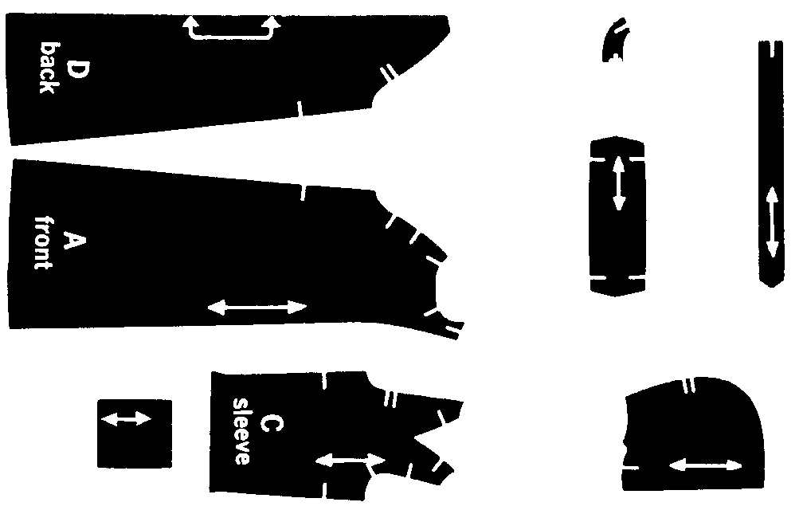

The ‘documentation’, ‘report’, or whatever you want to call it, consists of the metric measurements and information on how to layout, cut and sew the pieces together. As an aid to the seamstress who is making this garment, the original packet has illustrations of several variations of finished items.

Example 3
Imagine that you and your colleagues want to improve communications within your organization, church or local charity. In order to do this you decide that a monthly newsletter would help keep everyone in touch. In order to publish the newsletter you first want to get an idea of what the finished product would look like. You and your colleagues may discuss your needs but until you sketch a rough copy of its layout you really don’t know what to expect.
The documentation that accompanies these rough sketches would probably include the size of paper to use, whether the newsletter was folded or stapled, the use of one or both sides of the page, the number of columns and the font types and sizes to be used.
See the next page for the visual of the example.

Example 4
A physics teacher might want to convey the action and reaction of forces and decides that a demonstration of a man fishing would be suitable. Below is the rough drawing that the teacher used to explain the concepts.
In this case the teacher does not need to show the person or fish in any detail nor does his scale need to be accurate. His ‘report’ would describe the forces involved. He would probably show his learners how to perform the calculations as well.

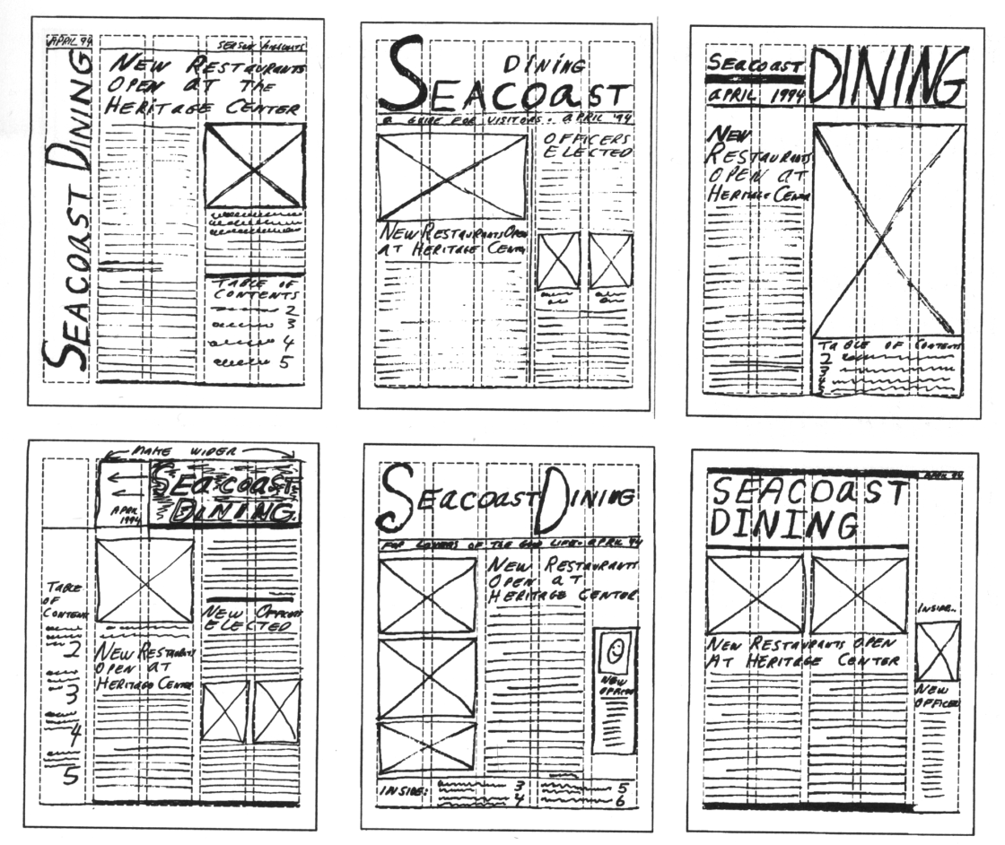
A rough sketch of a newsletter

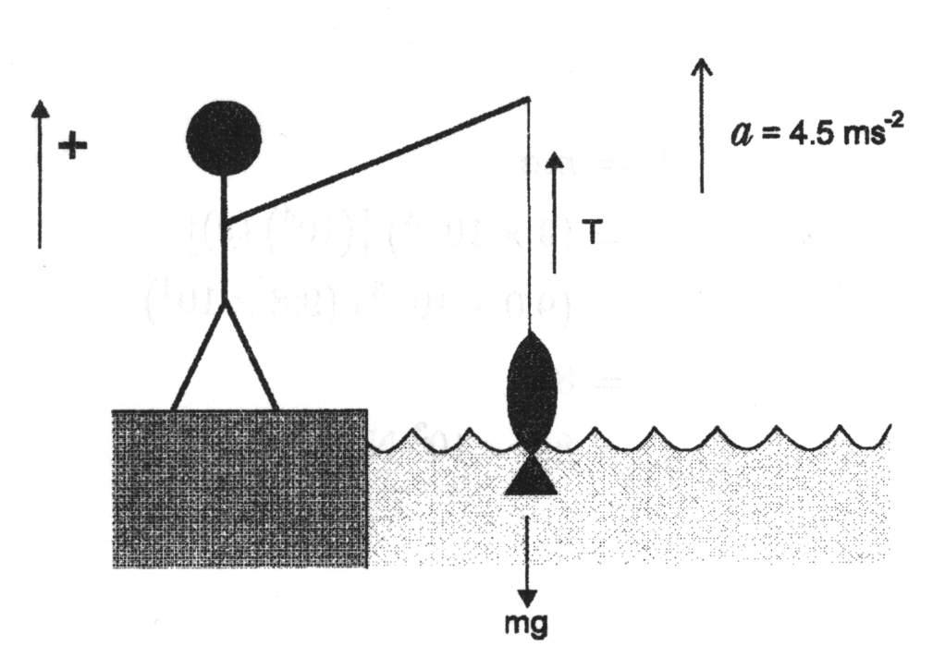
A rough sketch for a physics lesson

Example 5
The concept of a computer network.

Scale Drawings
A scale drawing is a reduced or enlarged drawing of an original but it is drawn true to scale. Below is a scale drawing of a chair that was done on a computer. Notice how realistic it looks. Closer inspection will show that it is indeed a drawing and not a photograph.
Although it shows a realistic drawing of a chair, it may be considered a rough sketch by some. A manufacturer can’t build the chair from this sketch. There are no scale or size measurements that go with the chair.
The difference between a realistic drawing and a rough sketch is determined by the user of the sketch. The person creating the sketch may put too little or too much detail in the drawing for it to satisfy the needs of the user of the sketch.
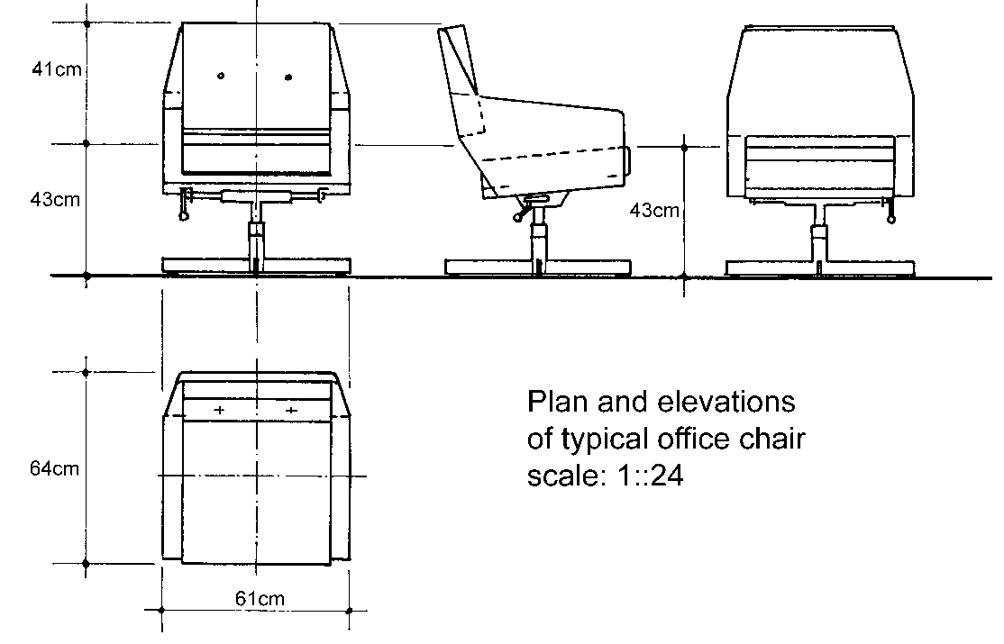

Another typical office chair that answers some of the criticism concerning the previous drawing.
Is this sketch better or worse than the previous one? Why? Can I build this chair in my factory? Why not?

Adding detail to scale drawings
In order to understand scale drawings it is a good idea to start from the known and proceed to the unknown. We are going to start with geometric shapes that are drawn to scale then proceed all the way to an introduction to engineering drawings.
The steps that take us from the rough to the precise involve four steps:
- Learn how to make square and isometric drawings of geometrical shapes.
- Learn what plans and elevations are when making drawings.
- Learn what is meant by ‘nets’ of objects and use these nets to visualize and measure three-dimensional objects.
- See examples of engineering drawings and the detail they contain.

Let’s look at the simple geometric drawings that were used in previous sections. Two-dimensional items must be drawn to scale in order to appreciate what they are telling us.
There are several ways to represent two-dimensional objects. Annexure A contains a standard square grid while the second page contains an isometric grid. The first page is obviously a page of squares, but what is the second page a picture of? The second page is a pattern of triangles! Look at this page again and you will see that the dots make up triangles with the edges removed.

Using rectangular grids
Both square and isometric grids may be used to assist with 2D or 3D drawings. On the right is a square drawn on a square grid and the next figure shows a triangle drawn on a square grid.

A triangle drawn on a square grid
Square grid paper is usually just referred to as grid paper. Some grid paper provides subdivisions that allow you to sketch very accurately. A popular grid is the millimetre grid that has very thin lines placed every millimetre and slightly thicker lines marking the centimetre. Some versions of the millimetre grid use slightly differently coloured lines to identify the different spacing.
Not only can you draw accurately using grid paper but you may use the grid to measure items as well. In addition, you may trace an item directly on the grid paper and have an accurate drawing that you can measure.
What is the area of the square and the area of the triangle? The area of the square is 16 units² and the area of the triangle is 12.5 units². I use the term ‘units’ because I do not have any information concerning the size of each square.
These drawings may be scale drawings of real items or they might be the real sizes of these items. If the squares represent centimetres then the area is given in cm². If the squares represent metres then the areas of the items are measured in m².

N
Room 12
Second floor
Kagiso building
James street
Coco town
Rough Sketch
Table
Desk
A

Cabinet
B
Compiled by: SO John Dlamini
On 31 April 2005 22:00

Legend to sketch
Point A: Place of entry, broken window on northern side of office.
Point B: Location of cabinet (where money was stored).
Distances on rough sketch
Point A to B: 2.4 m
With of room 12: 2 m
Length of room 12: 2.5 m

Two Dimensional Geometric Figures
How wonderful is it that God allows us to see mathematical aspects from all different perspectives?

Outcome
Explore transformations of two dimensional geometric figures

Outcome Range
- Use parallelism, symmetry, translation, reflection and rotation in describing artefacts
- Make conjectures about mathematical relationships found in artefacts
- Use transformations and symmetry in describing objects
- Use transformations and symmetry in designing patterns in 2 dimensions (e.g., tessellations, dress material, logos) of interest to teenagers

Assessment criteria
- Properties of symmetrical shapes are recognised and described
- The concept of lines of symmetry in 2-dimensional figures is explored using paper folding and reflections in the lines of symmetry
- The concept of transformation in terms of reflections, translations and rotations is identified and explained using concrete materials
- The descriptions are based on correct application of transformations and other geometrical properties
- Designs, based on transformations and other geometrical properties are innovative, and correct geometrically

Transformation
All the geometrical shapes can be transformed (changed) by reflections (a mirror image) or rotating the image:

Rotate
Rotation is a transformation in a plane or in space that describes the motion of a rigid body around a fixed point: the entire image is rotated by a certain number of degrees from 1 to 360. It retains its shape, but is turned sideways or upside down.
All these rotations are 90º left or right.

Partial rotations are also possible:

A rotation, a reflection and a translation transformations are isometries, meaning that, they leave the distance between any two points unchanged after the transformation.
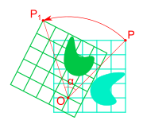

Mirror image (reflection)
A reflection "flips" the bodies it is transforming

Mirror images can also be rotated:

Translation

A translation has no fixed point, so it changes the position of an object, without changing the shape of the object.

Other transformations
These images can also be transformed in different ways:
Circles can become ovals:

Rectangles can become squares and squares can become rectangles:

Parallelograms can become rectangles or squares

And shapes and images can be skewed (drawn out of proportions)

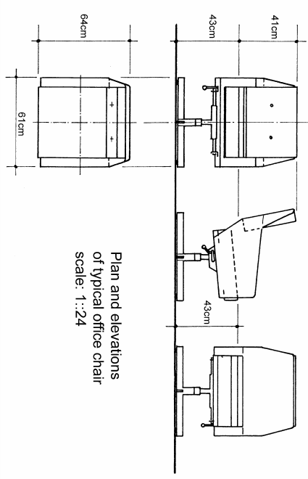
Drawings can be rotated, mirrored or skewed:

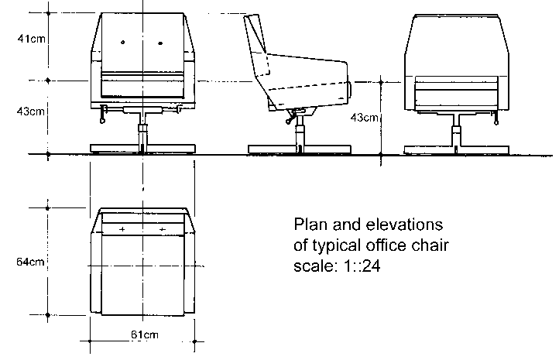

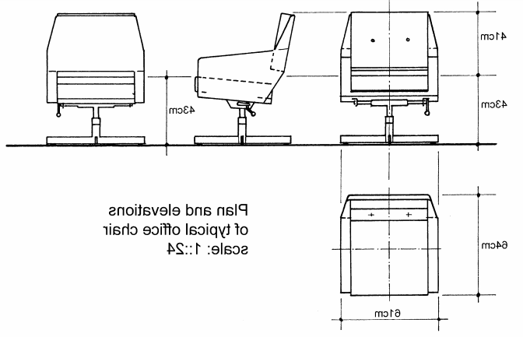
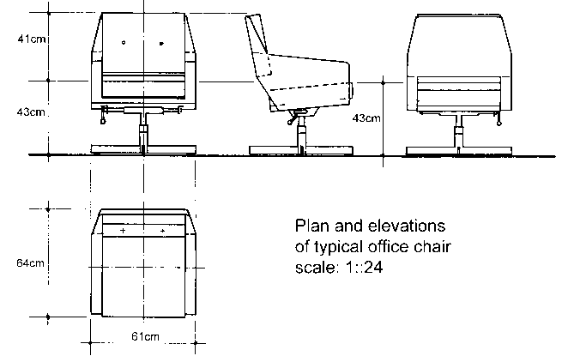

“Give, and it will be given to you. A good measure, pressed down, shaken together, and running over, will be poured into your lap. For with the measure you use, it will be measured to you.”

Luke 6:38 NIV
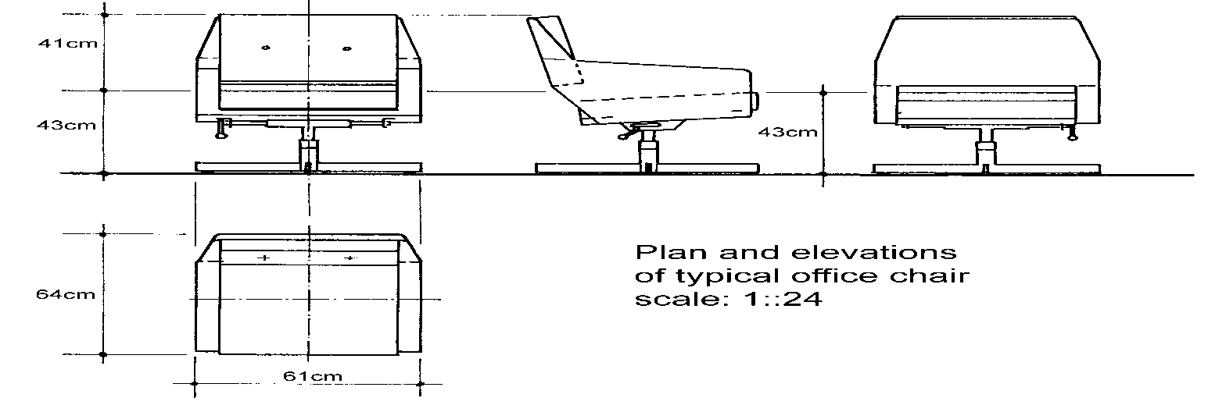

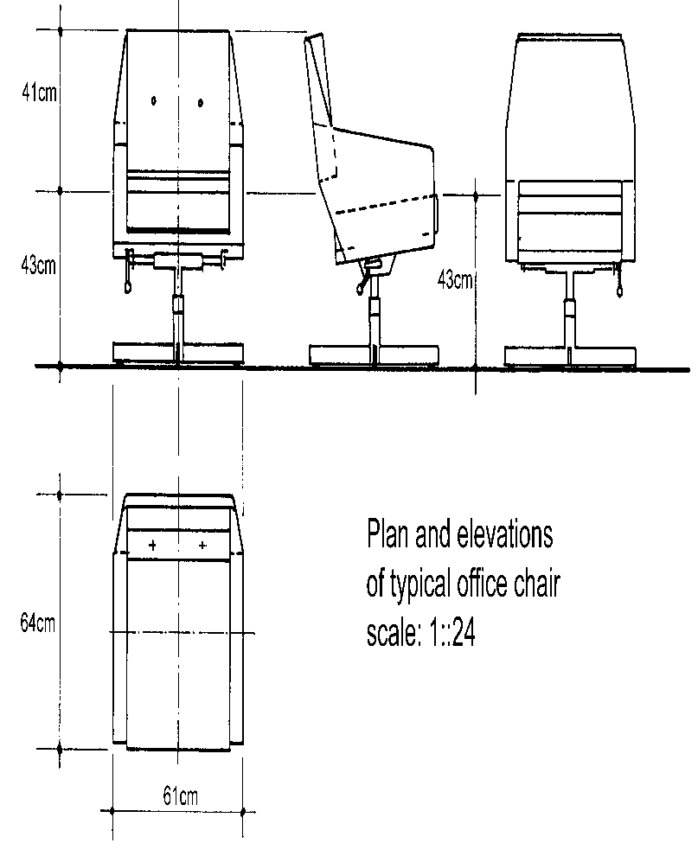

Tessellation
Another word for a tessellation is a tile. Actually, a tessellation refers to a set of tiles that make up a pattern. The tiles are like those you may see every day on floors and walls. Tessellations are the ultimate in symmetrical displays.
A dictionary will tell you that the word ‘tessellate’ means to form or arrange small squares in a chequered or mosaic pattern. The word ‘tessellate’ is derived from the Ionic version of the Greek word ‘tesseres’ which in English means "four." The first tilings were made from square tiles.
A regular polygon has 3 or 4 or 5 or more sides and angles and all sides and angles are equal. A regular tessellation means a tessellation made up of congruent regular polygons. A regular polygon is a polygon in which sides all the same length. ‘Congruent’ means that the polygons that you put together are all the same size and shape.
Only three regular polygons tessellate, that is, are able to be put together so that none overlap and there are no gaps between the tiles. Here are three simple examples of tessellations made from triangles, squares and hexagons (A triangle is a three-sided polygon, a square is a four-sided polygon and a hexagon is a six-sided polygon. The work ‘polygon’ means many sides.

A tessellation of triangles
A tessellation of squares
A tessellation of hexagons
When you look at these three figures you notice that the squares are lined up with each other while the triangles and hexagons are not. In addition, if you take six triangles and put them together you will notice that they form a hexagon. Look at the shape of the hexagon then look at the row of triangles. If you can’t see the hexagon, take the first six triangles, three from each row, and cover the rest of the line. Tiling, or tessellating, triangles and hexagons is similar.
Tessellations have been used for thousands of years and every culture uses them. The following figures show a few tessellations.
A tessellation made from groups of five squares
A tessellation consisting of triangles


A tessellation of bats, birds, butterflies and bees (MC Escher)
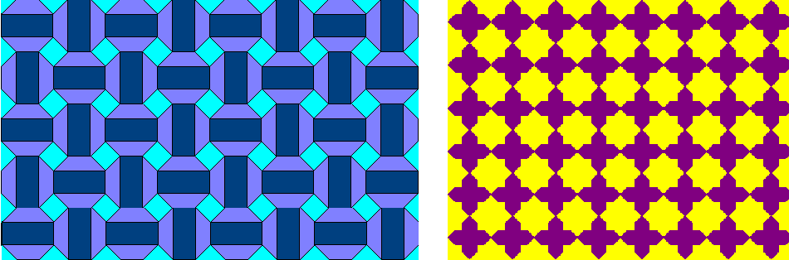
Two tessellations from North Africa
Note the symmetry in each tessellation. Identify the shapes that are contained in each tessellation and see if you can make a simple one yourself.
An interesting word that is used to describe repeating tile patterns is ‘rep-tiles’ or ‘reptiles’. The term has nothing to do with snakes, lizards or crocodiles but is frequently encountered when reading about tessellations.

Activity 2 (SO2, AC1-5)

UNIT STANDARD 9007

Unit Standard Title
Work with a range of patterns and functions and solve problems

NQF Level
2

Credits
5

Purpose
This unit standard is designed to provide credits towards the mathematical literacy requirements of the NQF at level 2. The essential purposes of the mathematical literacy requirements are that, as the learner progresses with confidence through the levels, the learner will grow in:
- An insightful use of mathematics in the management of the needs of everyday living to become a self-managing person
- An understanding of mathematical applications that provides insight into the learner’s present and future occupational experiences and so develop into a contributing worker
- The ability to voice a critical sensitivity to the role of mathematics in a democratic society and so become a participating citizen.

Learning Assumptions
The credit value is based on the assumption that people starting to learn towards this unit standard are competent in Mathematics and Communications at NQF level 1

Range
This unit standard includes the requirement to:
- Use algebraic notation to express generality
- Make conjectures, demonstrate and explain their validity
- Recognise equivalence among expressions and situations resulting from manipulation and rearrangement to forms appropriate for solving problems
Work with:
- Functions for which there are rules and for which there are no rules;
- Functions that are discrete (rules and no rules);
- Functions that are continuous (rules and no rules).
Investigate, and interpret graphs of situations with regard to the following: -increasing /decreasing,
- Maximal /minimal,
- Continuous / discrete,
- Rate of change,
- Intercepts,
- Interpolation /extrapolation.
(The above must be done in relation to the contexts in which the functions are acting as models.)
Work with the following basic functions: y =ax +b; y =LIX*+b; y =ax; xy=k, In terms of their:
- Shape and symmetry,
- Finding function values,
- Finding input values,
- Analysing the behaviour of function values (the rate of change).
Represent, interpret and solve problems that relate to these functions by using point-by-point plotting and numerical analysis
Convert flexibly among various representations of the above functions (i.e. words, tables, formulae, graphs).
Learners are not expected to master each concept and procedure when they first encounter it, but rather to continually develop their mathematical understandings through encounters with mathematical models of realistic situations.
The contexts and situations should be used to develop a critical awareness of human rights, social, economic, political, cultural and environmental issues. Examples of the power of modelling as a descriptive tool to describe situations between two variables and as an analytic tool to gain additional information about the situation must be developed.

Specific Outcomes and Assessment Criteria
Specific outcome 1: Convert flexibly between and within various representations of functions
Range: This outcome includes the requirement to:
- Translate from one representation to another (i.e. verbal, tables, formulae, graphs).
- Deal with situations involving the range of functions specified in the main range statement as well as functions for which there is no rule
Assessment criteria:
- Appropriate information is selected to convert flexibly between and within various representations of functions
- Appropriate representations are selected for specific applications
- Conversions represent the functions accurately and appropriately
Specific outcome 2: Compare, analyse and describe the behaviour of patterns and functions
Range: This outcome includes the requirement to work with functions:
- Identify, contrast and compare the features of the functions listed in the main range statement as well as functions for which there are no rules
- Recognise equivalent forms of an expression, equation or function
Assessment criteria
- Patterns and functions are compared in terms of: Shape and symmetry, Finding function values, Finding input values, The average rate of change of function values.
- The key features of the graphs of functions are described and interpreted correctly.
- The behaviour of functions is described as being increasing or decreasing or constant as determined visually from graphical representations.
Specific outcome 3: Represent situations mathematically in order to interpret and solve problems.
Range: This outcome includes the requirement to:
- Use expressions, functions and equations to represent situations
- Develop strategies for deciding whether symbolic, representations are reasonable and interpret such results
Assessment criteria
- Accurate point-by-point plotting is used to model contextual problems
- Representations are analysed and manipulated efficiently in arriving at results.
- Representations are verified in terms of available data
- Results are interpreted correctly in terms of the situation
- Interpretations and predictions are based on the properties of the mathematical model

Essential embedded knowledge
The following essential embedded knowledge will be assessed through assessment of the specific outcomes in terms of the stipulated assessment criteria. Candidates are unlikely to achieve all the specific outcomes, to the standards described in the assessment criteria, without knowledge of the listed embedded knowledge. This means that the possession or lack of the knowledge can be inferred directly from the quality of tile candidate’s performance against the standards.
- Relationships between variables
- Mathematical functions
- Representations of functions and relations

Critical cross field outcomes
- Identify and solve problems using critical and creative thinking: Solve a variety of problems based on patterns and functions
- Collect, analyse, organise and critically evaluate information: Gather, organise, evaluate and interpret information to compare and represent relationships and functions
- Communicate effectively: Use everyday language and mathematical language to describe relationships, processes and problem solving methods
- Use mathematics: Use mathematics to, describe and represent realistic and abstract situations and to solve problems.

Representations of Functions
God will guide your mind.

Outcome
Convert flexibly between and within various representations of functions

Outcome Range
This outcome includes the requirement to
- Translate from one representation to another (i.e. verbal, tables, formulae, graphs).
- Deal with situations involving the range of functions specified in the main range statement as well as functions for which there is no rule.

Assessment criteria
- Appropriate information is selected to convert flexibly between and within various representations of functions
- Appropriate representations are selected for specific applications
- Conversions represent the functions accurately and appropriately

The language used in mathematics

Equation
An equation is identified when a = sign is part of a sentence, for example 3 + 3 = 6. This is an important part of mathematics. From basics, problems are solved by the use of equations.
Multiplication, division, adding and subtraction, in the same expression: If the above operations are in the same expression, it is necessary to first multiply and divide and then add and subtract. However, work should always be carried out from left to right. For example:
a) 4+5-2x5
= 4+5-10
= 9-10
=-1

Activity 1

The addition and subtraction of algebraic terms
It should be noted that only similar terms can be added or subtracted. Examples:
a) 7a + 3a - 5a
(7 + 3 - 5) a
5a

b) 4a + 4b + 2ab - 7a + ab
4b + 4a - 7a + 2ab + ab
4b + (4 - 7)a + (2 + 1)(ab)
4b - 3a + 3ab

c) Add 5a + 4ab - 7b and 3 - 3b + 5a
d) Subtract 4x + xy - 2 from 5x + xy -3

Always rearrange the terms to ensure that similar terms are positioned underneath each other.

Activity 2

Variables
Variables are very important in mathematics. They are used from quite early in a school career. For example 3 + # = 7.
The # represents an unknown which is called a variable.
The same expression can also be written as 3 + x = 7, where the expression x represents the variable.
If there are two unknowns in the equation, then the term variable is preferred. For example: x- y = 2.
From the above, it can be seen that unknowns can represent many values, hence the name "variables".
This equation is true if x and y represent the following values:
2 - 0 = 2
3-1 =2
4 - 2 = 2

Brackets
Brackets are placed in order to indicate multiplication, therefore
(a) = 2 x a
3(a) = 3 x a
(a)3 = a x a x a
Brackets provide assistance in clearly writing expressions. For example, if a + b is multiplied by 4 it is written as 4(a + b)
This is equal to3xa +3xb=3a+3b
If there is no number before a bracket, it is assumed that it is 1, for example:
+(a + b) = +1 (a + b), or -(a + b) = -1 (a + b) and (a + b) = 1(a + b) = a + b

Examples
Note, the x must be done first, and then after the bracket has been removed, similar terms must be added or subtracted
a) 4(3+x) – 2(7-x) = 12+4x – 14+2x
=6x-2
b) 4(x+2x) – 3x(2x-2x+3)
=4x+8x – 9x
=3x
c) 2(3a + 3) - 4(a - 8) 6a + 6 - 4a + 32
2a + 38
Remember, that when multiplying signs, unlike signs give minus. Like signs give plus:
+X+ =+
-X- =+ +X- =-

Multiplication, division, adding and subtraction, in the same expression
If the above operations are in the same expression, it is necessary to first multiply and divide and then add and subtract. However, work should always be carried out from left to right. For example:
a) 4+5-2x5 2 = 4+5-2x
= 4+5-10
= 4+5-5
4
Exercises
a) 4 - 6 + 10 5
b) 2+4x3 6x2-3

The multiplication of variables
Time is wasted when a X a X a X a X a is written. However, this is necessary in mathematics, therefore a shorter notation was developed and a X a X a X a X a is written as a . Take note that there are four multiplication signs and not five. Thus a is multiplied four times by itself, but there are five a's in the expression
a5 is read as "a exponent 5", or "index 5" 5 is called the exponent or index a is called the base a is called "the powe~'

Multiplication of similar terms
Examples:
a) 2x2 2 2x(2x2) = 23= 8
b) bxb b'
c) bxbxb = b'
d) a 2 x a 2 (a x a x a x a)= a 4
e) Xy X Xy (Xy)2
Therefore, if their bases are the same and the variables are multiplied, the exponents are added.

Multiplication if coefficients differ
Examples:
a) 2a x 3a (2 x 3)a"1
6a 2
b) 3k2 x 5x2 (3 x 5)(X2 X2 X2
1 5X2+2

Multiplication of terms where powers differ
Examples:
a) 2xx 3x2 (2 x 3)xl +2
6x
b) 4a x 4b x 3a 2 (4 x 4 x 3)
48 a 3 b
c) (2X)2 x 3xx 2)~ y 2 2 X2 x 3x x 2x2 y
(2 2 x 3 x 2)x2+'+2y
24 )~ y

Formulae
A formula is a relationship between quantities, and they are handy ways of writing problems. these equations make it easier to solve mathematical problems, as shown in the following example:

Example:
Calculate the number that must be added to 18 in order to give an answer of 27. This is a simple equation which could be calculated mentally. However, its very simplicity allows it to be used as a simple example
Solution:
Let the unknown number be x.
Therefore: x + 18 = 27
Subtract 18 from both sides of the equation.
x + 18 - 18 = 27 - 18
Therefore: X = 9
In more complex problems there are more variables. The symbol that must be solved can be engaged in different ways to the formula. The most general operations that engage variables are [x], and [-], and powers.
The following examples show how the above mentioned operations engage y.
a) y + 4 = 28
b) y - 4 = 28
c) y = 28 x 3
d) 4y = 28
e) y³ = 28
It should be noted that if something is added to y and it is necessary to solve for y in the opposite direction, then subtraction is applied.
Combinations of + and -
Example:
Solve for y if y + a ~ 5 = 9
Solution:
y + a - 5 = 9
Therefore: y + a - 5 - a + 5 = 9 - a + 5
Therefore: y = 14 - a
Combinations of x and ÷ -Example:
'Solve for y if 4X = 32
Solution:
4xX = 32
Therefore: X = 32÷4
Therefore: X = 6
Combinations of x and +
Example: 3Y + a = 6 divide each term by 3
Solution: 3Y +a= 6

Therefore: Y+a/3 =2
Therefore: Y + a /3- a/3 = 2 – a/3
Therefore: Y = 2 – a/3
The above also applies for combinations of x and -
Combinations of -L, + and -
Example:
y +a -3 = 5
2
subtract a and add 3 to both sides of the equation.
y + a - 3 - a + 3 = 5 - a + 3
2
Therefore: y =8-a
2
multiply by 2
y x 2 = (8- a)2
2.
Therefore: y =2(8-a) and y =16-2a

Combination of powers, x and -.
Example:
3 X³ = 40,5
2
multiply both sides of the equation by 2
Therefore: 3 X³ x 2 = 40,5 x 2
2
Therefore X³ = 81
3
X³ = 27
and x = 3

Combination of powers, + and -
Example:
X² +Y-6=10
subtract y and add 6
Therefore: X² + y - 6 - y + 6 = 10 - y + 6
Therefore: X² = 16 - y
take √ on both sides of the equation.
X = √(16-y)
Therefore: x= 16-y
The right hand side of the equation can be simplified, but not the left hand side.

Expressions containing = and - cannot be easily simplified.
Combinations of powers, +, -, X, and -
Example:
4/3a²- 3 + b = 2
Therefore: 4/3 a² x3/4-3x3/4+bx3/4=2x3/4
Therefore: a²-9/4 + 3/4b =6/4
Therefore: a²-9/4 +3/4b +9/4 -3/4b =6/4 + 9/4 -3/4b
Therefore: a²= 15/4 – 3/4b

“Whatever you do, work at it with all your heart, as though you were working for the Lord and not for people. Remember that the Lord will give you as a reward what he has kept for his people. For Christ is the real Master you serve.“

Colossians 3:23-‬24, GNT

Functions
The mathematical concept of a function expresses dependence between two quantities, one of which is given (the independent variable, argument of the function, or its "input") and the other produced (the dependent variable, value of the function, or "output").
A function associates a single output to each input element drawn from a fixed set, such as the real numbers.
There are many ways to give a function: by a formula, by a plot or graph, by an algorithm that computes it, or by a description of its properties.
In applied disciplines, functions are frequently specified by their tables of values or by a formula. Not all types of description can be given for every possible function, and one must make a firm distinction between the function itself and multiple ways of presenting or visualising it.
One idea of enormous importance in all of mathematics is composition of functions:
if z is a function of y
and y is a function of x,
then z is a function of x.
We may describe it informally by saying that the composite function is obtained by using the output of the first function as the input of the second one.
This feature of functions distinguishes them from other mathematical constructs, such as numbers or figures, and provides the theory of functions with its most powerful structure.
Functions in algebra are usually expressible in terms of algebraic operations. The term transformation is often synonymous with function. The term transformation usually applies to functions whose inputs and outputs are elements of the same set or more general structure. Thus, we speak of linear transformations from a vector space into itself and of symmetry transformations of a geometric object or a pattern.
Mathematical functions are denoted frequently by letters, and the standard notation for the output of a function ƒ with the input x is ƒ(x). A function may be defined only for certain inputs, and the collection of all acceptable inputs of the function is called its domain. The set of all resulting outputs is called the range of the function
It is a usual practice in mathematics to introduce functions with temporary names like ƒ; in the next paragraph we might define ƒ(x) = 2x+1, and then ƒ(3) = 7. When a name for the function is not needed, often the form y = x2 is used.
If we use a function often, we may give it a more permanent name as, for example,
The essential property of a function is that for each input there must be a unique output. Thus, for example, the formula
does not define a real function of a positive real variable, because it assigns two outputs to each number: the square roots of 9 are 3 and −3. To make the square root a real function, we must specify, which square root to choose. The definition
for any positive input chooses the positive square root as an output.

Words
A function need not involve numbers. By way of examples, we find
- the function that associates with each word its first letter
- or the function that associates with each triangle its area.
Because functions are used in so many areas of mathematics, and in so many different ways, no single definition of function has been universally adopted

Definition
One simple intuitive definition, for functions on numbers, says:
A function is given by an arithmetic expression describing how one number depends on another.
An example of such a function is y = 5x−20x3+16x5, where the value of y depends on the value of x.
This is entirely satisfactory for parts of elementary mathematics, but is too clumsy and restrictive for more advanced areas.

Sets
Eventually the gradual transformation of intuitive "calculus" into formal "analysis" brought the need for a broader definition. The emphasis shifted from how a function was presented — as a formula or rule — to a more abstract concept. Part of the new foundation was the use of sets, so that functions were no longer restricted to numbers. Thus we can say that
A function ƒ from a set X to a set Y associates to each element x in X an element y = ƒ(x) in Y.
Note that X and Y need not be different sets; it is possible to have a function from a set to itself. Although it is possible to interpret the term "associates" in this definition with a concrete rule for the association, it is essential to move beyond that restriction.
For example, we can sometimes prove that a function with certain properties exists, yet not be able to give any explicit rule for the association. In fact, in some cases it is impossible to give an explicit rule producing a specific y for each x, even though such a function exists.

Partial function
As functions take on new roles and find new uses, the relationship of the function to the sets requires more precision. Perhaps every element in Y is associated with some x, perhaps not.
In some parts of mathematics it is convenient to allow values of x with no association (in this case, the term partial function is often used). To be able to discuss such distinctions, many authors split a function into three parts, each a set:
A function ƒ is an ordered triple of sets (F,X,Y) with restrictions, where
F (the graph) is a set of ordered pairs (x,y),
X (the source) contains all the first elements of F and perhaps more, and
Y (the target) contains all the second elements of F and perhaps more.
The most common restrictions are that F pairs each x with just one y, and that X is just the set of first elements of F and no more.

Range
The range of F, and of ƒ, is the set of all second elements of F; it is often denoted by rng ƒ. The domain of F is the set of all first elements of F; it is often denoted by dom ƒ. There are two common definitions for the domain of ƒ some authors define it as the domain of F, while others define it as the source of F.
The target Y of ƒ is also called the codomain of ƒ, denoted by cod ƒ; and the range of ƒ is also called the image of ƒ, denoted by im ƒ. The notation ƒ:X→Y indicates that ƒ is a function with domain X and codomain Y.

Argument
A specific input in a function is called an argument of the function. For each argument value x, the corresponding unique y in the codomain is called the function value at x, or the image of x under ƒ. The image of x may be written as ƒ(x) or as y.

Graph
The graph of a function ƒ is the set of all ordered pairs (x, ƒ(x)), for all x in the domain X. If X and Y are subsets of R, the real numbers, then this definition coincides with the familiar sense of "graph" as a picture or plot of the function, with the ordered pairs being the Cartesian coordinates of points.
The concept of the image can be extended from the image of a point to the image of a set. If A is any subset of the domain, then ƒ(A) is the subset of the range consisting of all images of elements of A. We say the ƒ(A) is the image of A under f.
Notice that the range of ƒ is the image ƒ(X) of its domain, and that the range of ƒ is a subset of its codomain.
In mathematics, the graph of a function f is the collection of all ordered pairs (x,f(x)). In particular, graph means the graphical representation of this collection, in the form of a curve or surface, together with axes, etc. Graphing on a Cartesian plane is sometimes referred to as curve sketching.
The graph of the function
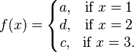
is {(1,a), (2,d), (3,c)}.

The graph of the cubic polynomial on the real line
is {(x,x3-9x) : x is a real number}. If the set is plotted on a Cartesian plane, the result is
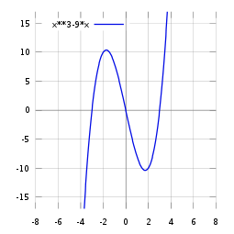

Specifying a function
A function can be defined by any mathematical condition relating each argument to the corresponding output value. If the domain is finite, a function ƒ may be defined by simply tabulating all the arguments x and their corresponding function values ƒ(x). More commonly, a function is defined by a formula, or (more generally) an algorithm — a recipe that tells how to compute the value of ƒ(x) given any x in the domain.

“As for the rich in this present age, charge them not to be haughty, nor to set their hopes on the uncertainty of riches, but on God, who richly provides us with everything to enjoy. They are to do good, to be rich in good works, to be generous and ready to share, thus storing up treasure for themselves as a good foundation for the future, so that they may take hold of that which is truly life. “

1 Timothy 6:17-‬19, ESV

Behaviour of Patterns and Functions
Your behavior is depicted by your faith.

Outcomes
Compare, analyse and describe the behaviour of patterns and functions
Represent situations mathematically in order to interpret and solve problems

Outcome Range
This outcome includes the requirement to work with functions
- Identify, contrast and compare the features of the functions listed in the main range statement as well as functions for which there are no rules
- Recognise equivalent forms of an expression, equation or function

Assessment criteria
- Patterns and functions are compared in terms of: Shape and symmetry, Finding function values, iii. Finding input values, The average rate of change of function values.
- The key features of the graphs of functions are described and interpreted correctly
- The behaviour of functions is described as being increasing or decreasing or constant as determined visually from graphical representations
- Accurate point-by-point plotting is used to model contextual problems
- Appropriate symbolic representations are used to model contextual problems
- Representations are analysed and manipulated efficiently in arriving at results.
- Representations are verified in terms of available data
- Results are interpreted correctly in terms of the situation
- Interpretations and predictions are based on the properties of the mathematical model

The system of Cartesian coordinates is the most commonly used coordinate system. In two dimensions, this system consists of a pair of lines on a flat surface (or plane) that intersect at right angles. Each of the lines is called an axis and the point at which they intersect is called the origin. The axes are usually drawn horizontally and vertically and are usually referred to as the x and y axes, respectively.
In Cartesian coordinates, a point on the plane whose coordinates are (2,3) is 2 units to the right of the y axis and 3 units up from the x axis. The figure on the next page show four points (2,3), (-2.3,4.5), (-4,-3) and (3,-4).

Cartesian or rectangular coordinates
The four points occupy different quadrants of the graph, I, II, III and IV. By convention, the coordinates start in the upper right hand corner and count counter clockwise. In addition, each quadrant is represented by the capital roman numerals for 1, 2, 3 and 4 respectively.
The system of latitude and longitude is another example of a coordinate system that uses two coordinates to specify the position of a point on the surface of the earth. The coordinate system for latitude and longitude is spherical and not rectangular because the earth is a sphere and not a cube.
When we draw a map, we represent towns as points in the plane (map). If we wish to describe the position of a town B with respect to town A, we draw the perpendicular North-South ad East-West lines at town A (0).

W
E
N
S
45˚

A
B
10km

We can now see these lines as the axes of the Cartesian plane. Any point on this plane can be described by (x;y) where x is its position in terms of the X-axis and y its position in terms of the Y axis. X and y are called the coordinates of the point.

4
3
2
1
-1
-2
-3
-4
1
2
3
4
-1
-2
-3
-4
y
x
x
y
(-2,-2)
(1,1)
(3,1)
One can use now the theorem of Pythagoras to calculate distances between points on the Cartesian plane. Look again at the first figure. What are the coordinates of town B?

The theorem of Pythagoras states the following:
In any right-angled triangle the following is true:
The square of the hypotenuse is equal to the sum of the squares of the other two sides (AC) = (AB)+ (BC)
C
A
B
According to this theorem one possibility for the coordinates of town B in figure 1 is (4, 3) since 4+ 3= 5

Activity 3

“Make it your aim to live a quiet life, to mind your own business, and to earn your own living, just as we told you before. In this way you will win the respect of those who are not believers, and you will not have to depend on anyone for what you need. “

1 Thessalonians 4:11-‬12 GNT

UNIT STANDARD 7469

Unit Standard Title
Use mathematics to investigate and monitor the financial aspects of personal and community life

NQF Level
2

Credits
2

Purpose
This unit standard will be useful to people who aim to achieve recognition at some level in Further Education and Training or to meet the Fundamental requirement of a wide range of qualifications registered on the National Qualifications Framework

Learning Assumptions
The credit value is based on the assumption that people starting to learn towards this unit standard are competent in Mathematics and Communications at NQF level 1

Range
Range statements are provided for specific outcomes and assessment criteria as needed

Specific Outcomes and Assessment Criteria
Specific outcome 1: Use mathematics to plan and control personal and/or household budgets and income and expenditure
Assessment criteria
- Plans describe projected income and expenditure realistically
- Calculations are carried out using computational tools efficiently and correctly and solutions obtained are verified in terms of the context
- Budgets are presented in a manner that makes for easy monitoring and control.
- Actual income and expenditure are recorded accurately and in relation to planned income and expenditure. Variances are identified and explained and methods are provided for control
Specific outcome 2: Use simple and compound interest to make sense of and define a variety of situations
Range: Investments, stokvels, inflation, appreciation and depreciation
Assessment criteria
- The differences between simple and compound interest are described in terms of their common applications and effects
- Methods of calculation are appropriate to the problem types
- Computational tools are used efficiently and correctly and solutions obtained are verified in terms of the context or problem
- Solutions to calculations are used effectively to define the changes over a period of time

Essential embedded knowledge
The following essential embedded knowledge will be assessed by means of the specific outcomes in terms of the stipulated assessment criteria. Candidates are unlikely to achieve all the specific outcomes, to the standards described in the assessment criteria, without knowledge of the listed embedded knowledge. This means that the possession or lack of the knowledge can be inferred directly from the quality of the candidate’s performance against the standards.
- Budgets
- Terminology and definitions associated with financial situations.
- Estimation and approximation.
- Compound increase and decrease

Critical cross field outcomes
- Identify and solve problems using critical and creative thinking: Solving a variety of numerical and financial problems
- Collect, analyse, organise and critically evaluate information: Gather, organise, evaluate and interpret financial information to plan and make provision for monitoring budgets and other financial situations
- Communicate effectively: Use everyday language and mathematical language to describe relationships, processes and problem solving methods
- Use mathematics: Use mathematics to analyse, describe and represent financial situations and to solve problems

Personal Budgets
God will supply your needs if you find your faith in him. Do not allow the love for money to become evil.

Outcome
Use mathematics to plan and control personal and/or household budgets and income and expenditure

Assessment criteria
- Plans describe projected income and expenditure realistically
- Calculations are carried out using computational tools efficiently and correctly and solutions obtained are verified in terms of the context
- Budgets are presented in a manner that makes for easy monitoring and control
- Actual income and expenditure are recorded accurately and in relation to planned income and expenditure. Variances are identified and explained and methods are provided for control

Budgeting
What is a Budget?
It has been said that becoming financially well off is not a matter of earning more money, but a matter of using the money you have in a better way. The only way to make the best use of your income is to draw up a money plan. The correct term for it is "budget".
A budget is a plan of the amount of money coming in and the amount of money going out. In other words, it is a written plan of all the money you are earning and spending.
The opposite of budgeting is to spend your salary on anything and everything that takes your fancy, only to discover halfway through the month that you have spent it all and have nothing left with which to buy urgent necessities or meet unforeseen expenses.

Calculate Your Earnings

To calculate your monthly income, draw up a schedule like that illustrated in Schedule A. Fill in your income. This should be simple to work out, it should only be a matter of looking at your last pay slip. If you are married or "share" income, add your partner's income. If you are paid on a weekly basis rather than monthly, multiply your income by four to get your total monthly income. If you are paid fortnightly, multiply your income by two.
This figure is your net monthly income, and could include things such as overtime, travel allowances, accommodation costs, car or house allowance, etc. Unless you have other income from interest, dividends, rent, etc. this is all you have to live on for the month. The secret of financial success is planning what to do with it.

Activity 1 (SO1, AC1-2)

Types of Expenditure

Fixed Essential Expenditure
This is expenditure that occurs every month, and the amount cannot be varied by you, e.g. rent, insurances, rates, car registration and telephone rental.

Variable Essential Expenditure
These are things that will be hard to do without, but you can vary how much you spend on them by changing the pattern of your lifestyle, e.g. telephone calls, petrol consumption, shopping habits and electricity usage.

Discretionary Expenditure
These are things you would like to have but could cut down on or even cut out, if things got very tough, e.g. cigarettes, outings, holidays, gifts and newspapers.

Reasons for Budgeting
The major reasons for budgeting for your expenses and savings are:
- to avoid getting into a situation in which you find that you have spent more than you can afford, and
- to exercise a measure of discipline over your spending, enabling you to save part of your salary, and accumulate a capital base on which to build the prosperity that you desire for yourself and your family.
- to save money for emergencies
- to save for large items, e.g. furniture, etc.
- to ensure that you can achieve your financial goals
When you to think about it, isn't this the only way for an intelligent person like yourself to set about providing the financial base for his or her life?

Drawing up a Budget
For your monthly expenses, draw up a schedule like Schedule B in the activities guide. (make photocopies of your basic schedule, to save time in subsequent months).
In the estimate column, under the heading fixed expenditure, list all your expenses.
Under the heading variable and discretionary expenditure, give approximate amounts.
Add up the various items and insert a sub-total at the bottom of the estimate column.
Then add ± 5% of the subtotal for unforeseen costs, like a heavier than usual petrol bill.
The resultant total represents an estimate of your anticipated expenses for the coming month.
In the next column, for actual expenditure, keep a tally of your actual expenses incurred.
By writing in exactly when payments are due in the date paid column, you can control your finances even better.
It will be difficult to state exactly what you spent on each and every item, such as entertainment, snacks, etc. without keeping books of account for every cent you give out. However, by noting those items on which you know the costs incurred, you will probably be able to spot the area(s) in respect of which you have overspent or under-provided.
Use the values inserted in this "actual expenditure" column as your guide for estimating the next months' costs - and so on.
The point of keeping a budget in this form, is that it enables you to provide for each month's expenses, based more or less on the previous month's records. Thereby you are able to avoid under-providing on the one hand, or overspending on the other.
The time taken to fill in your schedule need not be more than a few minutes per month. The effort involved is certainly worthwhile compared with the financial trouble it keeps you out of!

Activity 2 (SO3-4)

Why should you save?
The money you save is used to pay for things that happen that you haven’t planned for. It is wise to always have savings for repairs to the house, the car, or any other type of emergency.
If you have savings in the bank, you will not get into money trouble. This will mean you will not have to borrow money from the bank.

Example of a personal budget
Sipho earns a net (after deductions) salary of R5 475.00 per month. He has the following monthly expenses in October:

Bond on his house | R1 450.00
Transport | R1 350.00
Groceries | R800.00
School fees | R240.00
Cell phone | R196.00
Clothing account | R250.00
Entertainment | R300.00
Other/Sundries | R150.00
Savings | R100.00

Sipho’s October budget
Income R5 475.00

Bond on his house R1 450.00
Water and electricity R 300.00
Transport R1 350.00
Groceries R 800.00
School fees R 240.00
Cell phone R 196.00
Clothing account R 250.00
Entertainment R 300.00
Sundries R 150.00
Total R 5136.00
Less Expenses R5 136.00
Net Cash Flow R 339.00
Beginning Cash Balance R 315.00 (money remaining from September)
Ending balance R 654.00
From Sipho’s budget we can make the following deductions:
- He is living within his means i.e. he is not spending more than he is earning. This is what we need to maintain in order to ensure financial discipline.
- Sipho could open a savings or investment account of R150.00 per month, or take out a life insurance policy or funeral cover insurance for R150.00 per month and still remain within his budget.

Annual income/expenses
To calculate annual income/expenses, we take the monthly income/expenses and multiply it by 12, because there are 12 months in the year.
Annual income = R5 475.00 x 12
= R65 700.00
Annual expenses = R5 036.00 x 12
= R60 432.00

Savings
If Sipho were to save R150.00 per month, after 1 year (12 months) he would have R1 800.00 extra to spend on a holiday, or buy something for his home like a TV, radio etc.

Cash balance
In September Sipho had a cash balance of R315.00, this was the money remaining in his account after all his expenses had been paid, and it is money that he has not spent.
This amount may vary from month to month, due to sundry expenses, such as birthdays, repairs to their home, clothes that need to be bought, medical accounts etc. So Sipho’s actual budget varies from his planned budget.

Variances
By completing a budget every month, you will be able to see variances such as using more petrol, an increase in the water and lights, or even where and when you are spending too much. Stick to your budget and your savings plan and very soon you will have developed a new habit of not spending but rather saving.

What Is A Business?
A business is an organisation/undertaking in which the owner/partners sell goods or render services to customers in order to gain a profit.
Business exist:
- because a gap in the market is identified
- to meet needs and wants of potential customers
- to make a profit and create wealth
Business contributes tremendously to the wealth creation process in our land. Wealth is created through the processing of resources into products and services, which are sold to customers who have a need for the product or service.
For example, a contractor builds houses (a process) using bricks, sand and cement (resources), and these houses are sold to people who have a need for houses (market).
Businesses also create job opportunities, which is very important for the economic state of any country.

Costs
Costs are payments that have to be made while a business is in operation. It costs money to buy raw materials and stock, to manufacture products and to sell the products. In the same way it costs you money to go to work, earn a salary, pay the rent and buy clothes and food.
The business must know the costs to determine how much money is needed to run a business, how much money is needed through income from sales, how much the business should charge for the products/services, the budget, and the estimated cash flow.
Costs in a business are divided into fixed costs and variable costs.

Cost Saving Within A Business
Budgets need to be compiled in order to determine the profitability (whether or not the company will make a profit) of the business. These budgets have to be adhered to, to ensure that the company does not run at a loss, or that it does not go insolvent.
In an earlier section we learnt that a budget is a prior estimation of income and expenditure. All businesses estimate their income for the year and plan their expenditure around that. Businesses are also compelled to stick to their budgets, just as good money managers would.
Having a budget also helps us to cut back on spending and save costs. If we ensure high productivity and quality within the business, we will ensure efficiency.

Income from Sales
Income from sales is the income received from the number of items that are sold, or services rendered. Income from sales is also called revenue.
Once sales have been worked out for a period of time, say one week or one month, the sales can be compared with the budget, and/or estimated sales.
Sales can be increased by:
- Selling more to the customers.
- Finding more customers.
- Changing prices

Cost price
In a business the cost price of an item includes the actual price they paid for it plus the transport costs involved in getting the goods to their shops or warehouses.
From the cost price, the Cost of goods sold, COGS, or "cost of sales" price is calculated. To calculate this price, the following costs are added:
- costs to produce the goods, such as materials,
- and direct labour costs (the labour involved in producing the goods, not administrative costs).
This price gives a business the cost of sales. It means that goods have to be sold for more than this price in order to make a profit and pay overheads, such as sales commissions, delivery charges and administrative costs.

Selling price
To calculate the selling price, a business uses the costs of sales (or cost of goods sold) and adds an amount for profit. This amount should include the indirect costs such as:
- Administrative overheads: rent, telephone, administrative salaries, insurance, etc.
- Sales commissions
- Delivery charges, leaving an amount left over for profit.
Some business add a fixed amount to the cost of sales price of every product, other businesses add a percentage to the cost of sales price. Whatever methods a business chooses, after the goods have been sold, there must be enough money left over to show a profit.

What Is Profit?
Profit is the reward a business reaps from high levels of productivity, quality, customer satisfaction, cost saving, investment in training, etc. Because companies make profit, reward systems can be put into place to benefit employers and employees. Profit is also invested by companies, to ensure that money works for them and to secure future existence in the market place. Shareholders have to share in the profits of a company as well.
The price at which you sell, the selling price, should always be more than the total cost price otherwise the business will only be breaking even. In other words, that means that there is no reward/returns to the business owners for investing their money in the business.
Profit is determined by the following equation:

Profit = Margin x Volume - Expenses

Margin The difference between the price at which each item is sold and the cost of the item. The cost includes raw materials, sales commissions (if salesmen are used) and packaging.
Volume The number of units sold over a given period of time. The more units sold, the higher the profit.
Expenses Costs like rent, wages, water and electricity, transport, replacement of machinery, etc. The greater the expenses are, the lower the profit will be. Reducing expenses is one way of achieving a bigger profit.
Earlier we concluded that purpose of doing business is to make profit. To be able to make profit, there will be expenses (expenditure). If the income (generated from sales or services) is more than the expenses, a profit was generated.
A profit can only be generated if the expenses are managed carefully with the use of a budget.
“Some time after this, Jesus crossed to the far shore of the Sea of Galilee (that is, the Sea of Tiberias), 2 and a great crowd of people followed him because they saw the signs he had performed by healing the sick. 3 Then Jesus went up on a mountainside and sat down with his disciples. 4 The Jewish Passover Festival was near. 5 When Jesus looked up and saw a great crowd coming toward him, he said to Philip, “Where shall we buy bread for these people to eat?” 6 He asked this only to test him, for he already had in mind what he was going to do. 7 Philip answered him, “It would take more than half a year’s wages to buy enough bread for each one to have a bite!” 8 Another of his disciples, Andrew, Simon Peter’s brother, spoke up, 9 “Here is a boy with five small barley loaves and two small fish, but how far will they go among so many?” 10 Jesus said, “Have the people sit down.” There was plenty of grass in that place, and they sat down (about five thousand men were there). 11 Jesus then took the loaves, gave thanks, and distributed to those who were seated as much as they wanted. He did the same with the fish. 12 When they had all had enough to eat, he said to his disciples, “Gather the pieces that are left over. Let nothing be wasted.” 13 So they gathered them and filled twelve baskets with the pieces of the five barley loaves left over by those who had eaten. 14 After the people saw the sign Jesus performed, they began to say, “Surely this is the Prophet who is to come into the world.” 15 Jesus, knowing that they intended to come and make him king by force, withdrew again to a mountain by himself.

John 6:1-15 NIV

Simple and Compound Interest
Dishonest money dwindles away, but whoever gathers money little by little makes it grow. Proverbs 13:11

Outcome
Use simple and compound interest to make sense of and define a variety of situations: investments, stokvels, inflation, appreciation and depreciation

Assessment criteria
- The differences between simple and compound interest are described in terms of their common applications and effects
- Methods of calculation are appropriate to the problem types
- Computational tools are used efficiently and correctly and solutions obtained are verified in terms of the context or problem
- Solutions to calculations are used effectively to define the changes over a period of time

Savings And Investments
Savings means putting money aside on a regular basis or in lump sums when we are able to do so. Savings therefore is the "collection" or accumulation of capital. The interest rate which we earn on our savings accounts will probably be lower than the inflation rate, which results in our money losing its value slowly.
On the other hand, investment is the long-term application of our collected or accumulated money, provided it is invested wisely, that grows faster than the inflation rate. It is only through this means that we can increase the real value of our assets.
"But why then don't we simply invest our money right from the start?" you may ask. The answer is that investment normally involves "tying up" our money in some form where we cannot get at it as readily as if it were in a savings account. While our money is "tied up" for example, in fixed property or shares, it might temporarily drop in value, which means that for a period we will lose money if we withdraw our investment. It may even drop permanently if we made a bad investment.
So, a golden rule to remember is that the most important consideration before investing your money is to appreciate that you dare not invest money that you might need to meet every day living expenses over the next couple of months or years.
For example, if you know that you have to meet a certain expense in nine or twelve months' time, you should place the money with which you plan to do it into a savings account at the highest possible interest rate. Do not consider investing it, for example, in shares on the stock exchange hoping that it will grow rapidly in that period.
You might succeed in making a big profit, but you might not - and you will find yourself in a very unpleasant situation when the time comes to pay your debts, and the money with which you had planned to pay them has dropped in value by 25%.
The fact that it might have increased by 40% or 60% a year later won't help you explain to your creditors when they come with a court order to seize your belongings because you were unable to pay your debts on time.
To summarise, you should only consider investing when you have enough money to meet all your everyday expenses, have enough insurance to cover you against illness, theft, injury and other possible costs, and have a nest egg put aside to meet unexpected emergencies.
The money which you have in excess of the above, and which will not affect your life adversely if you cannot get it for the next couple of years, is the money which you can safely consider investing.

Stokvels
Stokvels are community savings clubs. They sometimes also play the role of social clubs and burial clubs. Stokvels also create savings for members through their increased buying and bargaining power. Government has realized that it has to support and encourage informal community-based savings. Consequently legislation has been introduced that deals specifically with stokvels.
Most stokvels work as rotating savings clubs. Members contribute a specified monthly sum to the club, with each of them getting to keep all the contributions when their turn in the rotation arrives. Some stokvels work as funeral clubs and only pay out a specified amount, on the death of a registered beneficiary. They are a good tool for saving, and provide an exciting social environment as well.
Stokvel members contribute a fixed amount of money to a common pool weekly, fortnightly or monthly. Money is drawn either in rotation or when a particular need or occasion arises.
Burial societies, on the other hand, can be seen as informal self-insurance schemes, which absorb the costs of social activities and cultural requirements of funerals.
Nearly 50% of black adults in South Africa invest approximately R12-billion in stokvels and burial societies annually. Stokvels have been part of black South African history for the past 50 years with "stock fairs" being held in the Eastern Cape in the early 19th century. Labourers then adopted the concept as an indigenous alternative to "settler" banking. What started as a simple savings solution has today grown into a fascinating range of stokvels for every possible need in life, ranging from joyous occasions such as the Christmas stokvel (saving for a generous December food shopping spree), to a hybrid of the stokvel, the burial society, which lends financial and social support to grieving families.
There are at least 800000 active stokvels in South Africa with a total membership of approximately 10 million people, representing a formidable economic force. Contrary to a prevalent belief, they are legal institutions.
Today stokvels are used for a wide variety of other purposes, including:
- Women's clubs - to buy groceries, furniture or presents;
- Joint ventures - to buy major items such as buses, cars or taxis;
- Investment syndicates - to help members invest in fixed deposits or unit trusts or to start their own businesses;
- Stokvel parties - where members take turns to organise huge celebrations at which food and liquor are sold. The host takes the profits. These parties may go on for two or three days.

Negotiating body
The enormous growth of the stokvel movement has led to the formation of a 'super-stokvel', the National Stokvels Association of South Africa (NASASA). Registered as an 'association not for gain', it represents the interests of the movement country-wide, negotiates benefits for its members from banks, insurance companies and commercial firms and aims to establish its own financial institutions. It also operates a funeral scheme. Members pay an annual fee of R30.
With a large South African bank, it has organised a People's Benefit Scheme (PBS) which helps a stokvel, or 'group', to manage its funds efficiently and achieve a financial track record. The scheme covers savings and fixed deposits, offers group loan facilities and has its own unit trust company.
NASASA can be contacted at PO Box 130459, Bryanston, 2021, on the telephone number (011) 832-1069 or by fax at the number (011) 838-1642.

Warning
Certain organisations claiming to be stokvels may in fact be running illegal get-rich-quick 'pyramid' schemes which offer exceptionally high returns on investments but make payouts from members' current contributions without having sufficient capital in reserve.
In 1996 an organisation guaranteeing a return of 300 per cent to its 53000 members had its funds frozen by the Registrar of Banks. This was done when the Registrar found that it held about R50 million - R40 million more than the R9,9 million limit for stokvels stipulated by the Banks Act.
These labourers worked and lived far away from their traditional homes and used the societies as a means of ensuring they had adequate funds to pay for the transport of their dead to their home areas and the cost of funeral rites.
Whenever any investment scheme promises returns or interest of 300%, you should stay away from that scheme. The prime bank lending rate is a good indicator of the economic situation in the country and what type of returns you can expect on investments. If the banks’ lending rate is 14%, no investment scheme or business can afford to pay 300% interest – it is probably a pyramid scheme and will collapse, taking your money with it. On the other hand, if an investment offers you a return of 20% while the banks’ rate is 14%, you could consider investing – but be aware that this is still risky, so do not invest all your money in one scheme.
Return on investments should always be compared to the current bank lending and investment rates as this is a good indicator of what you can realistically expect. Don’t be greedy, you could lose big if you don’t invest right.

Interest
Interest is the cost of money - it is money which is paid for the privilege to use the money. Interest is a very important aspect in every day life and business. Whether you buy a house, car or use a credit card, or invest for retirement or invest in business, the fluctuation in interest rates will influence you. It is vital to be able to understand and manage interest to your benefit.
Interest rates are based on the supply and demand of money. When the supply is good, the money gets cheaper (interest rates are lower); when the supply is poor, the money gets more expensive (interest rates are higher).
Interest can change at any time. If too many people want to borrow money, or if the Reserve Bank decides that there is too much money in circulation, then interest rates go up.
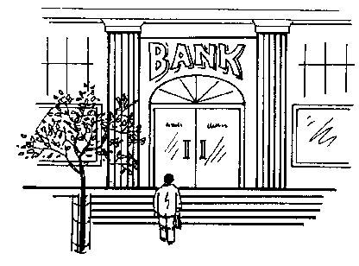
If too few people are borrowing money, interest rates usually go down. It works in the same way as the supply and demand for goods. When the interest rate goes up, the money borrowed becomes more expensive, repayment amount increases proportionally and it may take longer to repay the loan.
Only those who are judged creditworthy by the bank or the money lender will be given a loan. Banks want security to protect their money in case the business does not succeed.
They will request things like the bond on a property, personal and/or business assets, any guaranteed sum of money which they can take over like fixed savings and insurance policies.
If you were to take out a loan or buy on credit, and were to repay your debts in the time given, and at the required interest rate, you would be considered to be worthy of more credit.
If you do not do this, you lose your creditworthiness. The person, bank or business who loaned you the money or extended your credit is entitled to take your assets after a judgement of the court. If you have assets that can cover your debt, for example a house or a car, these assets can be used as security against a further debt.

Simple interest
The calculation of interest may be ‘simple’ or ‘compound’. Simple interest is the application of a percentage rate to the principal sum for the period in question.

Compound interest
Compound interest is interest on the principal sum, plus the accruing (added) interest, as expressed in the equation. Compound interest means “interest on interest”.
Where i is the actual interest, p is the principal sum (sum borrowed), t is the time or period of the loan in years and r is the percentage rate of interest.
For interest compounded annually, or
For interest compounded q times per year.
Interest on bank accounts is ‘simple’ interest but is compounded in the case of a deposit account to the extent that interest is allowed on interest previously credited to the account. The ‘rests’ between interest dates are critical. Clearly, the compounding effect of interest allowed yearly in arrears is not as good as the compounding on interest allowed, say, quarterly.
In the case of an overdrawn current account, interest is calculated from the actual date when a customer’s cheque is paid (not from the date on the cheque), and from the actual date when money is credited to the account (usually at the computer centre.
As the rate of interest on borrowing rises, more and more investments that previously looked profitable start to loo unprofitable. The demand for borrowing for investment purposes, therefore, is lower at higher rates of interest. If the interest rate goes up, people will spend less because is costs more to spend if they have to borrow the money.
At compound interest, an amount doubles itself:
At 7 percent in | 10 years | 89 days
At 6 percent in | 11 years | 327 days
At 5 percent in | 14 years | 75 days
At simple interest, an amount doubles itself:
At 7 percent in | 14 years | 104 days
At 6 percent in | 14 years | 239 days
At 5 percent in | 20 years | -

Example: Compound interest
A man invests R5 000 in a company at 13% interest per year for 3 years. He decides not to use any of the interest he earns until the end of the investment period. How much will he have earned after 3 years
Solution:
Amount at the beginning of the 1st year | R5 000
Interest(13% of R5 000) | R650
Amount at the beginning of the 2nd year | R5650
Interest (13% of R5 650) | R734.50
Amount at the beginning of the 3rd year | R6 384.50
Interest (13% of R6 384.50 | R829.99
Amount at the end of the 3rd year | R7 214.49

Example: Calculating compound interest using the formula
Calculate the compound interest on an investment of R200 000 which is invested for a period of 2 years at 10% interest per year.
Solution Procedure with calculator:
200000 X ( 1 + 10÷100 ) y^{x} 2 - 200000 = 42000

- 200 000
Remember: Interest = Final amount – Initial amount
The interest paid for the privilege to use R200 000 for 2 years at 10%, is R44 038.01

Activity 3(S01-4) Costs, prices, revenue, profit

What is Inflation?
In its simplest form, inflation is an unhealthy and steady increase in the price of goods and services. Since the early seventies, South Africans have been faced with an average inflation rate of well above 10%. The end result has been a steady erosion in the buying power of money. It affects all of us; it will make all of us poorer over time. It will eventually reduce our standard of living, it will destroy our confidence and peace of mind. Speak to anyone who retired on a fixed income in the last ten to fifteen years. At an inflation rate of 15%, the purchasing power of your money halves every 4,8 years.
This creates uncertainty and fear about the future. You cannot make plans for anything worthwhile in your life, not for your old age, not for the education of your children, not for the care of your loved ones.

How is Inflation Measured?
Inflation is measured by means of the CPI (Consumer Price Index).
This is done by measuring the cost of a representative basket of goods and services consumed by the average consumer and includes things such as cars, food, clothing, equipment, rentals, services etc.
Calculated on a monthly basis, the difference in cost is thus the inflation rate.

What Inflation Does To R50.00
Magnus Heystek's story of the disappearing R50 note:
He explains that R50.00 now will still be R50.00 in five years' time, but we will be able to buy much less with the same R50.00.
R50 in itself is not worth anything. It's what you can do with it in the future that is important.
So, the biggest threat to your money is something called INFLATION.
The purchasing power of money is one of the most important concepts when it comes to formulating an investment plan for yourself.
All investments must be geared towards protecting the purchasing power of your money.

How To Combat Inflation
The effect of inflation is that the value of the rand is dropping. Thus the value of assets rises as the purchasing power of the rand in which they are valued drops. But inflation is not bad for everybody - for every person who loses by inflation, another will gain.
The value of the average family home rises by 12% per annum due to inflation. The winners are present home-owners who see the value of their asset increase. The losers are those who have not yet bought, as it now costs them more to buy.
To beat inflation, one has to earn a real rate of return which means a return that beats the inflation rate after taxes. The successful investor is one who always strives to earn a rate of return equal or above the inflation rate.
Investments in the so-called "traditional" category of investments in banks have, on average, lost 5% of the purchasing power of their money per annum, over the last 20 years or more.
By investing in equities and mortgage bonds, your chances of beating inflation are better.
So it is clear that in times of inflation it is sound strategy to keep the major part of your assets in a form which should increase in value, and only a small part in banks, building societies and other areas where it is losing value every day.

The Rule of 72
The Rule of 72 is a simple way to calculate the effects of inflation. If we take the number 72 and divide it by the expected inflation rate, the answer will be the number of years for money in cash form to lose HALF of its purchasing power or assets to DOUBLE in value.
If inflation was at 16% on average over the last 20 years (i.e. 72 ÷ 16 = 4,5), every four and a half years an asset such as an income-producing property would double in price, and the money you have left sitting as interest-bearing deposits would buy half the products it would have bought four and a half years ago. If inflation goes to 20%, this doubling or halving will occur every three and a half years, (i.e. 72 ÷ 20 = 3,6).
Let's see how inflation can affect a typical married retiree who leaves work with what appears to be a large sum of money. Bill retires at 60 years of age with R200 000 which he invests in fixed deposits at 15%. The return is R30 000 per year of which tax takes around R5 000, leaving just over R25 000 to live on.
Let's look at what happens if inflation runs at 16%.
After four and a half years the purchasing power of the capital is down to R100 000 and the purchasing power of the annual income is down to R12 000.
In another four and a half years the capital is only worth around R50 000 and the income will buy only R6 000 worth of goods and services.
Certainly the face value of the fixed deposit would still be a nominal R200 000 but money is only worth what it can buy and its purchasing power has been slashed by 75% in just nine years.
Contrast this to the position of Jim who retired at the same age and used the R200 000 to buy income-producing property. The return of 10% after all costs meant that initially Jim's income was only R20 000 per year before tax, but due to inflation, grew every year. After nine years the property was worth nearly R800 000 and the income had risen to almost R80 000. By using inflation-beating techniques, Jim had managed to maintain his standard of living. On the other hand, Bill was forced to live on a decreasing (in real terms) income from his investment in fixed deposits.

Long-Term Effects of Inflation
What would you say if you were told that a twenty-five year old person, earning R2 000 per month today, will need to earn R530 000 per month by the time he/she is 65, just to be on an equal footing? (This is based on this person's salary increasing in line with an inflation rate of 15%).
This is exactly what will happen if inflation is not brought under control.
The following table illustrates the decreasing purchasing power of R1 000 at various inflation rates

Inflation | 10% | 12% | 15% | 8% | 20%
After 5 years | 620 | 567 | 497 | 437 | 402
After 10 years | 386 | 322 | 247 | 197 | 162
After 15 years | 239 | 183 | 123 | 84 | 65
After 20 years | 149 | 104 | 61 | 37 | 26

Frightening, isn't it?
Just imagine retiring on a fixed income at the age of 65, still fairly strong and healthy. If you are male, you can expect to live another 12 years on average. The average female can expect to live another 14 years.
You've saved and skimped all your life. And what happens? Inflation destroys it all, at a time when you are no longer able to work and protect yourself against price increases.

Example
John Smith takes out an endowment policy in 1998 which matures in the year 2014, i.e. in 16 year's time.
Assuming inflation stays at an average of 9% over the next few years, we can calculate what the real value of his money will then be, if the projected maturity value is R1.8 million, by using the Rule of 72.
72 ÷ 9 = 8 years
That means that the value of this money will halve every eight years, i.e. R1.8 million has to be halved twice in 16 years.
In other words, R1.8 million divided by 2 = R900 00
And R900 000 divided by 2 = R450 000
His R1.8 million payout in 2014 will only be worth R450 000.

Activity 5 SO2, (AC1-4) Inflation

Depreciation And Appreciation
Depreciation is a reduction in accounting earnings which are intended to reflect the reduction in value of an asset. In other words, the car, furniture, clothes, cell phones and computer equipment you buy decrease in value every year, meaning they are worth less than you paid for them. Depreciation occurs when your assets, including the buying power of your money, loses value.
Appreciation, on the other hand is when assets, including the buying power of your money, increases in value. Property such as houses and flats are seen as assets that increase in value.
Interest is sometimes seen as a method of protecting your money against losing buying power due to inflation, provided you let the interest accumulate and don’t use it.

Let's look at two case studies:
Thabo and Aletta are paying rent of R866 per month and decide to buy a smart new motor car for R36 000. They let the motor dealer arrange a loan on the car for them through a finance company. They are told that the interest rate is 19% FLAT. They don't know what that means, so assume it is REDUCING interest. In fact the TRUE RATE IS JUST UNDER 31%. Their monthly payments are R1320 per month for four years.
In addition they have to pay R866 per month for rent. Their monthly payments total R2 186. At the end of four years, they have spent R104 928 in rent and car payments and own a second-hand car worth R20 000, if they are lucky.
Now consider Mandla and Jackie who buy a R110 000 house with a R100 000 loan. If they voluntarily pay R2 186 monthly off the loan (that is no more than the other couple are paying) the bond will be down to R36 902 at the end of four years. Obviously these figures change depending on the rate of interest payable on the bond. If the house gains value at 12% per annum, it will be worth R157 336 at the end of that time.
You can now vividly see how varied spending and borrowing priorities can make such a difference to the start that two different couples can give themselves. Their incomes are the same and their monthly payments are the same. Yet, at the end of four years, Mandla and Jackie are very well off and the other couple have NOTHING to show for four years' work.

Activity 6 (SO 1-4) Appreciation and depreciation

A certain woman of the wives of the sons of the prophets cried out to Elisha, saying, “Your servant my husband is dead, and you know that your servant feared the Lord. And the creditor is coming to take my two sons to be his slaves.” 2 So Elisha said to her, “What shall I do for you? Tell me, what do you have in the house?” And she said, “Your maidservant has nothing in the house but a jar of oil.” 3 Then he said, “Go, borrow vessels from everywhere, from all your neighbors—empty vessels; do not gather just a few. 4 And when you have come in, you shall shut the door behind you and your sons; then pour it into all those vessels, and set aside the full ones.” 5 So she went from him and shut the door behind her and her sons, who brought the vessels to her; and she poured it out. 6 Now it came to pass, when the vessels were full, that she said to her son, “Bring me another vessel.” And he said to her, “There is not another vessel.” So the oil ceased. 7 Then she came and told the man of God. And he said, “Go, sell the oil and pay your debt; and you and your sons live on the rest.”

2 Kings 4:1-7 NKJV

UNIT STANDARD 9009

Unit Standard Title
Apply basic knowledge of statistics and probability to influence the use of data and procedures in order to investigate life related problems

NQF Level
2

Credits
3

Purpose
This Unit Standard is designed to provide credits towards the mathematical literacy requirement of the NQF at Level 2. The essential purposes of the mathematical literacy requirement are that, as the learner progress with confidence through the levels, the learner will grow in:
- A confident, insightful use of mathematics in the management of the needs of everyday living to become a self-managing person
- An understanding of mathematical applications that provides insight into the learner`s present and future occupational experiences and so develop into a contributing worker
- The ability to voice a critical sensitivity to the role of mathematics in a democratic society and so become a participating citizen

Learning Assumptions
The credit value is based on the assumption that people starting to learn towards this unit standard are competent in Mathematics and Communications at NQF level 1

Range
This unit standard includes the requirement to:
- Identify issues suited to resolution by basic statistical methods.
- Work with existing data.
- Generate statistics through the use calculators and other available technology.
- Represent data in the form of tables, charts and graphs.
- Use statistics and representations of data to
- Summarise real-life and or work related issues within the experience of the learner.
- Give opinions on statistics and representations of data.
- More detailed range statements are provided for specific outcomes and assessment criteria as needed

Specific Outcomes and Assessment Criteria
Specific outcome 1: Apply various techniques to organise and represent data in order to model situations for specific purposes
Range:Techniques include:
- Using a variety of methods to represent statistics including pie charts, bar graphs, stem and leaf plots;
- Reading tables (e. g., the meaning of row and column headings and the relationship between age by gender by province);
- Extracting a suitable set of data from tables and databases (e. g., census data, tables in newspapers, HIV data; weather data);
- Recording and organising data into tables;
- Calculating measures of centre and spread such as mean, median, mode, and range; the use of quartiles in classifying data items ("Measures of centre and spread" should be handled via examples, which are directly related to the life or work experiences of each learner. For example workers` wages and learners` test scores).
Assessment criteria
- Questions about sets of data that can be dealt with through statistical methods are identified correctly
- Existing tables are understood correctly through a proper application of row and column headings
- Raw data or statistics in the body of tables are used correctly
- Effective methods to record and organise data are used to solve problems
- Calculations of statistics are correct
- Appropriate statistics are used to answer questions
- Scales used in graphical representations and tables are consistent with the data, are correct, clear and appropriate to the situation and target audience
Specific outcome 2: Give opinions on the implications of the modelled data for the required purpose
Range: Purposes include:
- Determining trends in societal issues such as crime and health;
- Identifying relevant characteristics of target groups such as age range, gender, socio-economic group, cultural belief, and performance;
- Considering the attitudes or opinions of people on current issues relevant to the life experience of the learners;
- Determining weather patterns for a given region.
Assessment criteria
- Verbal (written or oral) explanation of findings is based on the representation of the data
- Trends, group profiles and attitudes are justified
- Appropriate information is extracted from representations in order to answer questions

Essential embedded knowledge
The following essential embedded knowledge will be assessed through assessment of the specific outcomes in terms of the stipulated assessment criteria. Candidates are unlikely to achieve all the specific outcomes, to the standards described in the assessment criteria, without knowledge of the listed embedded knowledge. This means that the possession or lack of the knowledge can be inferred directly from the quality of the candidate `s performance against the standards.
- Methods for selecting, organising data and calculating statistics
- The meaning of concepts such as centre and spread
- Techniques for representing and drawing conclusions from statistics

Critical cross field outcomes
- Identify and solve problems using critical and creative thinking: Give opinions, based on data and statistics, on a variety of problems and issues
- Collect, analyse, organise and critically evaluate information: Select organise, and give opinions on statistics to make sense of situations related to the life or work of the learner
- Communicate effectively: Use everyday language and mathematical language to represent data, statistics and probabilities and to communicate conclusions
- Use mathematics: Use mathematics to describe and represent situations and to solve life related problems.

ORGANISE AND REPRESENT DATA
When your mind is muddled, look to God to find organization and peace.

Outcome
Apply various techniques to organise and represent data in order to model situations for specific purposes

Outcome Range
- Techniques include: Using a variety of methods to represent statistics including pie charts, bar graphs, stem and leaf plots;
- Reading tables (e. g., the meaning of row and column headings and the relationship between age by gender by province);
- Extracting a suitable set of data from tables and databases (e. g., census data, tables in newspapers, HIV data; weather data);
- Recording and organising data into tables;
- Calculating measures of centre and spread such as mean, median, mode, and range; the use of quartiles in classifying data items ("Measures of centre and spread" should be handled via examples, which are directly related to the life or work experiences of each learner. For example workers` wages and learners` test scores).

Assessment criteria
- Questions about sets of data that can be dealt with through statistical methods are identified correctly
- Existing tables are understood correctly through a proper application of row and column headings
- Raw data or statistics in the body of tables are used correctly.
- Effective methods to record and organise data are used to solve problems
- Calculations of statistics are correct
- Appropriate statistics are used to answer questions
- Scales used in graphical representations and tables are consistent with the data, are correct, clear and appropriate to the situation and target audience

Use Statistics In Work Or Every Day Life
Statistics is the collection and analysis of numerical data in large quantities. This means that you gather information about a subject and then you analyse the information or data, so that you can distinguish trends. It is a very useful and easy way to “see” the story the numbers are telling.
Every time before an election, one of the organisations, Markinor, who collect and analyse data, will tell us before the election which political party will win the election and by how big a margin they will win the election. This is an example of gathering information and then analysing the information in order to find out what the trends are.

In the workplace, you can gather information about how many passengers you collect every day with your bus, how much fuel your bus uses, how many employees are off sick during winter, how much stationery is used by the administration department, etc. Once you have the information, you can analyse it to find out what the trend is.

Graphical Representation Of Data
Once you have analysed the information, you will want to present it in such a way that everyone understands the information.
Charts and graphs are good ways of presenting information. They are visually appealing and make it easy for users to see comparisons, patterns, and trends in data. For instance, rather than having to analyze several columns of worksheet numbers, you can see at a glance whether sales are falling or rising over quarterly periods, or how the actual sales compare to the projected sales.

Bar graphs
Bar graphs compare measurements at intervals, the bars run horizontally. Column charts compare measurements at intervals and provide a view of data at a specific time. The bars run vertically
The example below shows a column chart indicating how many ice creams were sold from January to May.
If you use a bar chart, the bars will run horizontally and not vertically as with a column chart.
Number Of Ice Creams Sold

- In a bar graph, the heights of the bars are important.
- When you draw a bar graph, state clearly what you are representing on the two axes. This means that you have to label the axes. Also insert it on the graph above.

- Draw the axes at right angles to each other
- Choose a scale for the vertical axis and write in the units.
- Use a ruler to help you read off the height of a bar.

Line Graphs or Curves
Show the changes in data or trends over a given period of time. They are used to emphasize rather than compare. We use a dot to show the height of each bar. If we join the dots, we get a line graph.
Example: Number Of Ice Creams Sold
0
10
20
30
40
50
60
70
80
90
100
Jan
Feb
March
April
May

Pie Charts
Show the breakdown of a total. A pie chart is a good way to show how a fixed number is divided. The whole circle (360ْ) represents the total number (or 100%) and we express each part as a fraction or percentage of the whole. A pie chart is constructed by converting the share of each component into a percentage of 360 degrees.
In the example on the next page, a total of 2000 cars were sold in 1996 and the pie chart shows the breakdown of the 2000 cars: which manufacturer sold how many cars.

A pie chart is useful to display the total value of your monthly expenses per your household budget.
Below is an example of a household budget in a table and then displayed as a pie chart:
Expenses
Mortgage | R 3,200.00
Car Loan | R 2,200.00
Water and lights | R 430.00
Groceries | R 900.00
Transport | R 200.00
Total | R 6,930.00

From this you can see that this couple spend most of their money on paying for their house and car.

Stemplots
Bar graphs can be a bit complicated to make although they are very easy to understand. If I have a small amount of data there is a quicker way to create a simple graph that has many of the same characteristics as a histogram. Let me define ‘a small amount of data’ as about 100 items or less. I’ve happily used this technique with several hundred items because it also has other hidden properties. So what we agree upon as small is just a matter of taste and convenience.
The result is called a ‘stemplot’ and I am going to demonstrate how to create it. It’s must easier to show you how to create a stemplot than it is to tell you how to do it.
You are arranging a birthday party for your grandfather and the list of guests amounts to 50. You have written down everyone’s age, to help you with the seating arrangements.
There are 50 numbers in total:
53 | 97 | 66 | 99 | 30
81 | 19 | 9 | 31 | 67
61 | 4 | 5 | 73 | 54
42 | 27 | 49 | 29 | 30
28 | 13 | 60 | 13 | 34
28 | 59 | 87 | 29 | 62
38 | 40 | 40 | 78 | 98
69 | 39 | 62 | 56 | 90
9 | 34 | 12 | 69 | 93
38 | 58 | 83 | 28 | 5.

These numbers consist of two digits so they may range from 00 to 99.
There are three steps in making a stemplot:
Write down the stems. The stem consists of the first digit of each number remembering that ‘4’ is actually ‘04’: The stems are written vertically down the page with a vertical line to their right. In this case the stems range from ‘0’ to ‘9’.
Create the leaves. Write down the second digit to the right of the stem that contains its first digit. For example, ‘29’ uses ‘2’ as its stem with the ‘9’ written to the right of the vertical bar.
The last step is to sort the values of the leaves for each stem.
The figure below shows the 3 steps.

Figure 25 The three steps needed to create a stemplot
I’ll now take you through the steps just to make sure you understand them. The stems are easy to understand so we write down and put a vertical line to their right (Step 1).
The first number is ‘53’ so we write the ‘3’ to the right of the stem ‘5’. The next number is ‘97’ so we write the ‘7’ to the right of the stem ‘9’. The third number is ‘66’ so we write the ‘6’ to the right of the stem ‘6’. Continue in this way until all the numbers are finished and you should end up with the leaves (Step 2). You must write the right-hand digit next to the ones that are already associated with the stem (left-hand digit). If you used the normal tally method of putting strokes or lines down instead of the second digit, you end up with a stem and leaf plot.
Finally we sort the number in each stem with the lowest number at the left.
When we are finished, we have something like a histogram but on its side. Turn the manual sideways or turn you head sideways in order to see its shape.
We have something a histogram can’t give us: the values of the items! We also have another benefit that we often find very useful: the numbers are now sorted! Check the list: 4, 5, 5, 9, 9, 12, 13, 13, 19, and so forth until we get to 99.
Now you know how many guests aged between 0 and 9 years, 10 to 19 years, etc. will attend the party. You also know their individual ages. Now you can arrange seating for the youngest children near their mothers, you can place the teenagers away from the very old people, and so on.

Create a stemplot with decimals
You will need to make some adjustments for numbers with more than two digits or numbers with decimals. Let us say that the list of numbers on the next page represents the average maximum winter temperatures taken over a period of time at 10:00.

13.6 | 18.9 | 11.0 | 8.1 | 14.8
14.6 | 17.4 | 11.0 | 17.4 | 9.3
19.1 | 18.1 | 9.2 | 22.4 | 15.5
12.9 | 10.8 | 6.2 | 10.3 | 13.7
13.8 | 16.6 | 19.3 | 7.9 | 15.8
17.3 | 3.6 | 16.9 | 20.6 | 6.2
11.6 | 11.0 | 16.8 | 22.1 | 12.4
6.7 | 14.9 | 14.7 | 18.9 | 20.0
15.2 | 10.5 | 14.3 | 16.5 | 6.1
8.3 | 12.5 | 15.8 | 14.3 | 15.8
Create a stemplot
Find the minimum and maximum numbers by scanning the rows and columns. The minimum is 3.6 and the maximum is 22.4. Use the whole numbers for the stem and the fraction for the leaf. If you do so you should end up with the stemplot in Figure 26.

Figure 26 Stemplot using decimals
I want to call your attention to several interesting items in this stemplot. (Interesting to one who wants to understand data that is.) The value of 3.6 is pretty far away from the other values. Values that are far away from their nearest neighbours may be what is called an outlier in statistics-talk. They lie outside the data. They may be really there or they may be there because of some error in the process of collecting or recording the information. I would check this value just to make sure it’s really 3.6 and not 6.3! You might also note that values 22.1 and 22.4 are also a bit far from their neighbours as well and may be outliers.
The values in stem ‘6’ also catch my attention. There appear to be too many values in this stem to go along with the rest of the distribution. These values would also need to be verified.
The overall shape of the distribution from 7.9 to 20.6 is fairly symmetrical even with the gaps that appear the values between 12.0 and 13.9 (the two stems of 12 and 13).
Now that we took a detour in looking at the previous distribution, let’s get back to the stemplot. You may also split the stems if it helps you. If you do then each stem appears twice. The leaves 0-4 are put with the upper stem while the leaves 5-9 are put with the lower stem. In the previous example, if I split the stems 14 and 15 I would obtain the grouping shown in Figure 27:

Figure 27 Stemplot with split stems

Displaying Data From a Table
The following table was taken from the 2001 census and published by Stats SA.
Columns

Language | Male | Female | Total
Afrikaans | 2,900,214 | 3,083,212 | 5,983,426
English | 1,772,483 | 1,900,720 | 3,673,203
IsiNdebele | 342,366 | 369,455 | 711,821
IsiXhosa | 3,726,376 | 4,180,777 | 7,907,153
IsiZulu | 5,045,450 | 5,631,855 | 10,677,305
Sepedi  Rows | 1,987,170 | 2,221,810 | 4,208,980
Sesotho | 1,704,071 | 1,851,115 | 3,555,186
Setswana | 1,774,785 | 1,902,231 | 3,677,016
SiSwati | 571,429 | 623,002 | 1,194,431
Tshivenda | 482,134 | 539,623 | 1,021,757
Xitsonga | 1,001,446 | 990,761 | 1,992,207
Other | 126,117 | 91,175 | 217,292
Total | 21,434,041 | 23,385,736 | 44,819,777

This table lists the languages along with the number of people, grouped by gender, who use this language as their home language. Look at the table. It contains a few very important details.
Firstly, a table is made up of rows and columns. The rows extend horizontally across the page and the columns extend vertically down the page. Secondly, the table has a caption that describes the contents of the table. In this case the caption is below the table while in other cases the caption may be above the table. This table has a total column as its last row that may or may not appear in other tables. Thirdly, each column is labelled (Language, Male, Female and Total) so that you know what is in each column of data.
A table is pretty simple. It lists data in rows and columns and you can find the information you are looking for by going to either the row or columns of interest and looking either across or down. The intersection of the row and column (where they cross) is the data you require.
Once data has been collected it will be displayed in a table. From the table, you can make certain deductions. However, the best way to display data is to convert the table into a graph.
In this example, if I want to find out how many people reported that they speak a home language that is not one of the official nine languages, I would look in the row called ‘Other’ and read the number to its right in the ‘Total’ column: 217,292.
The purpose of a graph is to provide a visual summary of data. Graphs are the most effective way to communicate data and a good graph shows facts that would be very difficult or impossible to see from a table.
The visual impact of a graph is much stronger than looking at rows and rows of data in a table. I can’t get excited over a table of numbers but a good graph can tell me plenty. There is one problem with a graph and you must be aware of it. Graphs are so easy to use and so powerful that some people look at them and forget to think. A graph might look pretty, but it is very easy to deceive the person looking at it. But I’ll show you what to do to create a good graph and at the same time, show you what to look for when someone is trying to ‘sell’ you bad data.
Graphs, like tables, should be clearly labelled to show the variables that are being presented and the units being used. There are three things to remember when putting data in a graph:
- Make your data stand out
- Avoid clutter on the graph
- Use visual perception to get the facts to others.
The table on the next page shows the actual values of the age of all South Africans grouped into five years age groups. The table also displays the percentage of each age group. Note that the column totals do not sum to 100%. I only used three decimal figures to calculate the results in order to demonstrate the potential problems with round-off errors.

Age | Male | % | Female | % | Total | %
0-4 | 2,223,731 | 10.3% | 2,226,085 | 9.5% | 4,449,816 | 9.9%
5-9 | 2,425,804 | 11.3% | 2,427,751 | 10.3% | 4,853,555 | 10.8%
10-14 | 2,518,956 | 11.7% | 2,542,961 | 10.8% | 5,061,917 | 11.2%
15-19 | 2,453,079 | 11.4% | 2,528,642 | 10.8% | 4,981,721 | 11.1%
20-24 | 2,099,293 | 9.7% | 2,195,230 | 9.3% | 4,294,523 | 9.5%
25-29 | 1,899,124 | 8.8% | 2,035,814 | 8.7% | 3,934,938 | 8.7%
30-34 | 1,594,488 | 7.4% | 1,746,412 | 7.4% | 3,340,900 | 7.4%
35-39 | 1,441,507 | 6.7% | 1,630,264 | 6.9% | 3,071,771 | 6.8%
40-44 | 1,233,632 | 5.7% | 1,385,832 | 5.9% | 2,619,464 | 5.8%
45-49 | 967,604 | 4.5% | 1,119,776 | 4.7% | 2,087,380 | 4.6%
50-54 | 769,499 | 3.5% | 868,521 | 3.7% | 1,638,020 | 3.6%
55-59 | 552,323 | 2.5% | 652,943 | 2.7% | 1,205,266 | 2.6%
60-64 | 444,510 | 2.0% | 620,784 | 2.6% | 1,065,294 | 2.3%
65-69 | 304,763 | 1.4% | 483,164 | 2.0% | 787,927 | 1.7%
70-74 | 232,547 | 1.0% | 398,922 | 1.7% | 631,469 | 1.4%
75-79 | 136,436 | 0.6% | 231,101 | 0.9% | 367,537 | 0.8%
80-84 | 90,835 | 0.4% | 180,111 | 0.7% | 270,946 | 0.6%
85+ | 45,907 | 0.2% | 111,425 | 0.4% | 157,332 | 0.3%
Total | 21,434,038 | 99.1% | 23,385,738 | 99.0% | 44,819,777 | 99.1%

The bar chart on the next page shows the details of the above table visually. It makes more sense to look at it this way, does it not? Something else you can note about this graph is that is consists of two bar charts displayed back to back.

The table below shows the number of units that were sold per item. To visually represent this data, a column chart or bar graph would be best:
Sales
 | Jan | Feb | Mar
Item 1 | 1000 | 700 | 900
Item 2 | 400 | 600 | 700
Item 3 | 100 | 500 | 200
Item 4 | 5000 | 7000 | 6000
Totals | 6500 | 8800 | 7800

This table shows school subjects:
 | 1st quarter | 2nd quarter | 3rd quarter | 4th quarter
subject
English | 60 | 62 | 66 | 71
Geography | 73 | 69 | 61 | 76
History | 51 | 49 | 55 | 53
Mathematics | 43 | 41 | 39 | 45
Science | 46 | 43 | 47 | 53
Second language | 58 | 61 | 53 | 57

And the column chart looks like this:

Activity 1 (SO1, AC1-7)

Frequency distribution and range
When you are drawing a chart or graph, you will need the frequency distribution and range of the information in order for the graph or chart to make sense.
- Frequency distribution: where you arrange (distribute) data in some kind of order. A frequency distribution tells you how often certain numbers or values occur.
- Population: The objects we are busy investigating (in the example in the activity, the learners in this class)
- Range: The difference between the lowest and highest items in a set of data is called the range of the data set.
Frequency or relative frequency distributions are most commonly displayed in histograms. A histogram looks very similar to a bar chart.
The histogram and the stemplot display the overall shape of a distribution of values as well as deviations from the centre of the distribution. We can see distributions that are symmetrical (Figure 1), skewed to the right (Figure 2) and skewed to the left (Figure 3). We have also seen that data appear to have a centre and also a spread of values around this centre. Some distributions have a single peak and others have more than one peak.
Figure 1 shows test results.

Figure 2 shows the histogram of the length of words occurring in War and Peace by Leo Tolstoy, 1869. This book consists of more than 550,000 words.

Figure 3 is a histogram of a word list. I am using the term ‘word list’ instead of dictionary because this list does not contain definitions. It’s an open source word list that is used for checking the spelling of words. Figure 23 shows the distribution of the number of letters in each word.
This histogram, in ‘statistics-talk’, is skewed to the left because it has a long tail that appears on the left. It’s completely different, perhaps, from what you would have expected. There are no one-letter words and there are no twelve-letter words.

Range
The range is defined as the difference between the largest and smallest values in the data set.
range = largest - smallest
The range is one measure of the spread of a set of data. If the range is very large we may expect the values in the data set to be spread widely.

Activity 2 (SO1, AC4-7)

Summarising Data
There are often situations in which it is useful to summarise a whole set of data by describing it with a single number. The sum of a set of numbers can be used to summarise data (e.g. the total mass of the pack of rugby forwards is an indication of the possible power of a rugby team).
The total is not always a useful summarizing number, however. Suppose we wish to compare the heights of 10 year old and 9 year old children in a group. The totals cannot be used for the data given because there are different numbers of children in the group.
Height of 10 year olds(m) | 1.76 | 1.77 | 1.8 | 1.66 | 1.6 | 1.79 | 1.8
Height of 9 year olds(m) | 1.69 | 1.7 | 1.5 | 1.42 | 1.42 | 1.75 | 1.67 | 1.62 | 1.6
Although the total for the 9 year olds (14.37 m) is higher than the total for the10 year olds (11.12 m), when we consider individual heights it seems that 10 year olds are typically taller than 9 year olds.
What we actually need is a single number which is typical or representative of the heights of individual 9 year and 10 year olds. One such a number is the arithmetic mean or average.

Mean
Arithmetic mean = (sum of cases)/total number of cases
Mean height of 10 year olds = 12.18/7= 1.74
Mean height of 9 year olds = 14.37/9 = 1.6
The "mean" is the "average" you're used to, where you add up all the numbers and then divide by the number of numbers.
 | 1st quarter | 2nd quarter | 3rd quarter | 4th quarter
subject
English | 60 | 62 | 66 | 71
Geography | 73 | 69 | 61 | 76
History | 51 | 49 | 55 | 53
Mathematics | 43 | 41 | 39 | 45
Science | 46 | 43 | 47 | 53
Second language | 58 | 61 | 53 | 57

If we look at the table above, to calculate the average mark per year for English:
Add the marks for each quarter: 259
Divide by the number of terms: 4
Average = 64.75

Median
Median is the middle value in a spread of values arranged in order from the lowest to the highest.
The median of an even number of items is the mean of the two middle items when the items are arranged according to size.
The median of an odd number of items is the middle item when the items are arranged according to size.
When do we use it? Suppose, for example, that at a party there are ten people aged 14, 15, 16, 14, 15, 16, 16, 15, 60, and 65 respectively. The mean of these ages is 24.6 which are not at all typical of the people at the party. A better statistic would be a median.:
14 14 15 15 16 16 16 60 65 = the mean is 16 – there are 9 ages which is an odd number, so the median is the age right in the middle, which is 16.
If we leave out one of the ages, say 65, there is an even number of items, namely 8.
14 14 15 15 16 16 16 60: now we calculate the mean of the two middle ages 15 and 16, and our median becomes 15.50

Mode
When numbers occur frequently in a set of data, the number occurring most frequently is the mode. This is used if you have the same number occurring so frequently in a set of data that it can be regarded as the typical item. Suppose, for example that members of a group are asked to contribute to a gift for another person, and the contributions are
R1, R1, R2, R100, R100, R0.50, R2, R1, R1, R100, R100, R100.
This set of data can be described well by saying that the majority of people each contributed R100.
About the only hard part of finding the mean, median, and mode is keeping straight which "average" is which. Just remember the following:
mean: regular meaning
median: middle
mode: most often

Using centres and averages
For each set of data (information) that you have collected, you will have to decide which of the three statistics (mean, mode, and median) will give you the best description of the data.
The mode is useful when dealing with nominal data (grouped data) like eye colour or ordinal data (ordered data) like shoe sizes
We now know how to calculate the mean, mode and average but we must still learn how and when to use them. Although the mode is very important in many real life situations it is not used that often in statistical calculations. In many situations the mode is not useful at all because there is no mode. The median is used more frequently than the mode because it is able to describe the data set with more flexibility. The median is also easily understood. The mean, or average, is the most commonly used measure of the centre of a set of data because it is backed by statistical theory. Let’s now see these different ways of measuring the centre of data in action.
Assume that I am the owner of a sporting body and I employ twelve sportsmen (or sportswomen). The annual salaries of each sportsman (sportswoman) are as follows:
- six receive R200,000
- four receive R400,000
- one receives R800,000
- the superstar receives R2,400,000
What is their average salary?
If I used the mode to calculate the average salary it would be R200,000 because this value occurs with the highest frequency (6 times).
If I use the median I must first order the salaries as shown in the table below and then determine the middle value:
Order | Salary
1 | R200,000
2 | R200,000
3 | R200,000
4 | R200,000
5 | R200,000
6 | R200,000
7 | R400,000
8 | R400,000
9 | R400,000
10 | R400,000
11 | R800,000
12 | R2,400,000.

There are an even number of entries (12) so I must obtain the average of the middle two values (R200,000 and R400,000) and indicate that the median is R300,000.
If I use the average (mean) I must sum all the salaries and divide by the number of players which is R500,000 (R60,000,000 divided into 12 players).
Which is the best number to use for the average salary?
The mode indicates that the highest frequency and most players receive R200,000. This number just doesn’t seem right to me even though half the players receive this salary and the other half receive more.
The average produces R500,000. No player receives this amount but then it is an average. However, 10 players receive less that R500,000 and only two receive more. Again, this just doesn’t look right to me.
The median also produces a value that no player receives but at least half the players receive less than this amount and half receive more than this amount. This is the middle of the road average so I would agree with it. As a matter of fact, if the superstar was paid R24,000,000, this measurement of the centre (R300,000) would not change and I would still have half of the players being less and half being paid more. However, if I used the average (mean) I would find that the average salary would be R2,300,000!
The median is a good choice to use for the central value when the distributions are skewed to the right or to the left. Salaries are almost always skewed to the right (very few people obtain very high salaries while most of the workers receive salaries that are on the lower end.) Note that the median value always has half the values on one side and half the values on the other side. There is always a middle value that exists or is the average of the two centre values. The values don’t matter, only their positions when sorted matter.
When the distribution of values is more or less symmetrical and there are no outliers, then the average or mean is the best value to use for the centre of the data set.
Values that skew the distribution of values of the data affect the mean or average, sometimes dramatically. If I did pay my superstar R24,000,000 and advertised that my average salary bill is R2,300,000, the other 11 players would be at my door asking why their salary is so low!

Quartiles
‘What! More things to learn?’ No, you already know them but you don’t know you know them!
Three of the numbers are already familiar to you: minimum value, maximum value and the median. The minimum and maximum values are used to calculate the range, so you know them. The median is the middle-most number in the data set and divides the data set into two separate but equal sizes of data: 50% of the values are above the median and 50% of the values are below the median.
Now take each half and divide it in half again (find the median of each half). What do we have? With the lower half of the data, we have the values that fall below (and above) 25% of the data and with the upper half of the data, we have the values that fall above (and below) 75% of the data.
When we calculate the median of the lower and upper half of the data set we calculate the ‘lower quartile’ and ‘upper quartile’ of the data. We also have the last two numbers of our five-number summary.
- The ‘lower quartile’ (lower quarter point) is also called the ‘25th percentile’ or the ‘1st quartile’ or just Q1: 25% of the data fall below this value.
- The ‘upper quartile’ (upper quarter point) is also called the ‘75th percentile’ or the ‘3rd quartile’ or just Q3: 75% of the data fall below this value.
- The median is also called the ‘50th percentile’, the ‘2nd quartile’ or just Q2: 50% of the data fall below this value.
- The minimum and maximum values are often called Q0 and Q4, respectively
The five-number summary consists of Q0, Q1, Q2, Q3 and Q4 (minimum, 1st quartile, median, 3rd quartile and maximum values). I told you that you knew five-number summary, didn’t I?
Quartiles divide your data set into 4 equal sized groups of data.

Number | Value
1 | 15
2 | 17
3 | 17
4 | 18
5 | 18
6 | 18
7 | 19
8 | 19
9 | 20
10 | 20
11 | 20
12 | 21
13 | 22
14 | 23
15 | 24
16 | 29
17 | 32
18 | 33
19 | 33
20 | 41

Example 1: Q1, 1st quartile
In order to calculate the first quartile (25th percentile) we just use the equation and insert the correct number to obtain the correct element to choose.
The value returned is not a whole number so split it into two pieces 5 and 0.25.
The 5th value in the table is 18. The value 0.25 means that Q1 is 0.25 times the distance between the 5th and the 6th entry. So we have to calculate this value:
5.25th item = 5th item + 0.25×(6th item – 5th item) or
Q1 = 18 + 0.25×(18 – 18) = 18
Therefore, the 1st quartile or Q1 is 18. This also means that 25% of the values are 18 or lower.

Example 2: Median, 2nd quartile
In order to calculate the median or the 2nd quartile we just use the same formula but put in different values.
The value returned is not a whole number so split it into two pieces 10 and 0.5.
The 10th item in the table is 20. The value 0.5 means that the median is 0.5 times the distance between the 10th and 11th entry. So we have to calculate this value: 10.5th item = 10th item + 0.5×(11th item – 10th item).
Therefore the median = Q2 = 20 + 0.5×(20 – 20) = 20.
Therefore, the median is 20. This also means that 50% of the values are lower than 20.

Example 3: 3rd quartile
In order to calculate the median or the 3rd quartile we just use the same formula but put in different values.
The value returned is not a whole number so split it into two pieces 15 and 0.75.
The 15th item in the table is 24. The value 0.75 means that the median is 0.75 times the distance between the 15th and 16th entry. So we have to calculate this value: 15.75th item = 15th item + 0.75×(16th item – 15th item).
Therefore the median = Q3 = 24 + 0.75×(29 – 24) = 27.75.
Therefore, the 3rd quartile or Q3 is 27.75. This also means that 75% of the values are lower than 27.75.

Activity 2 (SO1, AC4-7)

Deuteronomy 28:11–12 —
“And the Lord shall make thee plenteous in goods, in the fruit of thy body, and in the fruit of thy cattle, and in the fruit of thy ground, in the land which the Lord swore unto thy fathers to give thee."

“The Lord shall open unto thee his good treasure, the heaven to give the rain unto thy land in his season, and to bless all the work of thine hand: and thou shalt lend unto many nations, and thou shalt not borrow.”

Modelled Data
When He is in your heart, nothing is unachievable.

Outcome
Give opinions on the implications of the modelled data for the required purpose

Outcome Range
Purposes include:
- Determining trends in societal issues such as crime and health;
- Identifying relevant characteristics of target groups such as age range, gender, socio-economic group, cultural belief, and performance;
- Considering the attitudes or opinions of people on current issues relevant to the life experience of the learners;
- Determining weather patterns for a given region.

Assessment criteria
- Verbal (written or oral) explanation of findings is based on the representation of the data.
- Trends, group profiles and attitudes are justified
- Appropriate information is extracted from representations in order to answer questions

Activity 2 (SO1, AC4-7)

Annexure A

FORMATIVE ASSESSMENT WORKBOOK

Unit Standard 7480

Activity 1 (SO1, AC 1, 2, 7)
This is an individual activity
Use appropriate algorithms to do the following calculations on your calculator:
- Find the sum of:
52 | 68
1345 | 65
15.8 | 989
1123.4 | 6598
12.894 | 1345
12.368 | 15.8
0.0012 | 1123.4
68 | 12.894
65 | 12.368
989 | 0.0012
6598 | 15.8
- John is a bus driver and travelled the following distances during his first trip for the day:
Bus stop | Arrive | Depart | Distance
A | 6:15 | 6:26
B | 6:38 | 6:44
C | 7:01 | 7:13
D | 7:36 | 7:47
E | 8:07 | 8:19

- How far did he travel from A to C?
- How far did he travel from C to D?
- What was the total distance covered in this trip?
- How long did he spend at bus stop A?
- How long did he spend at stops C and D?
- Calculate the answers:
(3.56 x 2.34) +( 2.3 – 1.2)
- (11.2 – 5.6 ) – (2.4 + 4.3)
- (989.21 – 3.4) x (5.3 – 2.3)

- 10.99 + (7.8 x 2.2)
- 414.3 – 298.99 +3.56
- 42.2 x( 5.3 – 4.3)
- 33.1 x( 4.5 + 3.9)
- 0.003 + 2.13 x (4.5 + 4.2)
- Determine the error should you omit the brackets.

Activity 2: (SO1, AC3 – 6)
This is an individual activity
- What is the value of the ‘6’ in each of the following numbers?
169
2,016
6,543
- The pictures below show whole fruit or pies that have been divided into smaller parts. The orange slice looks like one sixteenth of an orange. Use the picture of the orange that has been cut in half to work out if you agree with me.
- See if you can divide the fruit and pies into the following:
- Four quarters
- Eight eighths
- Six sixths
- Twelve twelfths

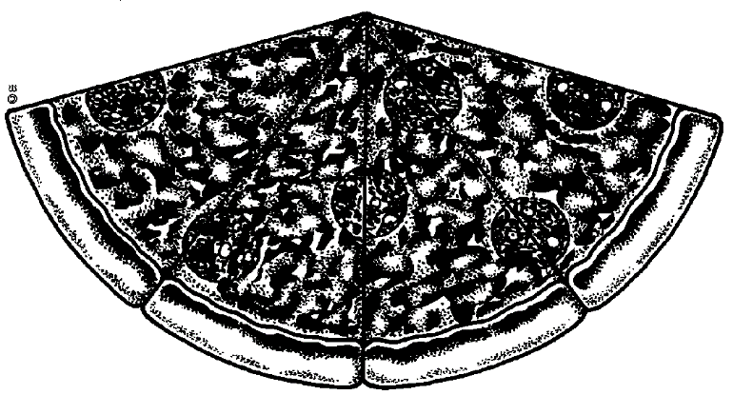
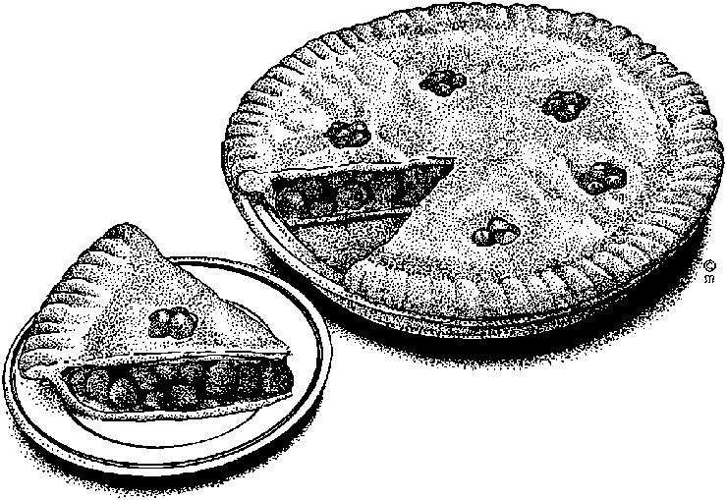

- Round the values in the table to the term specified. Remember to take the term that you are going to round to, find the digit that corresponds to its position then change that digit according to the digit on its right. Do not start rounding from the right then stop when you reach that position. This will give you the wrong answer! Look again at 198.7630467 and notice that the rounding always used the original number. If the rounding had been ‘rolled-up’, so to speak, the value for ten-thousandth would have been 198.7631 and this value is wrong!

Value | Round to (Term) | Result
1.34 | Units
1.34 | Tenths
34,501 | Tens
34,501 | Hundreds
34,501 | Thousands
34,501 | Ten-thousands
34,501 | hundred-thousands
74,436 | Tens
74,436 | Hundreds
74,436 | Thousands
74,436 | Ten-thousands
74,436 | hundred-thousands
198.7630467 | Millionth
198.7630467 | hundred-thousandth
198.7630467 | Ten-thousandth
198.7630467 | Thousandth
198.7630467 | Hundredth
198.7630467 | Tenth
198.7630467 | Units
198.7630467 | Tens
198.7630467 | Hundreds
198.7630467 | Thousands
- Write 8.4751 correct to
3 decimal places
2 decimal places
1 decimal place.
- Round the following values as indicated
Value | Round to | Minimum | Maximum
250ml | 1ml
180ml | 10ml
500ml | 20ml
- What is the difference between rational and irrational numbers? Give an example of each.
Rational numbers are all numbers that can be represented as a ratio () of two numbers
Irrational numbers are those that cannot be represented as a ratio of two whole numbers

Activity 3: (SO2, AC, 1-5)
- Round off all the numbers to 3 decimal numbers
1.256784 =
4.3812629 =
1.001111 =
22.22222 =
8.989993 =
- Convert the following repeating decimals to common fractions:
a | 1.45454545
b | 1,33333
c | 52.535535535
d | 909.9090909090
- Convert the following fractions to decimal form (9)
1/2
1/3
1/4
1/5
1/6
1/7
1/8
1/9
1/10
- If we say that the rule used to determine the number of significant figures the answer of a calculation should have for multiplication and subtraction is that the number with the least significant figures determines the answer, what is the correct answer for the following: (1)
12,345 x 6, 7 =

- If we say that the rule used to determine the number of significant figures the answer of a calculation should have for multiplication and subtraction is to retain the smallest number of decimal places, what is the correct answer for the following: (1)
10,345 + 9, 9 =

- Write the following in scientific notation:
a | 0.0009 m
b | 12cm
c | 1000 mm
e | 0.03 m
f | 1.2 m
g | 120 m
- When is the use of scientific notation useful? Give an example.

- A woman is standing near a lorry. Estimate the length and height of the lorry. Assume that the woman is 1.6m tall.
- A bottle of wine costs 38.95. You want to buy 6 bottles as gifts. Approximately how much will 6 bottles cost? You must estimate your answer and explain your steps. (2)

Unit Standard 9008

Activity 1 (SO1, AC1-7)
This is an individual activity
- Estimate (guess) and then measure the lengths of the following line segments. Give your answers in cm and mm.
Estimate | Measured
1. | 1.
2. | 2.
3. | 3.

1
2
3

- 1. In each case give the greater/greatest measurement:
- 250 g; 0.2 kg
- 0.01 kg; 12 000 mg; 10 g
- Give some examples of fluids that you can buy in packages that are marked in
  - ml
  - l
- Answer the following questions:
How many seconds are there in 2 minutes?
How many minutes are there in 3 h 45 min?
How many seconds are there in 610,2 minutes?
Write the following according to the international time system:2.16 p.m
12.05 p.m
3.12 a.m.
- Below the ruler shown in the learner guide is a line. According to this ruler how long is the line?
- What is the mass indicated on the spring balance in the learner guide?
- What is the temperature indicated by the sketch of the thermometer?
- What is the time on the clock shown in the learner guide?
- What is the volume of the fluid in the sketch of the measuring cylinder shown in the learner guide?
- Complete each of the following:
150cm = ____m

360mm = ____m

62ml = ____litres

3.6 tonnes = ____kg

- Complete the table below:
Quantity | Unit | Abbreviation
Mass
 | Meter
 |  | s
Temperature
 |  | A
Light
Chemical standard unit

- Normal body temperature is 98.6°F. What is this in °C? And what is the temperature in Fahrenheit back from °C?
- What is a thermometer used for? (1)
- What is the normal body temperature of a human being in Celsius? (1)
- What is the point at which water freezes in Celsius? (1)
- What is the point at which water boils in Celsius? (1)
- It is winter and the temperature is 12°C. Calculate the temperature in Fahrenheit
- The temperature in New York is 98°F. Calculate the temperature in Celsius.
- You correspond with someone in England and s/he has written you about a village that is 135 miles from where s/he lives. Calculate the distance in km.
- You read about a person overseas who has cultivated a giant pumpkin, weighing 395 pounds. Calculate the weight in kg.
- A farmer near you has harvested a watermelon that weighs 95kg. You want to let your friend in the UK know about this. Calculate the weight in pounds. Round the answer to the nearest pound
- You travel 45 km to work every day. Convert this into miles.

Activity 2 (SO2, AC1-5)
- Take 1 piece of A4 paper. Calculate the area. Calculate the circumference. What shape is the paper?
- Fold the paper in half, so that it resembles A5 size paper. What shape is the paper now? Calculate the area. Calculate the circumference.
- Which shapes have been combined to make this drawing?

- Draw a square where all the sides are 6cm long. Calculate the area. Calculate the circumference.
- Draw a parallelogram where two of the sides are 6cm long and two sides are 30mm long.
- Transform the parallelogram into a trapezium

- Using your knowledge of geometric shapes, draw the following: A house with a door and windows. Decorate the windows with triangle tessellations. Decorate the walls with rectangle tessellations.
- A lorry and a mirror image of the lorry.
- A rough sketch of the training room. Translate (shift or move) the door to the right.
- Draw the following rectangle and tessellations at a 90º rotation to the right.
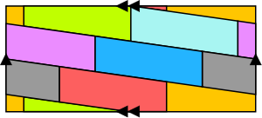

Unit Standard 9007

SO 1-3 All criteria

Activity 1
4 - 6 + 10 x 5
2 + 4x3 - 6x2 - 3

Activity 2
Simplify:
3a + 2ab - 6a + 2b – ab
3xy + 4x - 3y - 4xy + x
a - 2 + 3a – 5
3p + 3q - 4pq - 2pq
Add the following expressions:
3a + 4ab; 3a - 4ab
a - 3; 3b + 6
a - 4; b + 5; c – 13
Subtract the second expression from the first.
a - 2: 2b + 6
a + b; 3b + 2

Activity 3
- Draw Cartesian axes on a sheet of squared paper and place the following points in the plane:
(1,1), (2,1) (-1,1)
Draw a straight line through these points.
What can be said about the y-coordinate of each point on this line?
- Place (8,2) on the Cartesian plane.
What is the distance from (0,0) to (8,2)?
- Place (6,-2) on the Cartesian plane. What is the distance from (0,0) to
(6,-2)?
What is the distance from (0,2) to (6,-2)?

Unit Standard 7469

Activity 1 (SO1, AC1-2)
This is an individual activity
- Complete schedule A
Schedule A
Monthly Income (Schedule A)
Husband
Wife
Other
Total Income (Net)

Activity 2 (SO3-4)
This is an individual activity
- Arrange the following budget items in the applicable category as set out in the schedule.
telephone  travel costs  cigarettes  school fees  rates & taxes  funeral policies | savings  alcohol  hire purchase  groceries  short-term insurance  stokvel | petrol  life insurance  entertainment  clothing  cell phone | bond or rent  retirement annuity  vehicle payments  unforeseen costs  water & electricity

- Complete Schedule B
Schedule B
Monthly Expenses
Expenditure | Estimate | Actual | Date Paid
Fixed Expenditure
Variable Expenditure
Discretionary Expenditure
Sub Total
Total Expenditure
This is an individual activity.
- Draw up your personal budget.

BUDGET
EXPENDITURE |  | ESTIMATE | ACTUAL | DATE PAID
Fixed Expenditure
Sub Total
Variable Expenditure
 | Sub Total
 | Discretionary Expenditure
 | Sub Total
 | Unforeseen Costs
 | TOTAL EXPENDITURE

Activity 3(S01-4) Costs, prices, revenue, profit
Discuss this activity in a group and note the answers.
- John and Rebecca Moalisi have decided to start their own business. They are going to make and sell hot dogs in front of a busy shopping centre. Their monthly costs (expenses) will be approximately R700 to buy bread rolls and viennas. They aim to sell 600 hot dogs per month. One hot dog will cost them 50c to prepare and they’ll sell them for R2.50. Is their business going to be profitable or not? Use the following formula for your calculation: Profit = Margin x Volume – Expenses
- Explain costs in terms of a business
- How does a business generate revenue?
- How can you cut back on your personal expenses in order to save some money?

Activity 4 (SO2, AC104)
Discuss the first part of this activity in a group and note the answers.
- Calculate simple interest
Money required: R 10 000
Interest rate: 22,5%
Pay back period: One Year
What is the interest in rand per month?
R 10 000 X 22,5 divide by 12
__________ _____
1 100

- What is the total interest payable over the one year period?
- What is the total monthly payment?
- This is an individual activity: What is the interest per month if the interest rate increases by another 1,5%?
R 10 000 x 24
_________ ______
1 100
- What is the total interest payable over the one year period if the increase came into effect at the beginning of the seventh month?
Discuss the first part of this activity in a group and note the answers.
- Calculate compound interest: There are 95500 people living in Mankwe. The annual growth rate is 6.% every year. What will the population of Mankwe be after 10 years?
This is an individual activity
- You invest R678 for 12 years at a rate of 15.6%. What would your returns be at the end of year 12?
- A father wants to have R16 000 available for his sons education on his 18th birthday. Calculate the amount he must invest on his son’s 10th birthday at 14% compounded interest?
- The Maluti Company bought equipment to the value of R43 200. The yearly depreciation is 12 %. After 12 year it is sold. Calculate the value of the equipment after 12 year.

Activity 5 SO2, (AC1-4) Inflation
Discuss the first part of this activity in a group and note the answers.
The Rule Of 72
- Assuming a rate of inflation of 12%, calculate, using the Rule of 72, when the price of goods will double (i.e. the number of years).

This is an individual activity
- Assuming a rate of 10%, use the Rule of 72.
This is an individual activity
- Assuming a rate of 8%, use the Rule of 72.
This is an individual activity
- Angela is set to retire in 27 years’ time. At the moment she earns R5000 per month. If inflation remains at 8% on average, what will Angela have to be earning at the time of her retirement to maintain her standard of living? (Use the Rule of 72).

Activity 6 (SO 1-4) Appreciation and depreciation
This is an individual activity
- Describe appreciation and depreciation. Which assets usually appreciate in value and which assets depreciate?

Unit Standard 9009

Activity 1 (SO1, AC1-7)

- Study the bar graph above and then answer the questions.

How many ice creams were sold during January?
During which month were the most ice creams sold?
In which month were the least ice creams sold?
What was the total number of ice creams sold for the period?
- Study the line chart on the next page and then answer the questions below
What tendencies do you pick up from this graph?
When would be a good time to start a new ice cream business?
0
10
20
30
40
50
60
70
80
90
100
Jan
Feb
March
April
May

- Study the pie chart below and then answer the questions

Which company sold most cars?
Which company sold the smallest percentage of cars?
How many cars did Chevrolet sell during 1996?

- In a group draw a column chart or a bar chart for the following information. Use the grid on the next page to help you.
Why do you use a taxi to and from work | Cheap | 1631
Why do you use a taxi to and from work | Fast | 1091
Why do you use a taxi to and from work | Safe | 312
Why do you use a taxi to and from work | Convenient | 1849

2200
2000
1800
1600
1400
1200
1000
800
600
400
200
 | Cheap | Fast | Safe | Convenient
- In a group, draw a pie chart for the following information. A total of 2000 replies were received. Use the pie below to help you.
Which taxi route do you use every day? | Route A | 755
Which taxi route do you use every day? | Route B | 830
Which taxi route do you use every day? | Route C | 415

- Draw a column chart to show the average marks per term.

1st quarter | 2nd quarter | 3rd quarter | 4th quarter
55.16 | 54.16 | 53.50 | 59.16
Ideally, your charts should look as follows:
Your information as a column chart

Your information as a bar chart
Pie Chart
Average of school marks for the year:

Activity 2 (SO1, AC4-7)
- Use the names of learners in your class and the number of children they have to complete the table on the following page:
Names of Learners in your class | Number of Children
Names of Learners in your class | 1 | 2 | 3 | 4 | 5 | 6
1
2
3
4
5
6
7
8
9
10
11
12
13
14
15
16
17
18
19
20
21
22

We would like to indicate how many learners (number of cases) fall within the class intervals.
The class intervals range from 0 – 1children, 2 – 3 children etc.

Class Interval | Tally (number of learners) | Number of children
0 - 1
2 - 3
4 - 5
6 and more
TOTAL:

What is the range of the data set?

- From the table below, calculate the average for the other subjects:
 | 1st quarter | 2nd quarter | 3rd quarter | 4th quarter
subject
English | 60 | 62 | 66 | 71
Geography | 73 | 69 | 61 | 76
History | 51 | 49 | 55 | 53
Mathematics | 43 | 41 | 39 | 45
Science | 46 | 43 | 47 | 53
Second language | 58 | 61 | 53 | 57

- Calculate the average per term:
- In a group, do the following: In each case state which of the three statistics is not an appropriate description of the given data. Order the data and draw a histogram of the data to see how it is distributed. If it is evenly distributed, the mean is most probably the best summary. If not, consider the median. If there are many occurrences of the same value, consider using the mode.
5 7 2 3 8 1 5 2 6
6 2 9 0 3 2 0 2 1 3 1 0 2
21 30 14 5 16 24 17 3 29

Activity 3 (SO2, AC1-3), (SO1, AC3-6)
In a group, study the tables and graphs that follow and answer the following questions:
Which male age group is the biggest percentage?
What percentage of females fall into the 35-29 age group?
Which gender makes up the bigger percentage of the total population?
In the age group 80 to 84, which gender is the bigger percentage?

Age | Male | % | Female | % | Total | %
0-4 | 2,223,731 | 10.3% | 2,226,085 | 9.5% | 4,449,816 | 9.9%
5-9 | 2,425,804 | 11.3% | 2,427,751 | 10.3% | 4,853,555 | 10.8%
10-14 | 2,518,956 | 11.7% | 2,542,961 | 10.8% | 5,061,917 | 11.2%
15-19 | 2,453,079 | 11.4% | 2,528,642 | 10.8% | 4,981,721 | 11.1%
20-24 | 2,099,293 | 9.7% | 2,195,230 | 9.3% | 4,294,523 | 9.5%
25-29 | 1,899,124 | 8.8% | 2,035,814 | 8.7% | 3,934,938 | 8.7%
30-34 | 1,594,488 | 7.4% | 1,746,412 | 7.4% | 3,340,900 | 7.4%
35-39 | 1,441,507 | 6.7% | 1,630,264 | 6.9% | 3,071,771 | 6.8%
40-44 | 1,233,632 | 5.7% | 1,385,832 | 5.9% | 2,619,464 | 5.8%
45-49 | 967,604 | 4.5% | 1,119,776 | 4.7% | 2,087,380 | 4.6%
50-54 | 769,499 | 3.5% | 868,521 | 3.7% | 1,638,020 | 3.6%
55-59 | 552,323 | 2.5% | 652,943 | 2.7% | 1,205,266 | 2.6%
60-64 | 444,510 | 2.0% | 620,784 | 2.6% | 1,065,294 | 2.3%
65-69 | 304,763 | 1.4% | 483,164 | 2.0% | 787,927 | 1.7%
70-74 | 232,547 | 1.0% | 398,922 | 1.7% | 631,469 | 1.4%
75-79 | 136,436 | 0.6% | 231,101 | 0.9% | 367,537 | 0.8%
80-84 | 90,835 | 0.4% | 180,111 | 0.7% | 270,946 | 0.6%
85+ | 45,907 | 0.2% | 111,425 | 0.4% | 157,332 | 0.3%
Total | 21,434,038 | 99.1% | 23,385,738 | 99.0% | 44,819,777 | 99.1%

The table below shows the number of units that were sold per item. Of which item were the most products sold?
During which month were the sales of this item the highest?
Which item sold the least number of units?
During which month were the sales of this item the lowest?

Sales
 | Jan | Feb | Mar
Item 1 | 1000 | 700 | 900
Item 2 | 400 | 600 | 700
Item 3 | 100 | 500 | 200
Item 4 | 5000 | 7000 | 6000
Totals | 6500 | 8800 | 7800
In which quarter did the learner get the highest marks for English?
In which quarter did the learner get the highest marks for geography?
In which quarter did the learner get the lowest marks for Mathematics?
In which quarter did the learner get the lowest marks for Science?
In which quarter did the learner get the highest average?
School subjects:
 | 1st quarter | 2nd quarter | 3rd quarter | 4th quarter
subject
English | 60 | 62 | 66 | 71
Geography | 73 | 69 | 61 | 76
History | 51 | 49 | 55 | 53
Mathematics | 43 | 41 | 39 | 45
Science | 46 | 43 | 47 | 53
Second language | 58 | 61 | 53 | 57

Refer to the HIV AIDS handout and do the following:
- Refer to table 2 in this article and draw up a column chart to compare HIV prevalence per province. If possible, do this on a computer or graph paper.
- Refer to table 1 in this article and draw up a pie chart to compare HIV prevalence between male and female. The total number of people in South Africa who are infected with HIV is 8 428 000, of which 3 772 00 are male and 4 656 000 are female.
- The article makes the following statement regarding the age of people infected with HIV: Age: “The highest prevalence rate was among the 25-29 age group (28%), followed by the 30-34 group (24%). “ If we assume, based on these statistics, that in your organisation 28% of workers in the age group 25 to 29 are infected with HIV and 24% of workers in the age group 30 to 34 are infected, how would this affect your organisation in terms of absenteeism and productivity?

Create a stemplot for the average daily temperatures for July
July 1 | July 2 | July 3 | July 4 | July 5 | July 6 | July 7
22 | 23 | 21 | 22 | 20 | 21 | 21
July 8 | July 9 | July 10 | July 11 | July 12 | July 13 | July 14
14 | 13 | 11 | 9 | 9 | 8 | 12
July 15 | July 16 | July 17 | July 18 | July 19 | July 20 | July 21
17 | 18 | 17 | 19 | 18 | 17 | 19
July 22 | July 23 | July 24 | July 25 | July 26 | July 27 | July 28
21 | 22 | 24 | 16 | 15 | 16 | 14
July 29 | July 30 | July 31
12 | 11 | 17

What does the stemplot tell you about the average temperature in July?

What is the range of the dataset?
What does this mean in terms of the stemplot?
What is the mean of the dataset?
What is the mode of the dataset?
What is the median of the dataset?
Which method would most accurately describe the temperatures in July?
Calculate the minimum, maximum and median of the stemplot dataset.
Calculate the lower quartile (Q1) and the upper quartile (Q3),
Show the dataset as Q0, Q1, Q2, Q3, and Q4
What do the quartiles tell you about the temperatures in July?
Use the table below and draw a graph to compare truck hijackings from 2001 to 2007 for Gauteng Province. Also discuss what conclusions can be drawn from these statistics.

